**ASSIGNMENT 22.2**

**Column 1: Video id of 11 characters.**

**Column 2: up loader of the video**

**Column 3: Interval between day of establishment of Youtube and the date of uploading of the**

**video.**

**Column 4: Category of the video.**

**Column 5: Length of the video**

**Column 6: Number of views for the video.**

**Column 7: Rating on the video.**

**Column 8: Number of ratings given for the video**

**Column 9: Number of comments done on the videos.**

**Column 10: Related video ids with the uploaded video.**

**You can download the data set from the below link.**

**Find out what are the top 5 categories with maximum number of videos uploaded**

**DRIVER CLASS:**

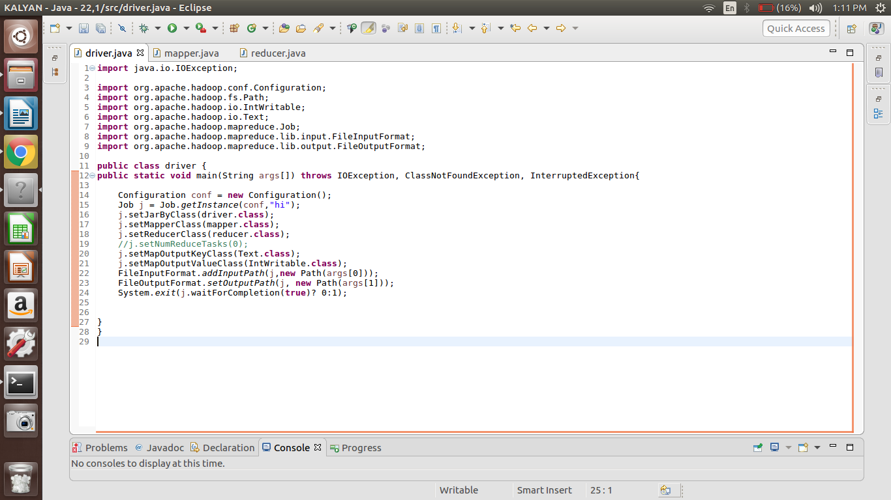

**MAPPER CLASS:**

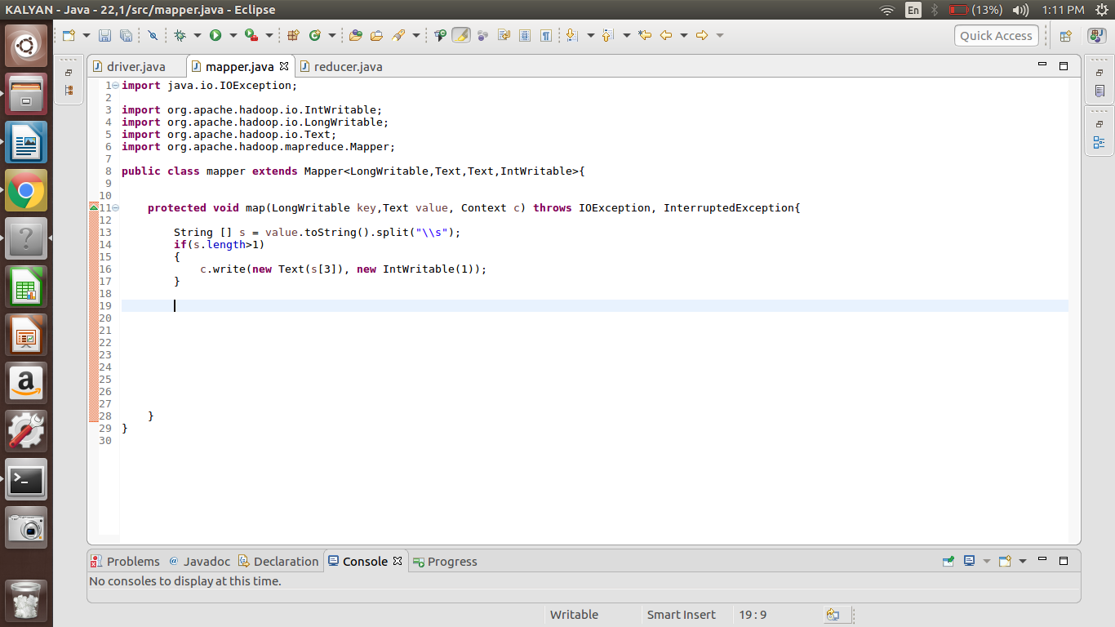

**REDUCER CLASS:**

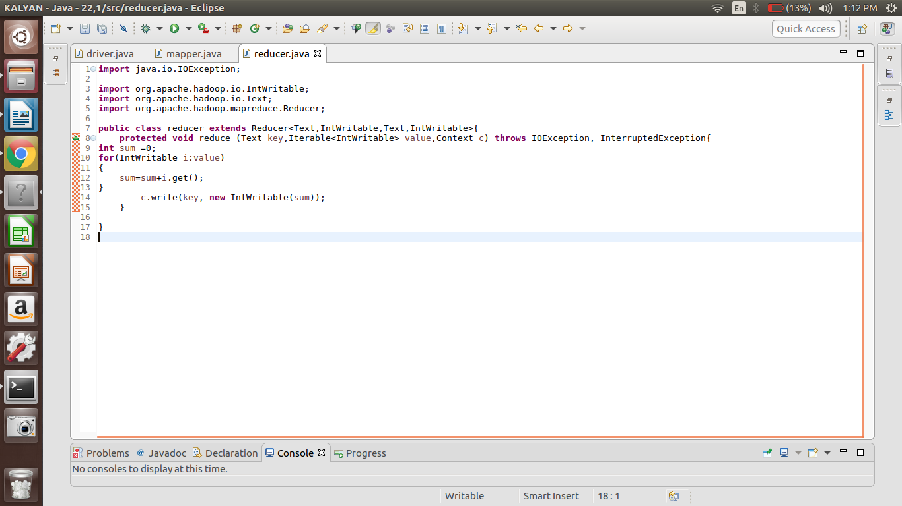

**RUNNING JAR:**

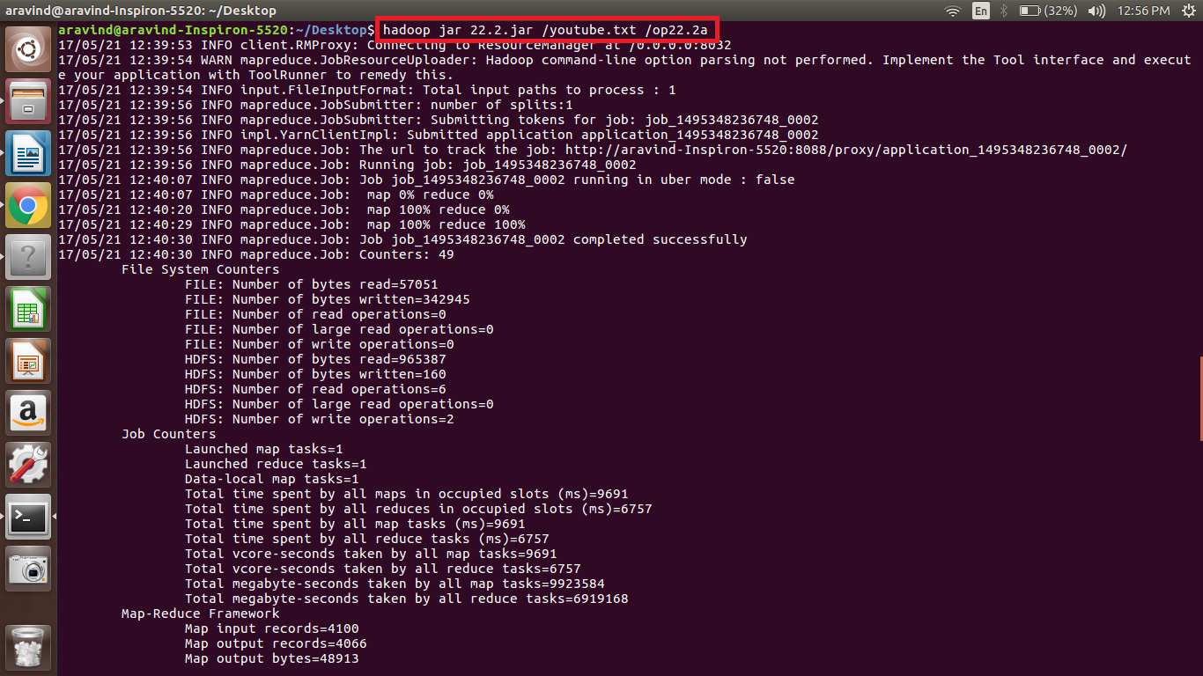

**OUTPUT:**

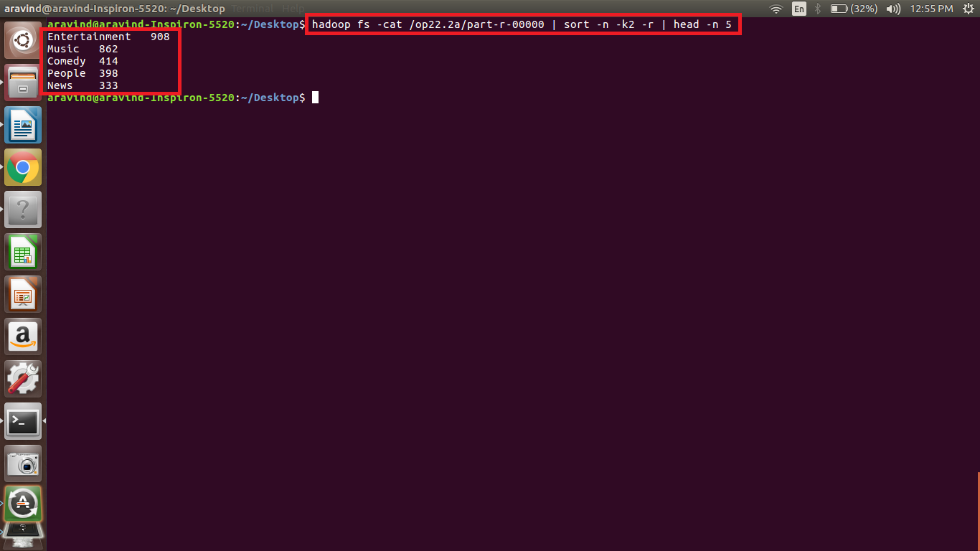

**Next ques in next page**

**Find the top 10 rated videos in youtube.**

**DRIVER CLASS:**

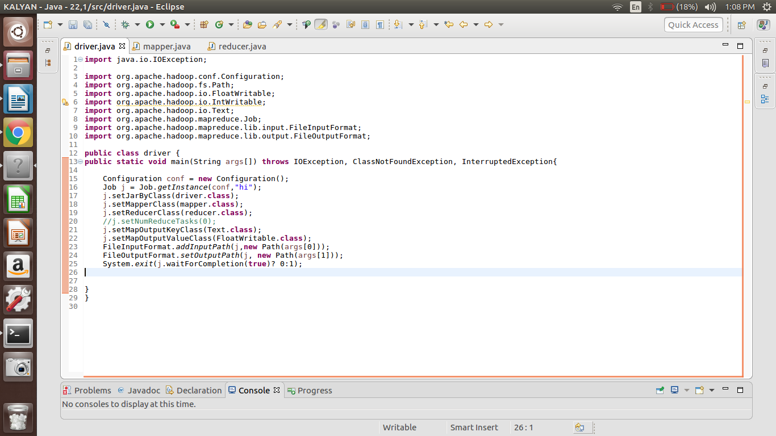

**MAPPER CLASS:**

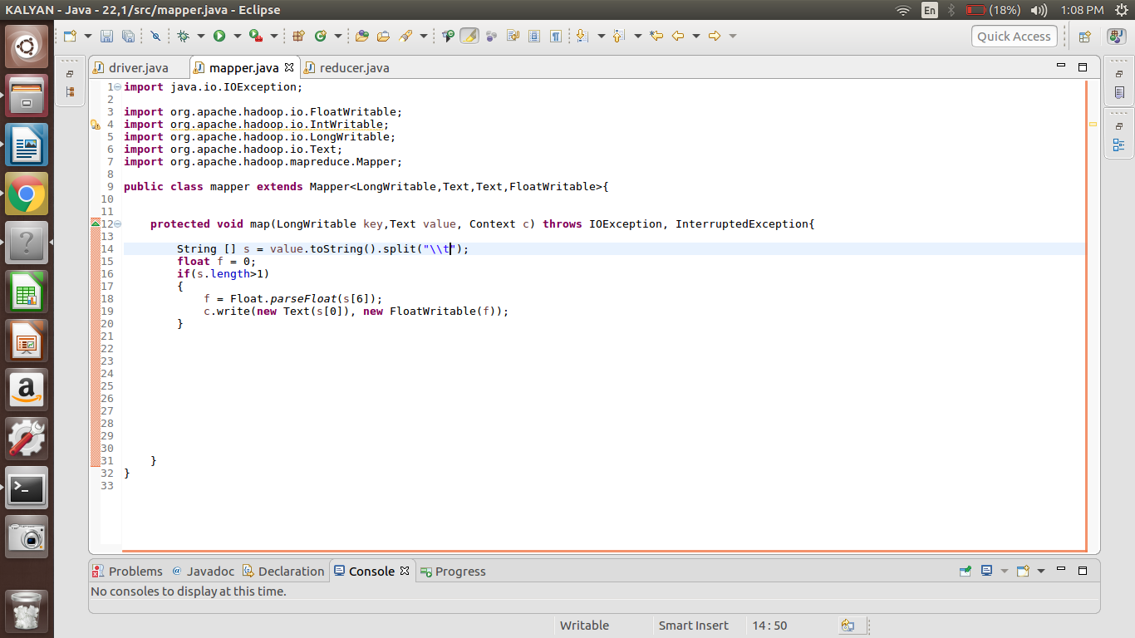

**REDUCER CLASS:**

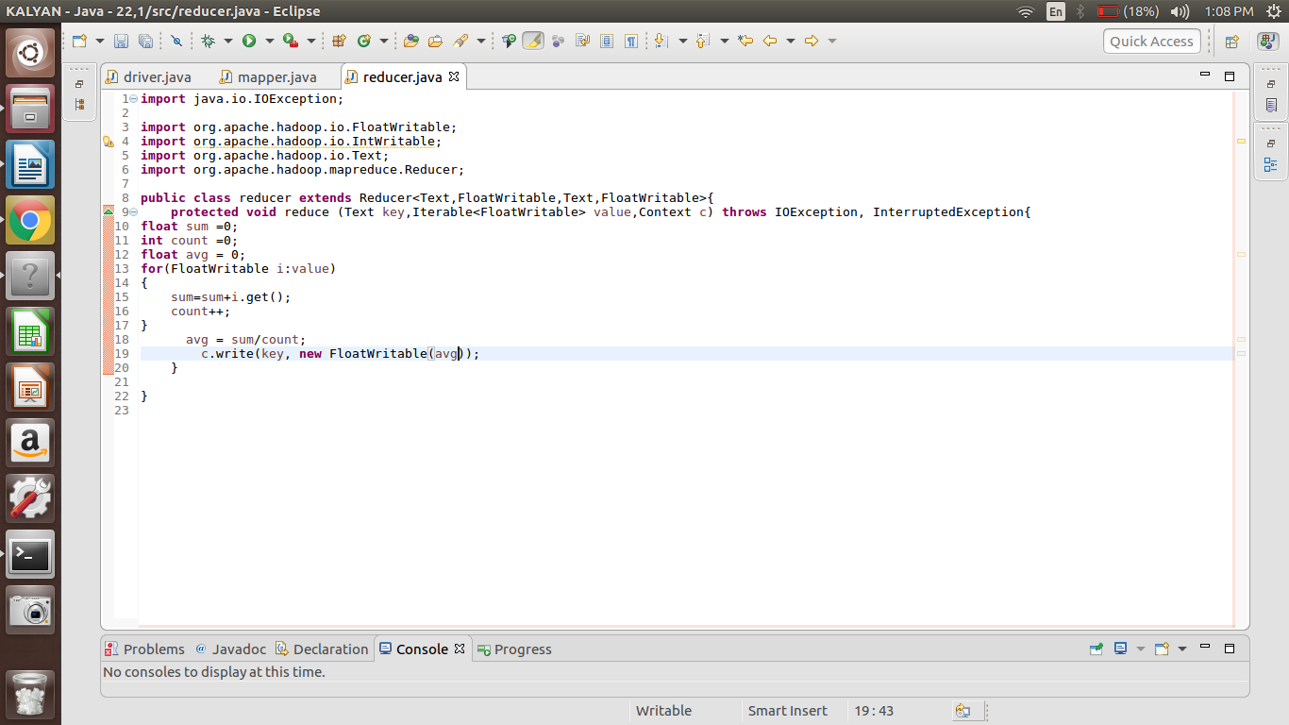

**RUNNING JAR:**

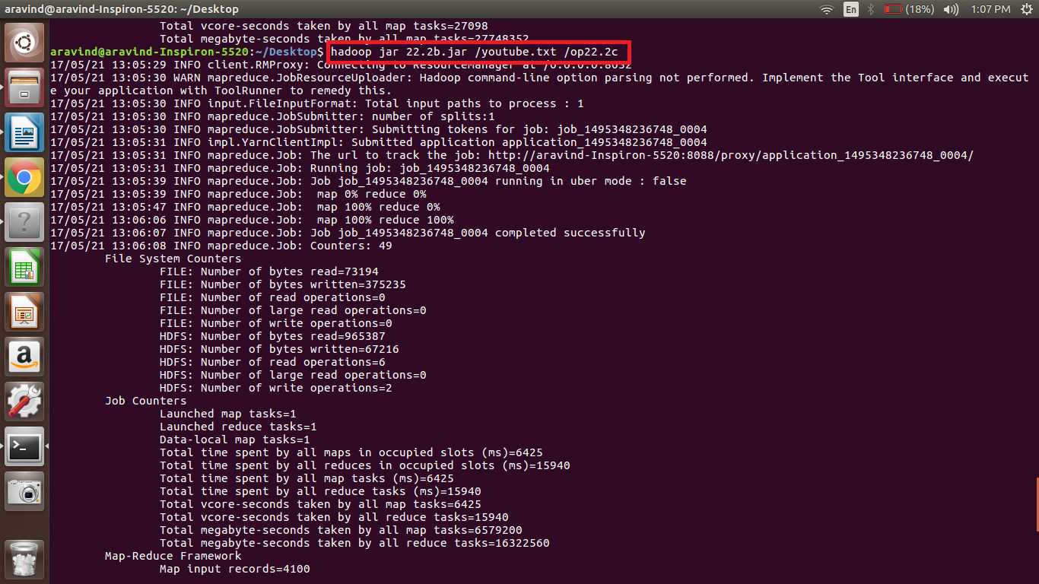

**OUTPUT:**

