**1.Write a hive query find the average age of male and female persons died in the titanic tragedy**

**Ans)first create a table titanic_details**

**Load titanicData into titanic_details table**

**In sql query group by sex where survived=1**

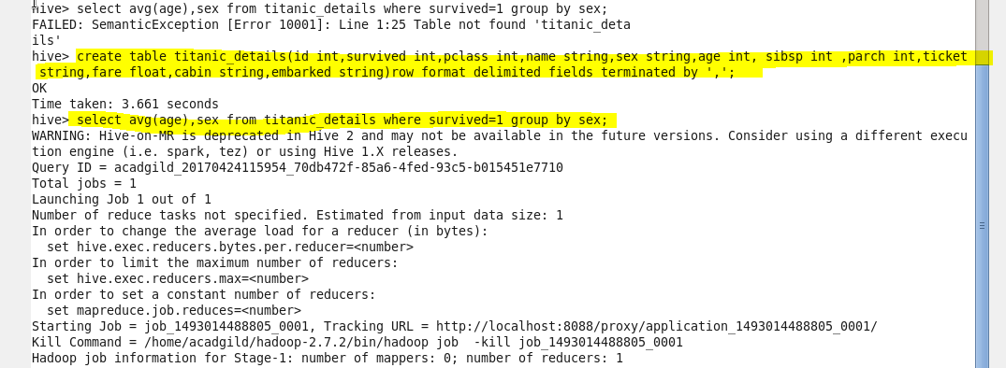

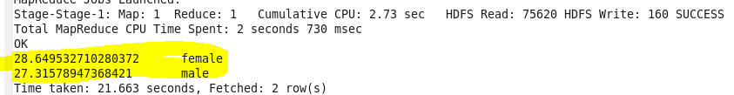

**Ques2** **Write a hive query to find the number of people died and survived in each class**

