**Ass25.3**

**Get a list of employees who receive a salary less than 100, compared to their immediate employee with higher salary in the same unit**

So to compare with a previous value ,we are using lag function that defines the column name and which previous value and we are inserting these lag value as temporary column and then we are filtering out the content which has less than 100 difference

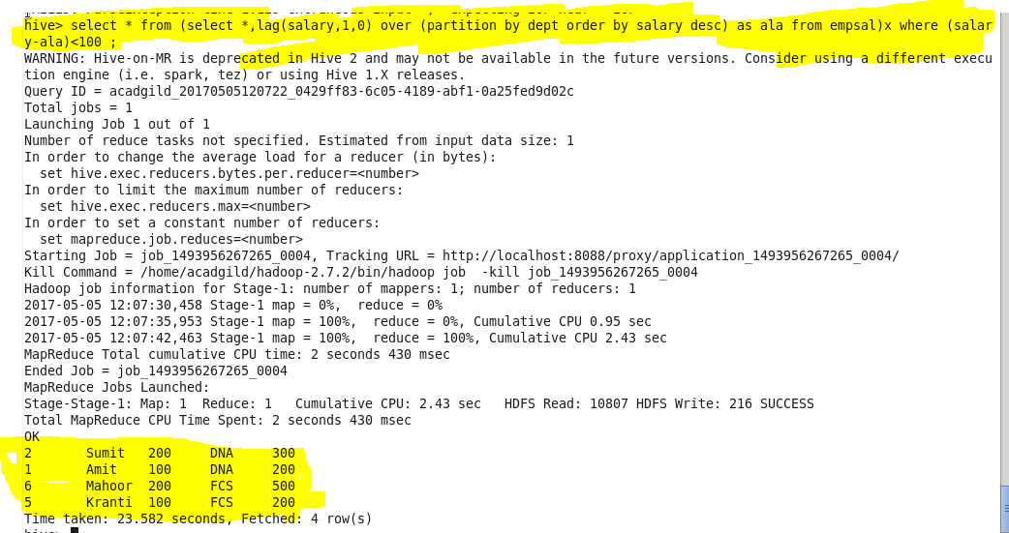

**List of all employees who draw higher salary than the average salary of that department**

To select name which has salary greater than average, first we include the average of the salary and include it as a column temporarirly then we are filtering out the dataset by comparing the average salary with the salary content

