**ASSIGNMENT 25.6**

**Problem Statement:**

Data Definition:

Column 1: Weather Station

Column 2: Date(year/Month/Day)

Column 3: Observation Type

Column 4: Temperature

**Input File-**

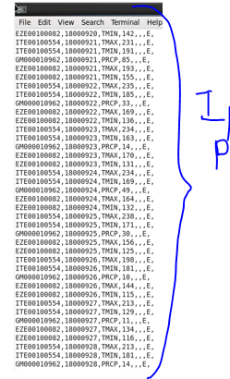





1. **Write a hive query to find the minimum temperature observed in a given weather station in a particular year.**

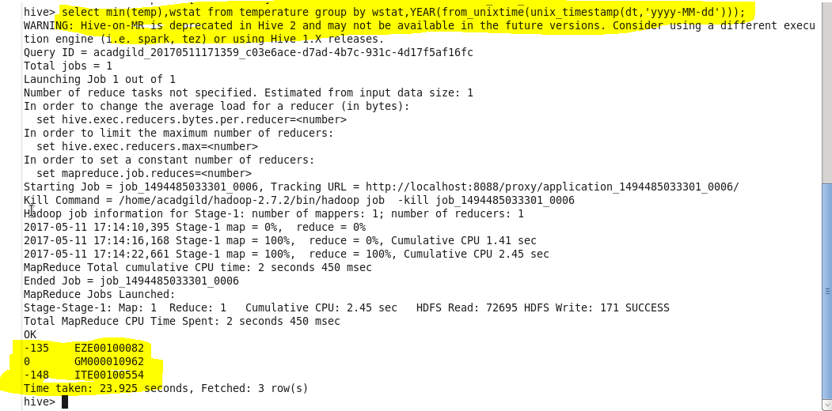

**Q2 .Write a hive query to find the maximum temperature observed in a given weather station in a particular year.**

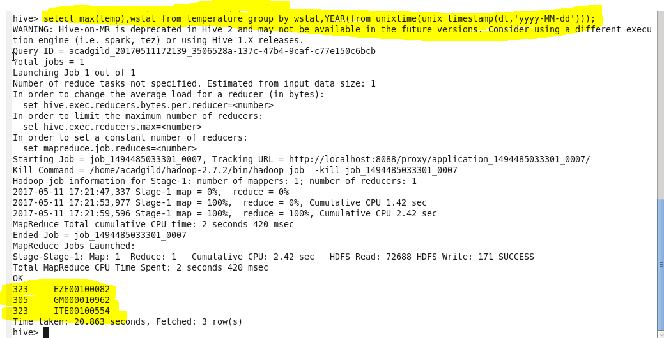

**3.)**

**Write a hive query to find the number of readings given by each weather station according to the dataset.**

