**Assignment-26.3**

**Problem Statement-**

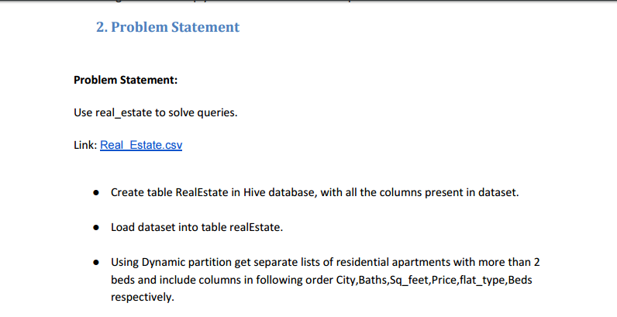

**Input File-**

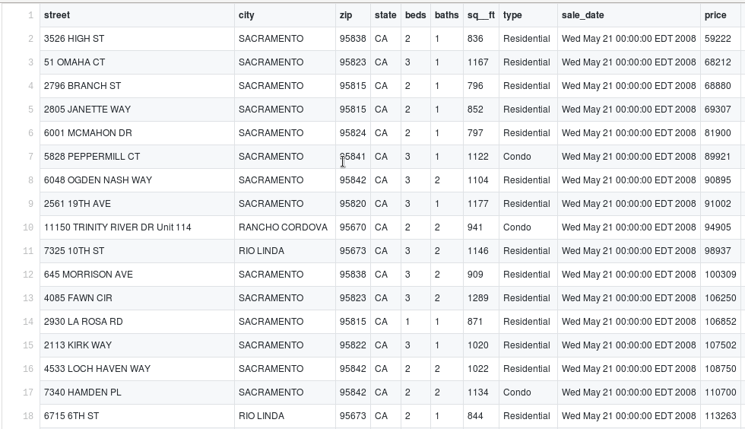

**Solution-**

* Created a table named real_partition and mentioned columns.
* Partitioned the table by flat type.
* Then loaded data by load command where flat type is Residential.
* After creating a partition, I have given select statement to get the required columns with the condition flat type should be residential and beds should be greater than 2.

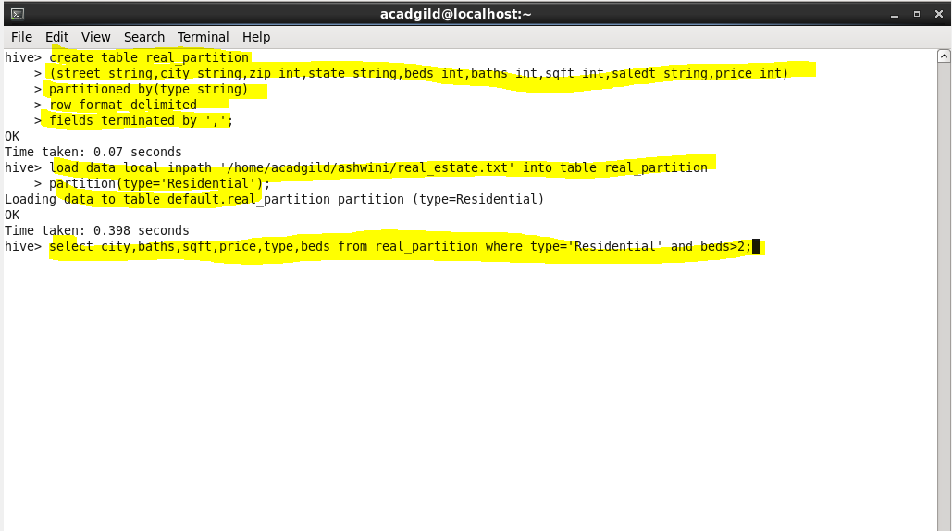

**Output-**

**There is much more output data, only a few are included.**

