**Problem Statement:**

**Problem Statement:**

**Implement view in hive.**

**Step 1-** Two tables named people_data and job_data have been created and data is loaded into both the tables.

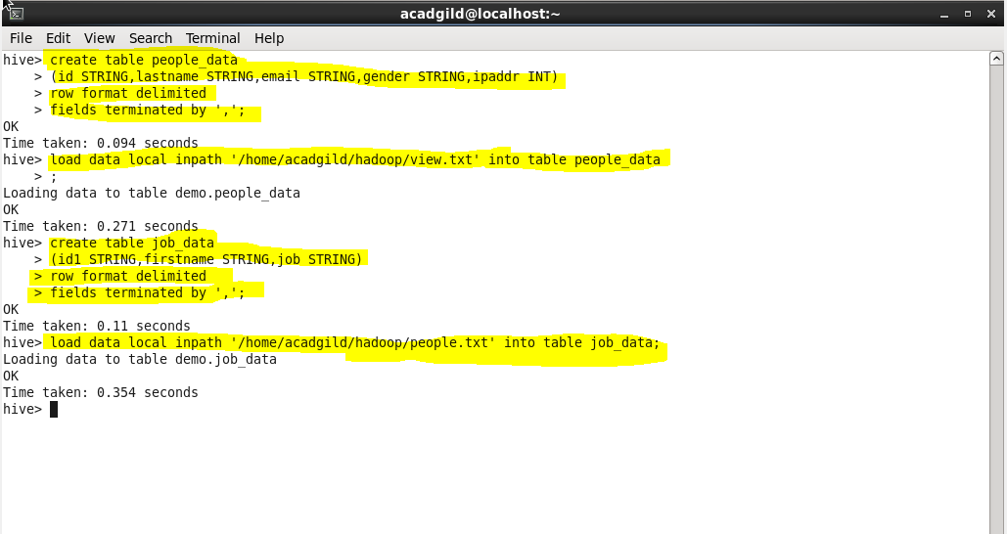

**Step-2 –** Hive View is to get data from two different tables. View is a logical construct of holding data it is just used to display data and not stored in memory. View is created to reduce the complexity of join queries. In place of using join queries which are more complex to select columns to be joined, it is easy to create view and display data based on this view.

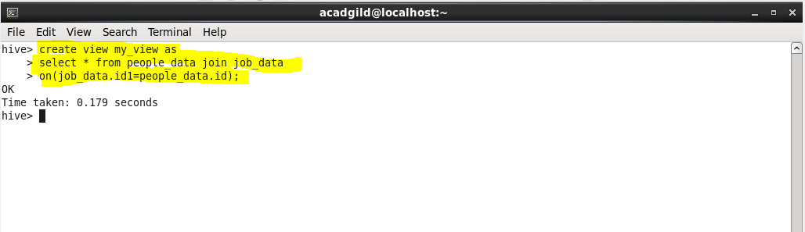

**Step-3-** Selecting data from this view now became easy. We can select all data as well as can provide a condition to select data from the joined tables.

**SELECT * FROM my_view;**

**This command will give output as-**

