**ASSIGNMENT 27.4**

**Run parallel job in hive**

**Input file**

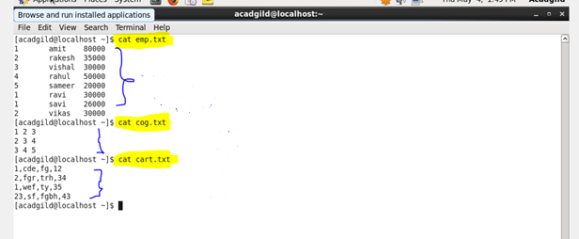

**Create and load the file emp**

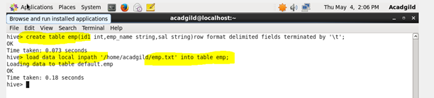

**Create and load the file cog**

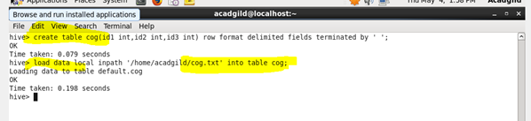

**Create and load the file cart**

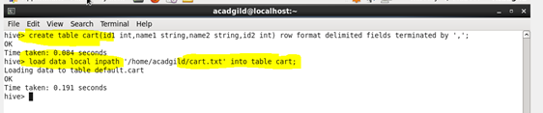

**Setting the parallel configuration in hive command line**

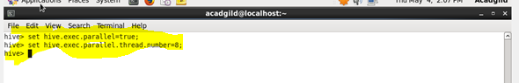

**Query**

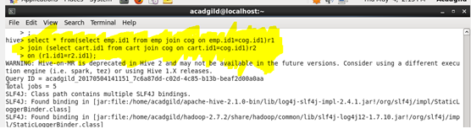

**Output**

