**ASS-28.1**

**ACID PROPERTIES:**

A transaction is a very small unit of a program and it may contain several low level tasks. A transaction in a database system must maintain **A**tomicity, **C**onsistency, **I**solation, and **D**urability − commonly known as ACID properties − in order to ensure accuracy, completeness, and data integrity.

* **Atomicity** − This property states that a transaction must be treated as an atomic unit, that is, either all of its operations are executed or none. There must be no state in a database where a transaction is left partially completed. States should be defined either before the execution of the transaction or after the execution/abortion/failure of the transaction.
* **Consistency** − The database must remain in a consistent state after any transaction. No transaction should have any adverse effect on the data residing in the database. If the database was in a consistent state before the execution of a transaction, it must remain consistent after the execution of the transaction as well.
* **Durability** − The database should be durable enough to hold all its latest updates even if the system fails or restarts. If a transaction updates a chunk of data in a database and commits, then the database will hold the modified data. If a transaction commits but the system fails before the data could be written on to the disk, then that data will be updated once the system springs back into action.
* **Isolation** − In a database system where more than one transaction are being executed simultaneously and in parallel, the property of isolation states that all the transactions will be carried out and executed as if it is the only transaction in the system. No transaction will affect the existence of any other transaction.

**TRANSACTIONS IN HIVE:**

A transaction is a very small unit of a program and it may contain several low level tasks

Transactions are provided at the row-level in Hive 0.14. The different row-level transactions available in Hive 0.14 are as follows:

1. Insert
2. Delete
3. Update

There are numerous limitations with the present transactions available in Hive 0.14. ORC is the file format supported by Hive transaction. It is now essential to have ORC file format for performing transactions in Hive. The table needs to be bucketed in order to support transactions.

**EXAMPLE:**

**First ,we need to set some properties to do row level insertions**

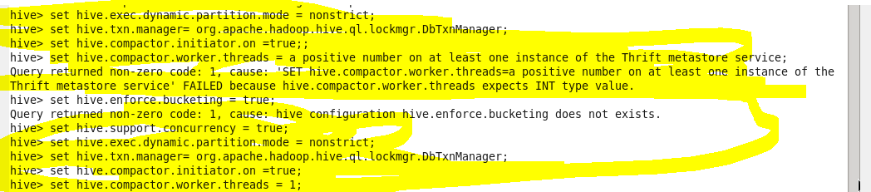

**Creating a table with bucketing and table properties of transaction to be true**

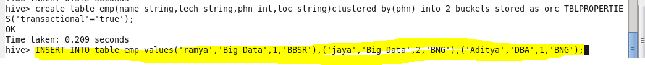

**Now we are inserting the content into the table**

**After insertion**

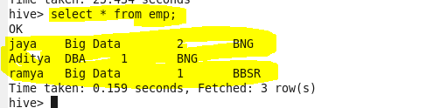

**Update**

**We cant do update on the bucketed column but with other columns we can do bucketing**

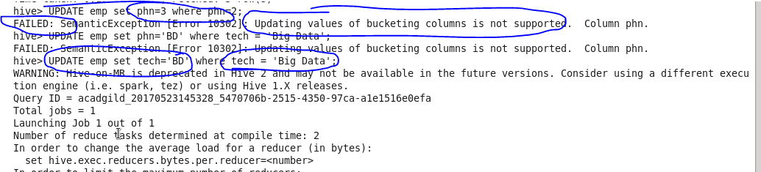

**Update output**

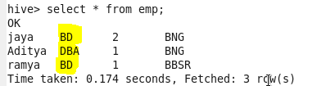

**Delete :**we are deleting the row that matches the where condition

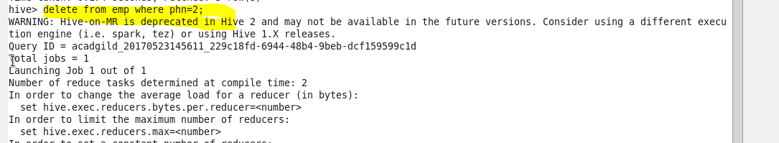

**Delete output:**

