**ASS-28.3**

**Store the above dataset into the following file formats.**

First we create a text file since the other formats requires a table in hive to overwrite on the present file format

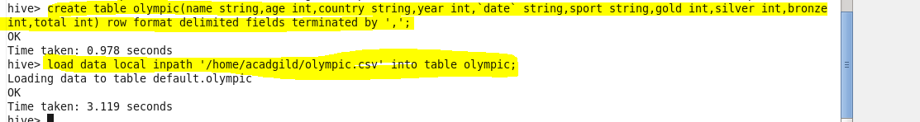

We can directly load the content into textfile from the local system

**● SEQUECEFILE-**In this we cant directly load the content into the sequence file

First we create a sequence file and then we overwrite it with the existing text file content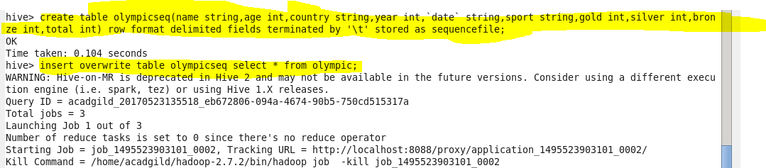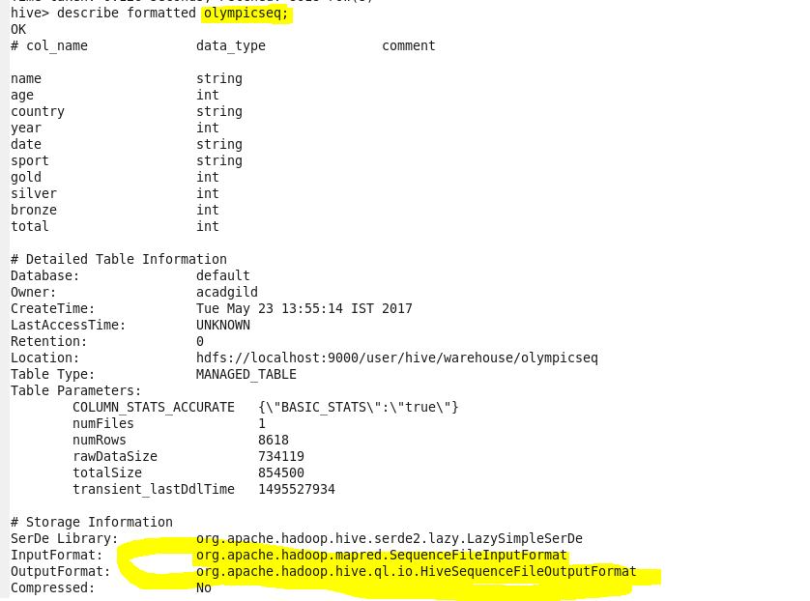

**● RCFILE**

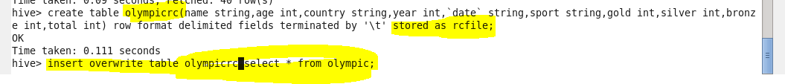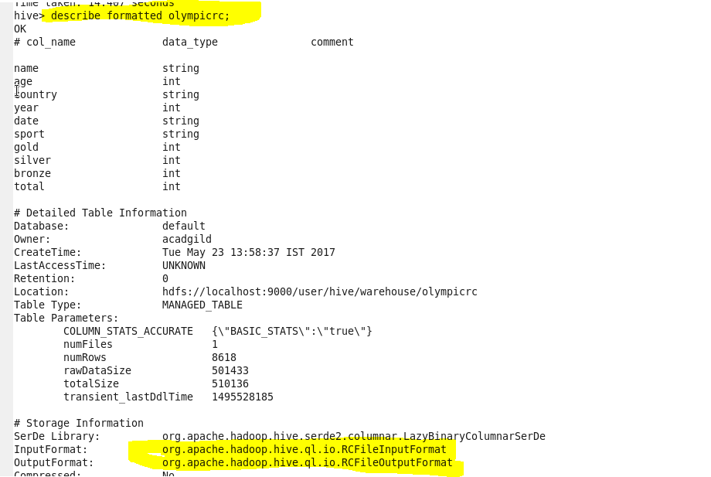

**● ORC FILE**



