**Ass-29.1**

**Write a hive UDF that implements functionality of string concat_ws(string SEP, array). This UDF will accept two arguments, one string and one array of string. It will return a single string where all the elements of the array are separated by the SEP.**

First we are creating a table with ipadrs,name and subject known as string array

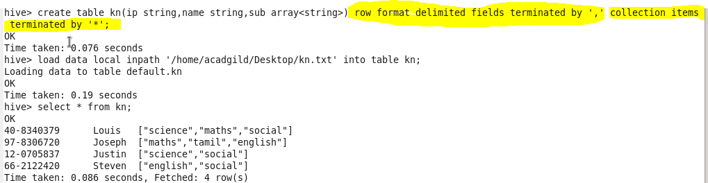

Next we are creating a user defined program that would get subject column as input.Now this string that enters the loop is added to a temporary string buffer which is appende by the sep and this is repeated until the string array ends.

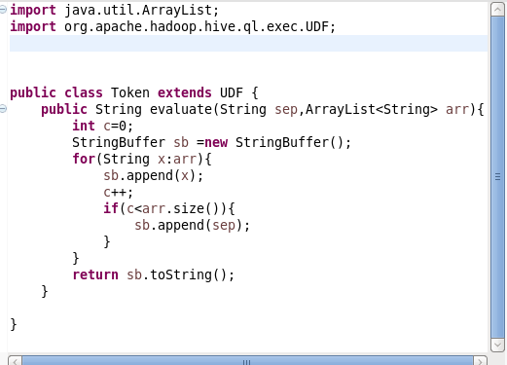

The jar file is added to hive,then we are calling the function to perform the concat.The output is then displayed with separator

