**ASS-32.2**

**Use Hbase shell for performing the following operations**

**● Create the table customer with two column families**

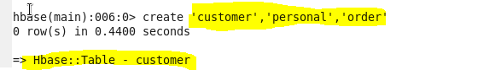

Create a table of name ‘customer’ with two column families personal and order

**● Personal details and order details as column families. Create a unique number as row key (ssn/Aadhar no.,etc) Insert at least 10 records to each column Insert following values for personal details column family Name, age, city, state**

At first we are inserting in the personal column family ,here we are adding name,age,city,state

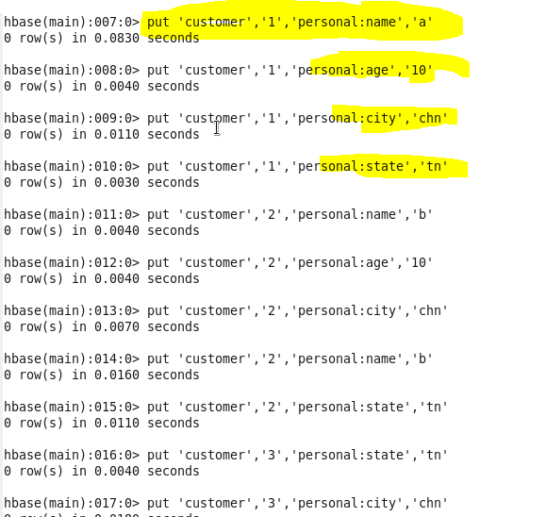

**● Insert following values for order details column family Order no, order quantity, and order amount**

now we are inserting in the order column family ,here we are adding no,quantity,amount

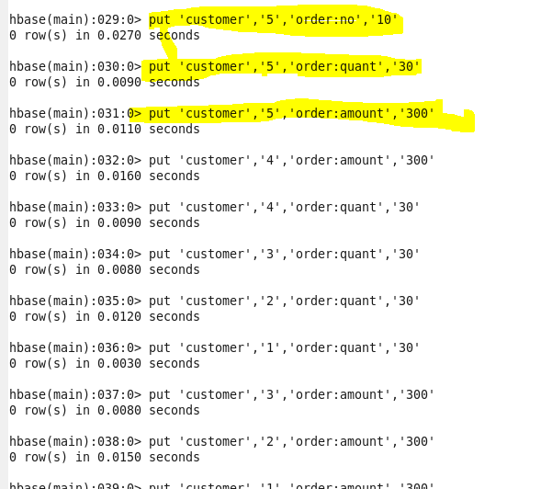

**Output Terminal:** 