**ASS-32.3**

**Write a Java client API to perform following operations:**

**● Use HBaseAdmin class and create the table named company with one column family name details.**

**Here we are creating a table with an array that creates column families of array length**

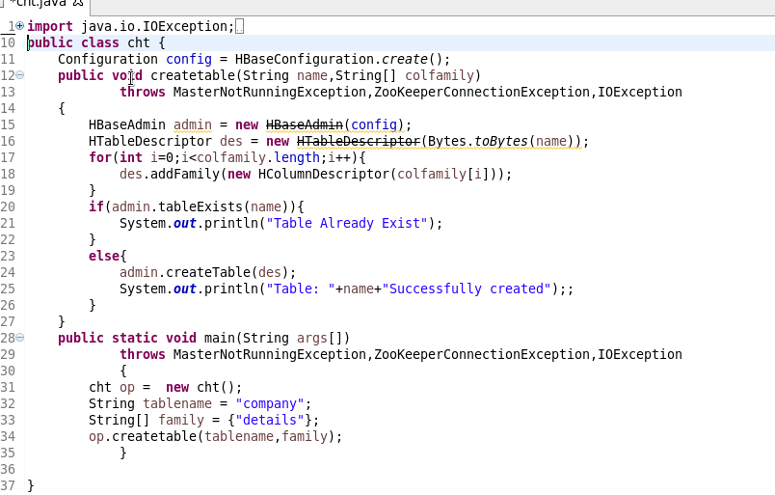

**Console displays that the table is created in hbase**

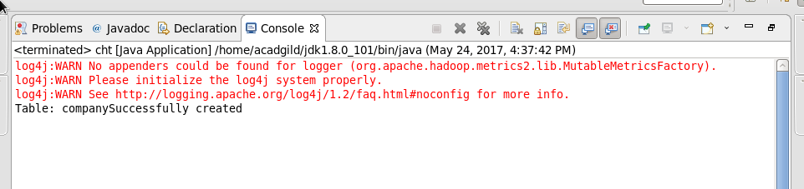

**Thus the table is created into the hbase using a java class that performs create table function,the table ‘company’ is created in hbase with column family-‘details’**

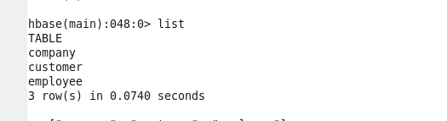

**● Create the method name insert and use put class to insert records to company table.**

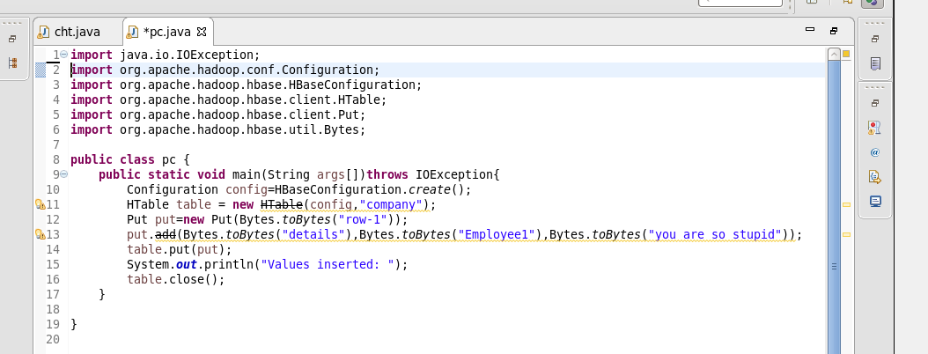

**Thus the value is inserted into the table using a java class that performs put function**

