**ASSIGNMENT35.1**

**Problem Statement:**

**● Create a employee table in Mysql and columns as Emp_id, Emp_name, Dept_name(Hadoop Developer), Emp_sal.**

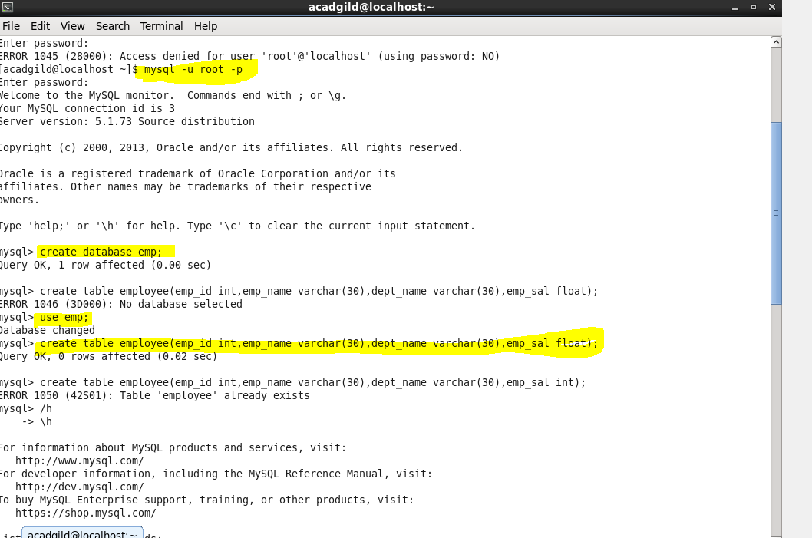

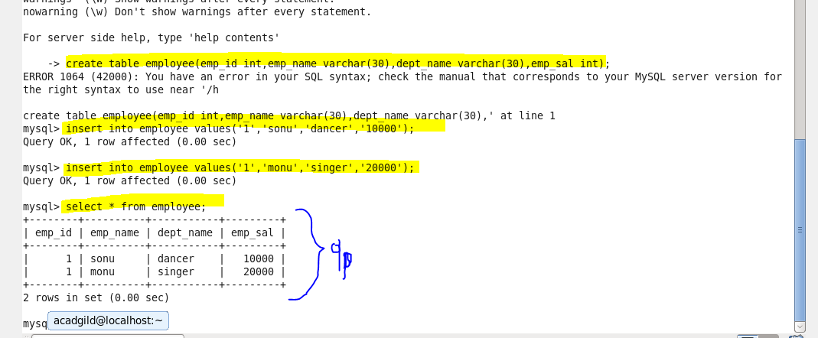

**● Import the employee tablcontents into the HDFS directory using Sqoop**

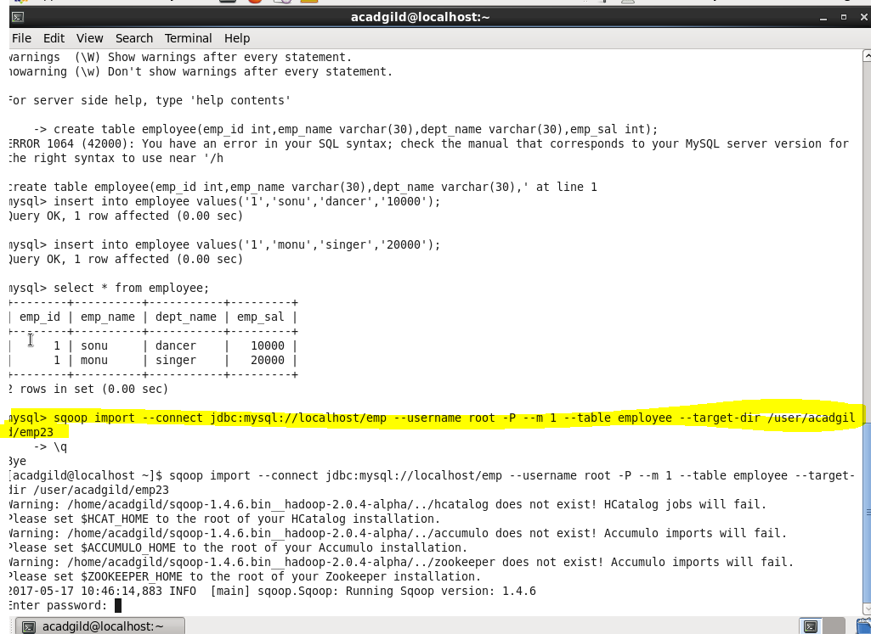

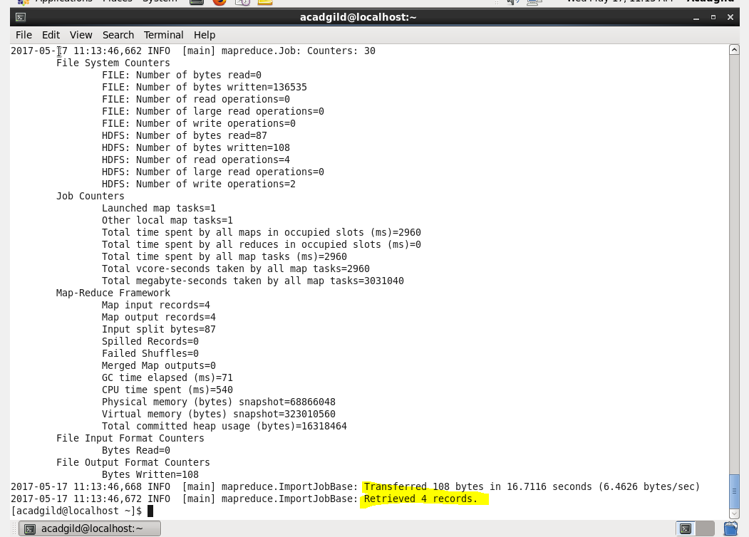

**\*\*\*\*records viewed from HDFS.**

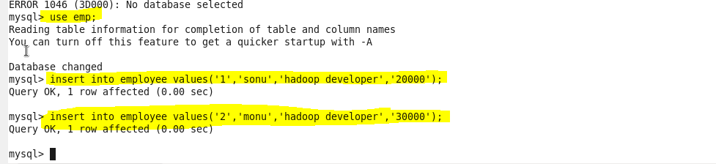

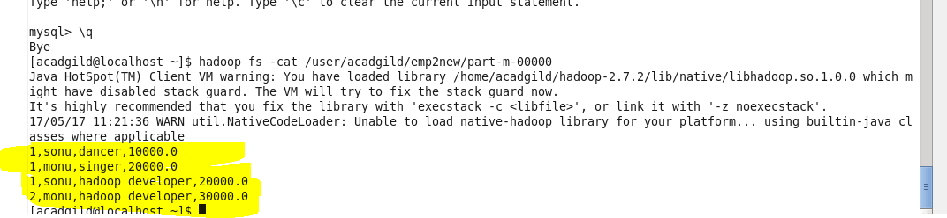

**● Create a employee2 table in Mysql and Export employee details file from HDFS directory to Mysql table employee2 using Sqoop.**

