1. Write a Java program to copy a file from HDFS to LFS

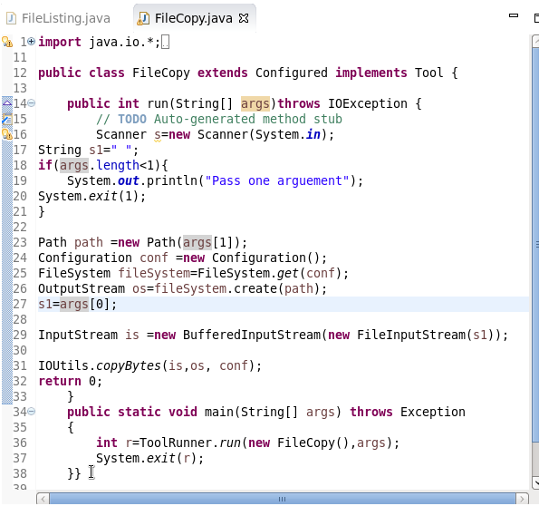

1. Explain the importance and usage of the below terms in details ● DFSInputStream ● DFSOutputStream ● FSDataInputStream ● FSDataOutputStream

ANS)

**DFSInputStream :**

1. Handles communication of the namenodewith various datanodes.
2. Handles integrity of data contained by the blocks.
3. Manages data read activity in case of datanodefailure.

6.Called internally by FSDataInputStream.

**FSDataInputStream :**

Provides stream (channel) for reading data.

FSDataInputStream

Lets the application read from a file

FSDataInputStreamin = null;

in = fs.open(new Path(uri));

**FSDataOutputStream :**

Provides stream (channel) for writing data.

OutputStreamout = fs.create(new Path(dst));

IOUtils.copyBytes(in, out, 4096, true);

**DFSOutputStream :**

* Handles communication of the namenodewith various datanodes.
* Called internally by FSDataOutputStream.