**Write a mapreduce program to find out number of males and females survived in the titanic tragedy. Download the Titanic data set from the below link Titanic_Dataset DATA SET DESCRIPTION Column 1 : PassengerId Column 2 : Survived (survived=0 & died=1) Column 3 : Pclass Column 4 : Name Column 5 : Sex Column 6 : Age Column 7 : SibSp Column 8 : Parch Column 9 : Ticket Column 10 : Fare Column 11 : Cabin Column 12 : Embarked** 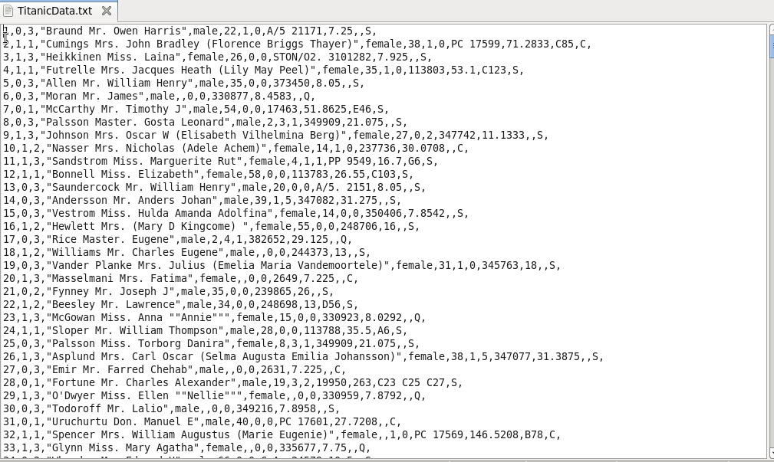

**DRIVER**

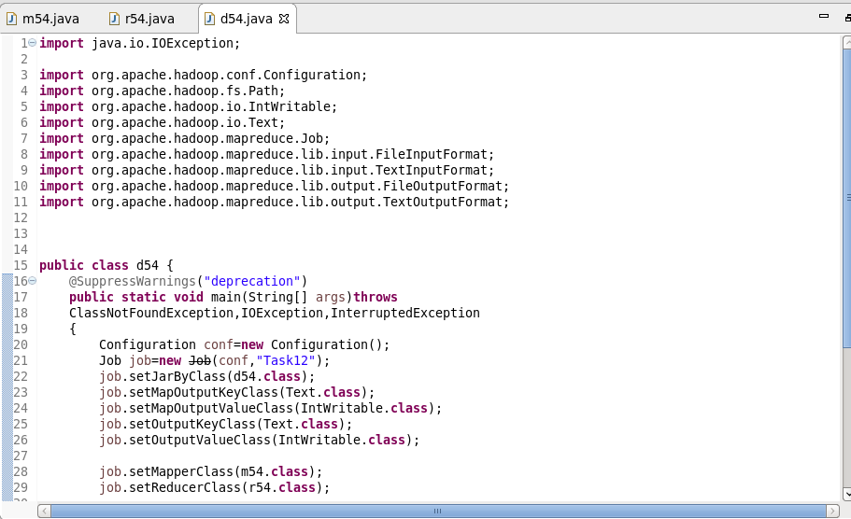

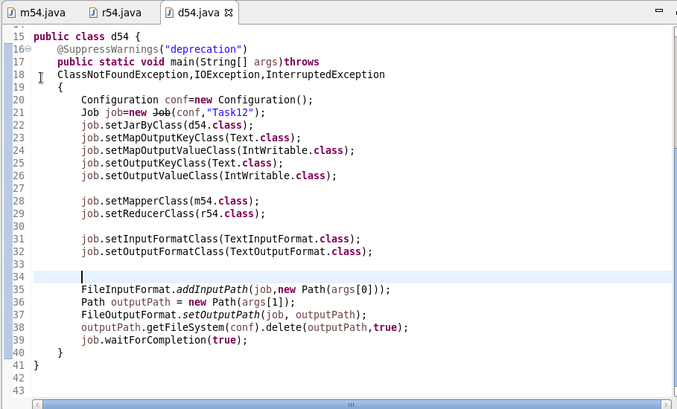

**Mapper**

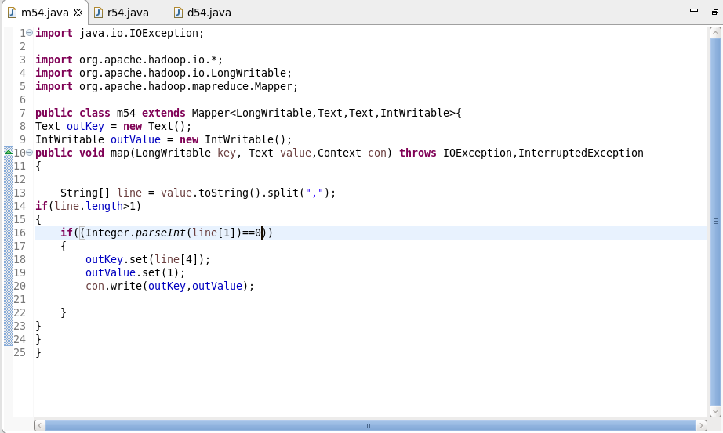

**Reducer**

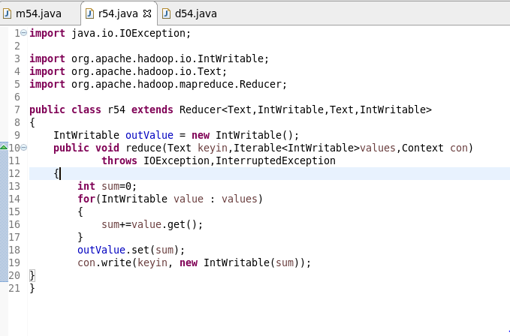

**Output**

