**Problem statement1: Find the number of GoogleKnowlege_Occupation people who were guests in the show, in a particular time period. Take the time period as 1/11/99 to 6/11/99 i.e., 6 months**

**Problem statement2: Find the number of GoogleKnowledge occupation types in each group, who have been guests on the show.**

**Driver class**

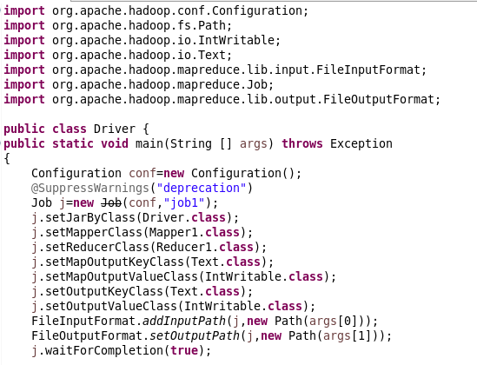

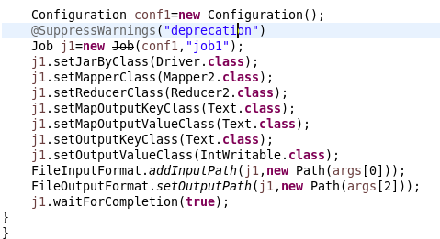

**Mapper 1**

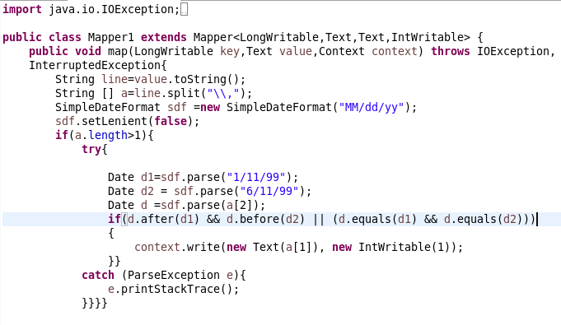

**Reducer 1**

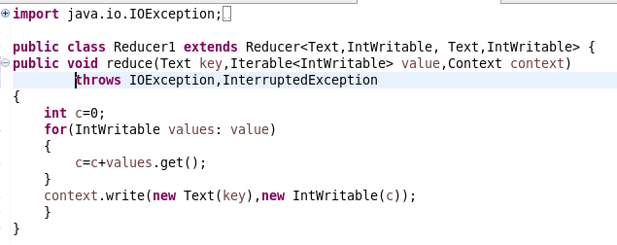

**Jar command**



**Mapper 2**

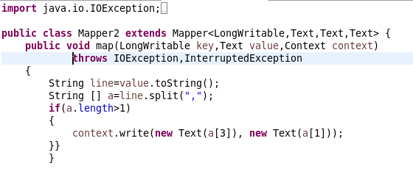

**Reducer 2**

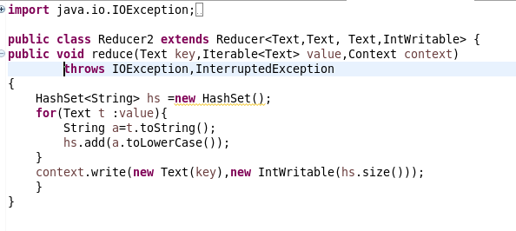

**Command 1**



**Output 1**

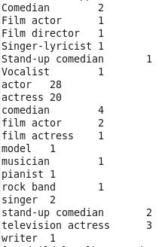

**Command 2**



**Output 2**

