**Write a mapreduce program to find the total amount of petrol in volume sold by every distributor**

**Driver class :**

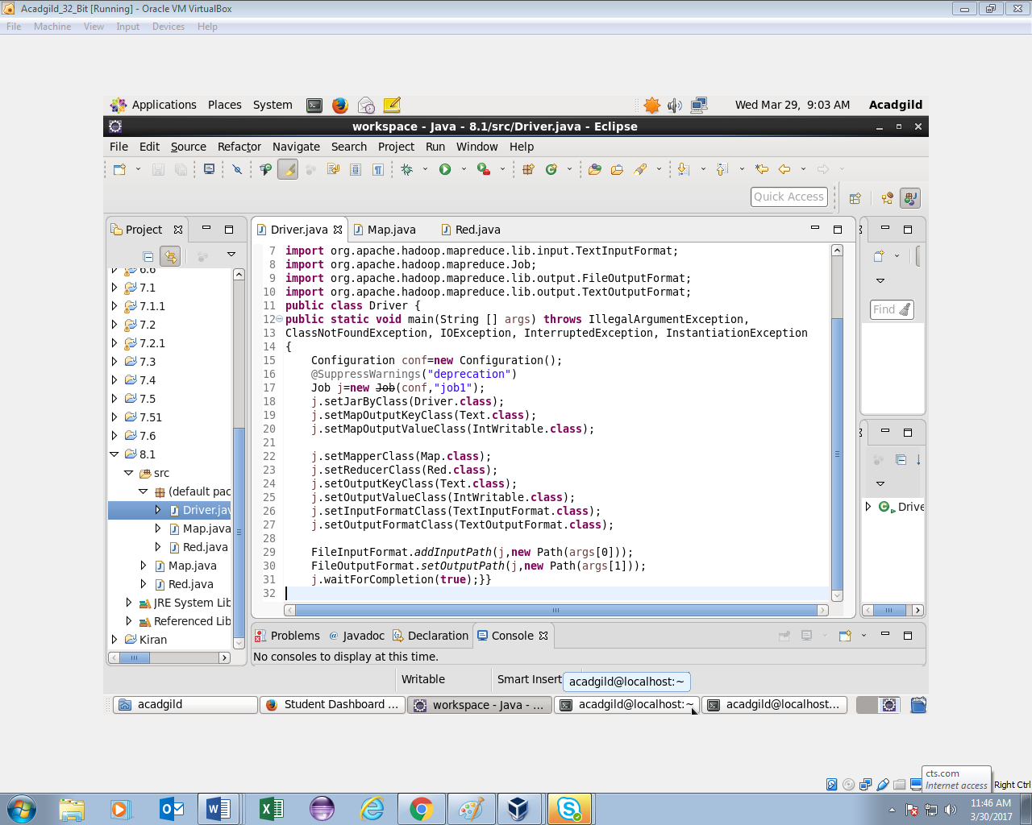

**Mapper class**

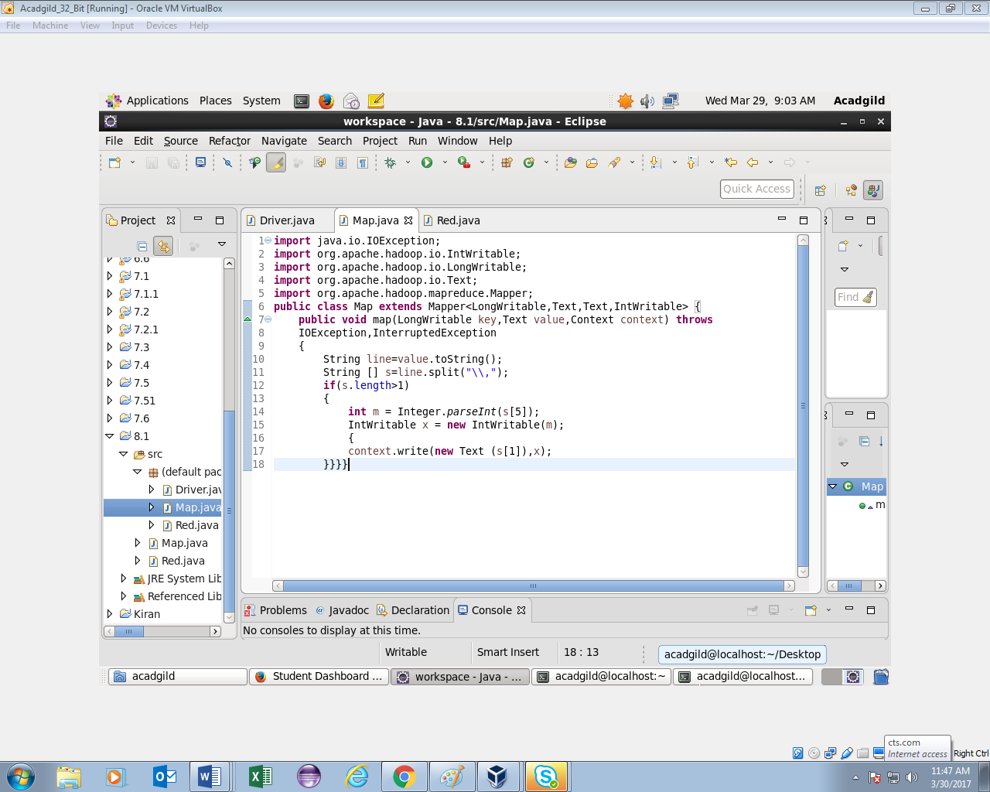

**Reducer class**

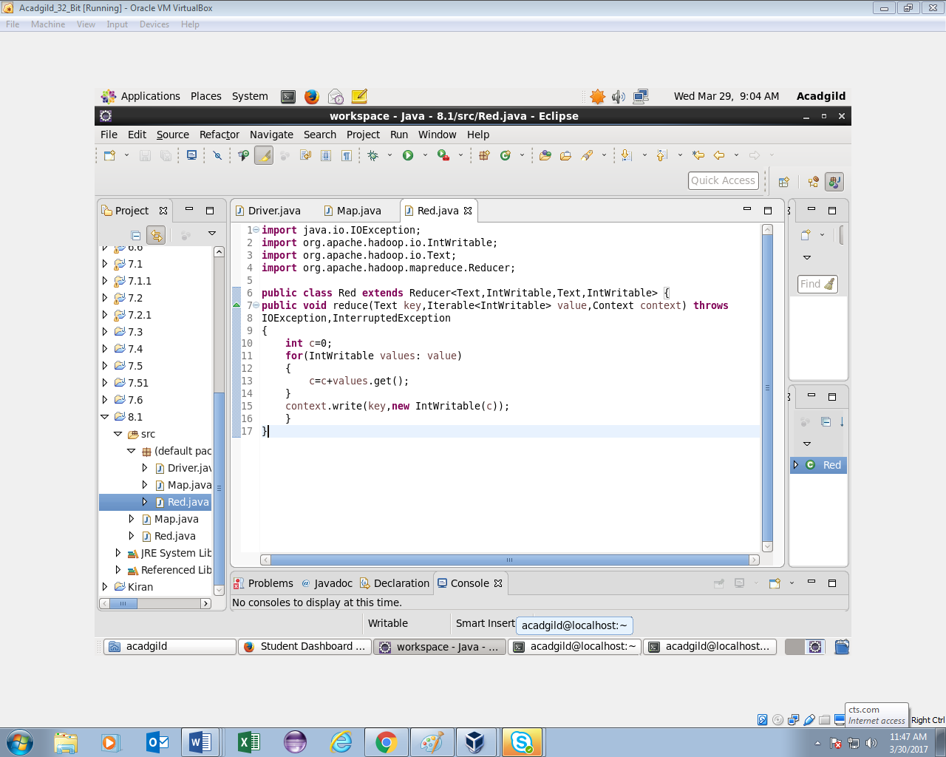

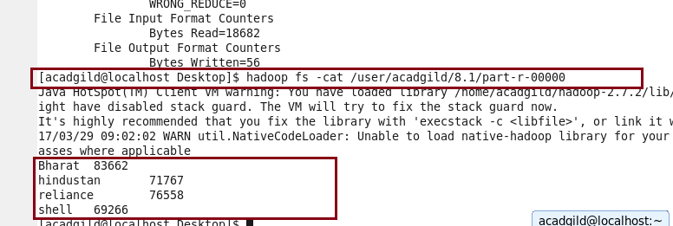

**Write a mapreduce program to find which are the top 10 distributors ID's for selling petrol and also display the amount of petrol sold in volume.**

**Driver class :**

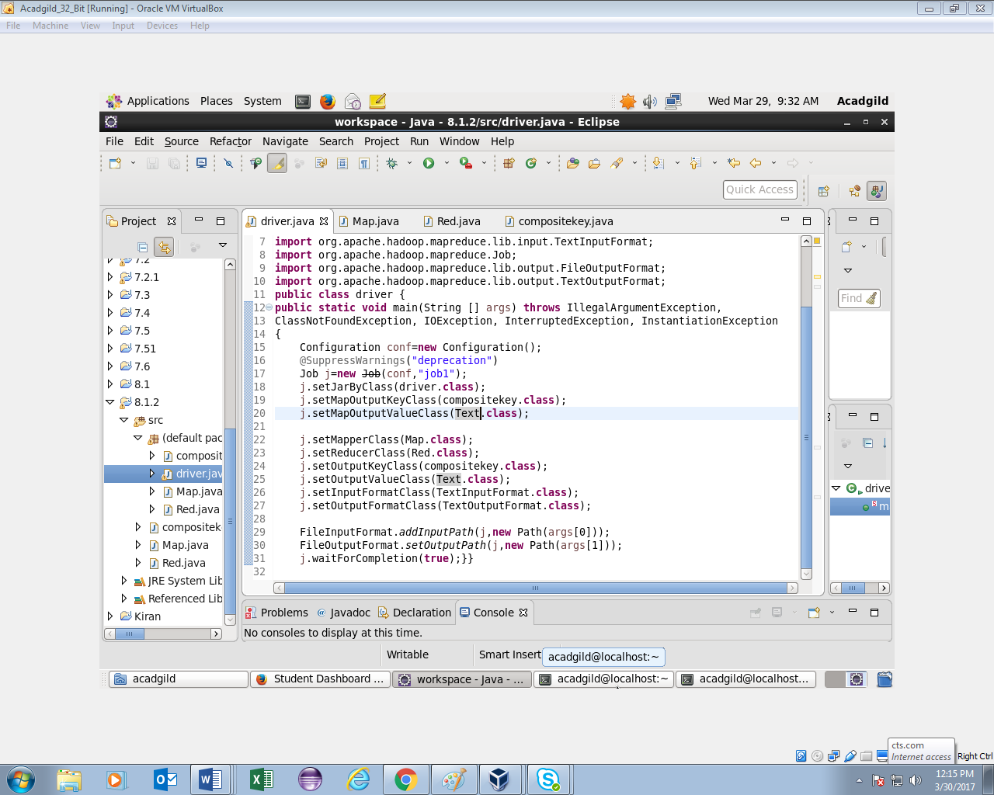

**Mapper class**

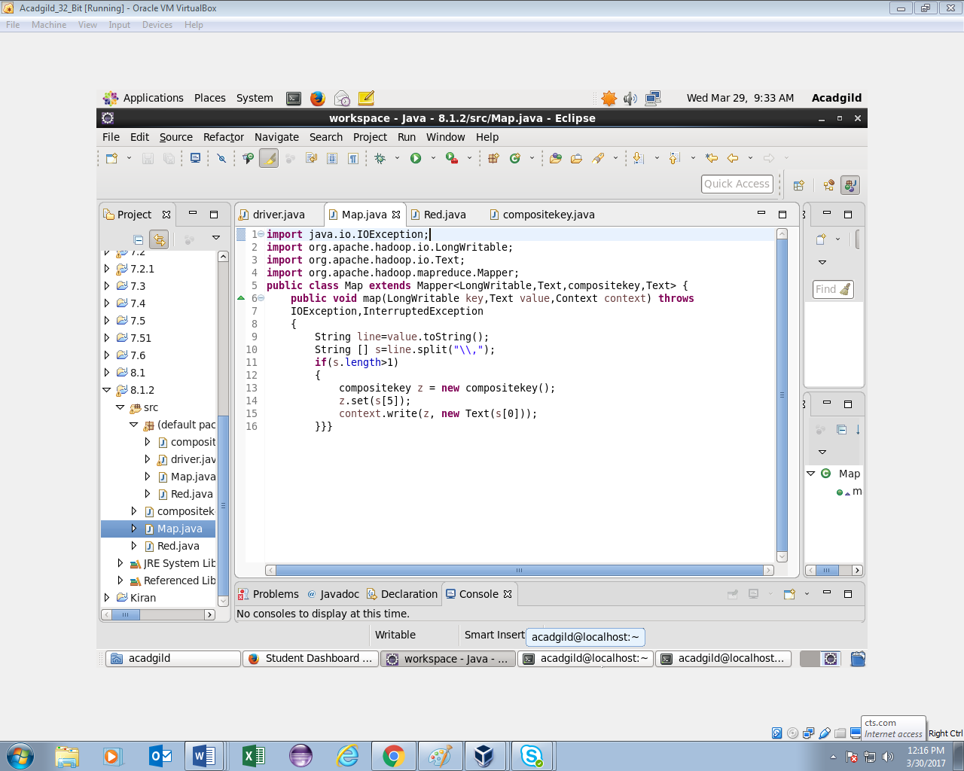

**Reducer class**

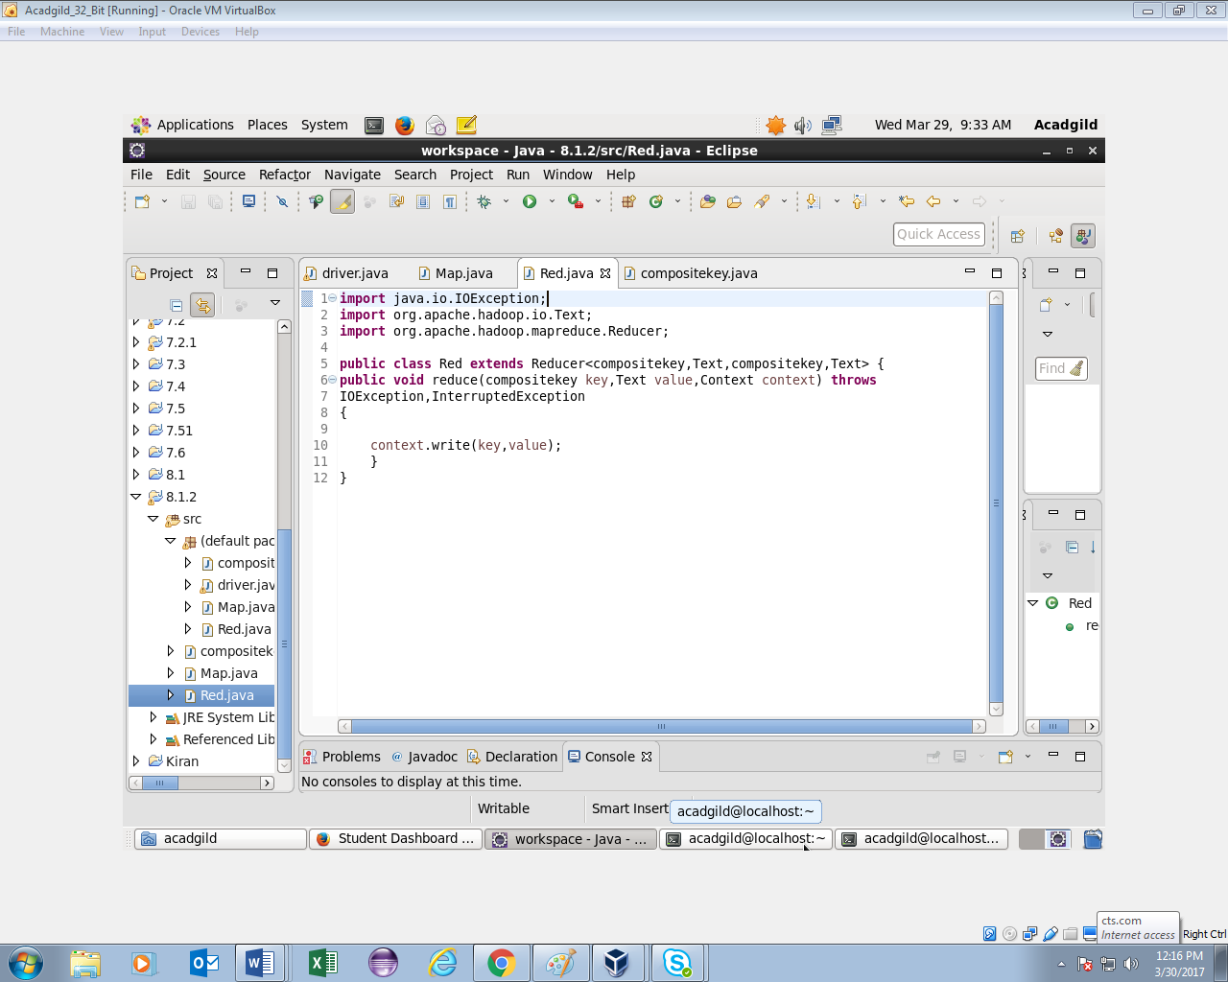

**Compositekey class**

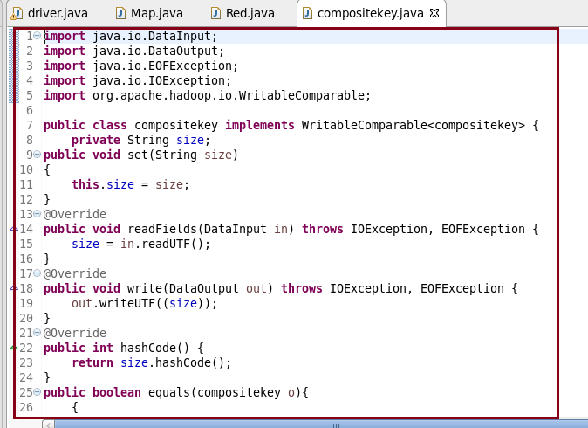

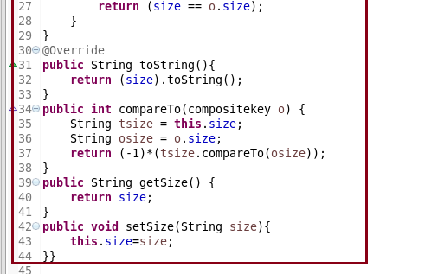

**Output:**

