1. Explain the running modes of pig and integrate Tez with Hadoop and run a simple pig query using tez.

Solution:

Execution modes of pig are:

* **Local Mode** - To run Pig in local mode, you need access to a single machine; all files are installed and run using your local host and file system. Specify local mode using the -x flag (pig -x local).
* **Tez Local Mode** - To run Pig in tez local mode. It is similar to local mode, except internally Pig will invoke tez runtime engine. Specify Tez local mode using the -x flag (pig -x tez_local).
* **Mapreduce Mode** - To run Pig in mapreduce mode, you need access to a Hadoop cluster and HDFS installation. Mapreduce mode is the default mode; you can, *but don't need to*, specify it using the -x flag (pig OR pig -x mapreduce).
* **Tez Mode** - To run Pig in Tez mode, you need access to a Hadoop cluster and HDFS installation. Specify Tez mode using the -x flag (-x tez).

Pig Query:

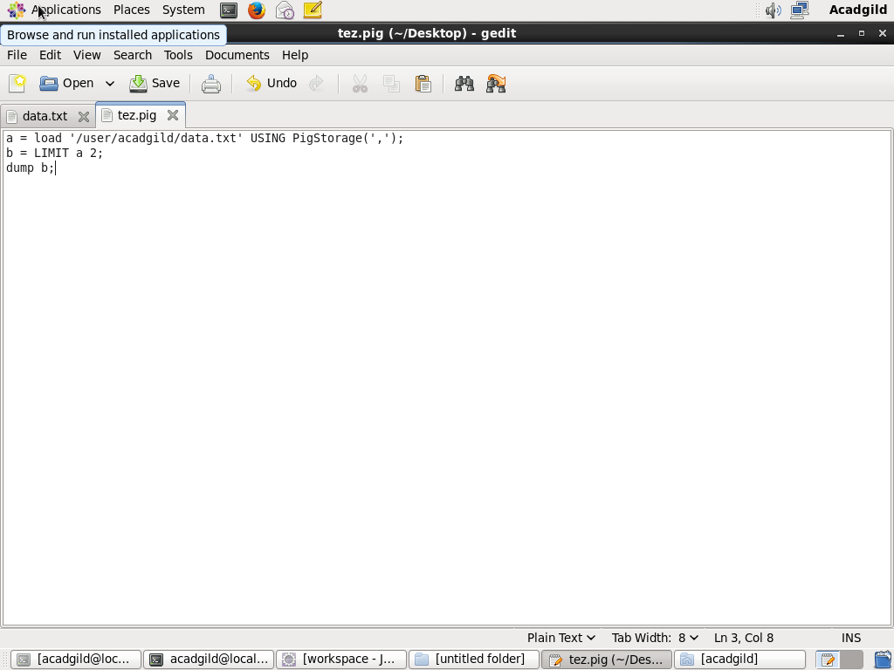

Data.txt file:

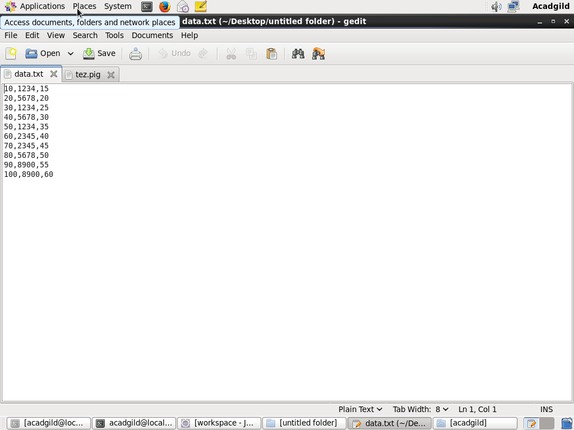

Tez implementation:

