**Ans 1:- Explain what is a cluster and what is a Hadoop cluster**

 A group of similar things or people positioned or occurring closely together.In simple words, a computer cluster used for Hadoop is called Hadoop Cluster. A [Hadoop](http://searchcloudcomputing.techtarget.com/definition/Hadoop) cluster is a special type of computational [cluster](http://searchexchange.techtarget.com/definition/cluster) designed specifically for storing and analyzing huge amounts of [unstructured data](http://searchbusinessanalytics.techtarget.com/definition/unstructured-data) in a [distributed computing](http://whatis.techtarget.com/definition/distributed-computing) environment. 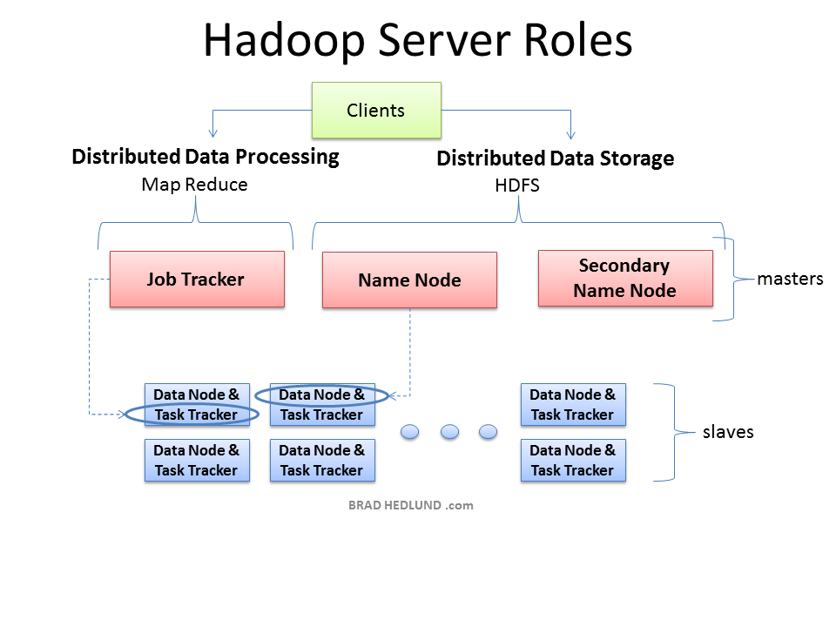

The three major categories of machine roles in a Hadoop deployment are Client machines, Masters nodes, and Slave nodes. The Master nodes oversee the two key functional pieces that make up Hadoop: storing lots of data (HDFS), and running parallel computations on all that data (Map Reduce). The Name Node oversees and coordinates the data storage function (HDFS), while the Job Tracker oversees and coordinates the parallel processing of data using Map Reduce. Slave Nodes make up the vast majority of machines and do all the dirty work of storing the data and running the computations. Each slave runs both a Data Node and Task Tracker daemon that communicate with and receive instructions from their master nodes. The Task Tracker daemon is a slave to the Job Tracker, the Data Node daemon a slave to the Name Node.

Client machines have Hadoop installed with all the cluster settings, but are neither a Master or a Slave. Instead, the role of the Client machine is to load data into the cluster, submit Map Reduce jobs describing how that data should be processed, and then retrieve or view the results of the job when its finished. In smaller clusters (~40 nodes) you may have a single physical server playing multiple roles, such as both Job Tracker and Name Node. With medium to large clusters you will often have each role operating on a single server machine.

In real production clusters there is no server virtualization, no hypervisor layer. That would only amount to unnecessary overhead impeding performance. Hadoop runs best on Linux machines, working directly with the underlying hardware. That said, Hadoop does work in a virtual machine. That’s a great way to learn and get Hadoop up and running fast and cheap. I have a 6-node cluster up and running in VMware Workstation on my Windows 7 laptop.

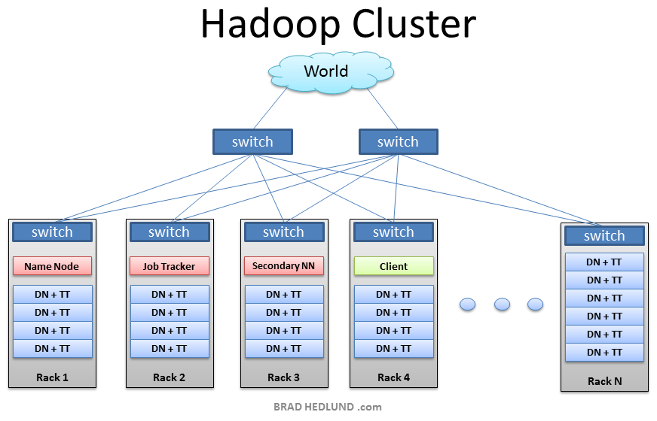

This is the typical architecture of a Hadoop cluster. You will have rack servers (not blades) populated in racks connected to a top of rack switch usually with 1 or 2 GE boned links. 10GE nodes are uncommon but gaining interest as machines continue to get more dense with CPU cores and disk drives. The rack switch has uplinks connected to another tier of switches connecting all the other racks with uniform bandwidth, forming the cluster. The majority of the servers will be Slave nodes with lots of local disk storage and moderate amounts of CPU and DRAM. Some of the machines will be Master nodes that might have a slightly different configuration favoring more DRAM and CPU, less local storage. In this post, we are not going to discuss various detailed network design options. Let’s save that for another discussion (stay tuned). First, let’s understand how this application works.

**Ans 2:- What is meant by a Rack and explain the rack arrangement in a Hadoop cluster**

Hadoop components are rack-aware. For example, HDFS block placement will use rack awareness for fault tolerance by placing one block replica on a different rack. This provides data availability in the event of a network switch failure or partition within the cluster.

Hadoop master daemons obtain the rack id of the cluster slaves by invoking either an external script or java class as specified by configuration files. Using either the java class or external script for topology, output must adhere to the java org.apache.hadoop.net.DNSToSwitchMapping interface. The interface expects a one-to-one correspondence to be maintained and the topology information in the format of ‘/myrack/myhost’, where ‘/’ is the topology delimiter, ‘myrack’ is the rack identifier, and ‘myhost’ is the individual host. Assuming a single /24 subnet per rack, one could use the format of ‘/192.168.100.0/192.168.100.5’ as a unique rack-host topology mapping.

To use the java class for topology mapping, the class name is specified by the topology.node.switch.mapping.impl parameter in the configuration file. An example, NetworkTopology.java, is included with the hadoop distribution and can be customized by the Hadoop administrator. Using a Java class instead of an external script has a performance benefit in that Hadoop doesn’t need to fork an external process when a new slave node registers itself.

If implementing an external script, it will be specified with the topology.script.file.name parameter in the configuration files. Unlike the java class, the external topology script is not included with the Hadoop distribution and is provided by the administrator. Hadoop will send multiple IP addresses to ARGV when forking the topology script. The number of IP addresses sent to the topology script is controlled with net.topology.script.number.args and defaults to 100. If net.topology.script.number.args was changed to 1, a topology script would get forked for each IP submitted by DataNodes and/or NodeManagers.