**Assignment-25.1**

**Problem Statement-**

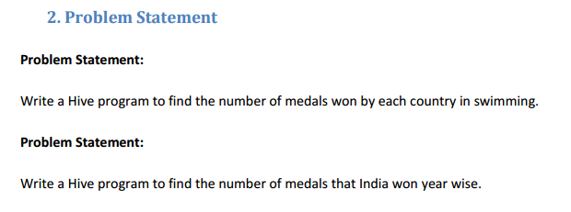

**Input File-**

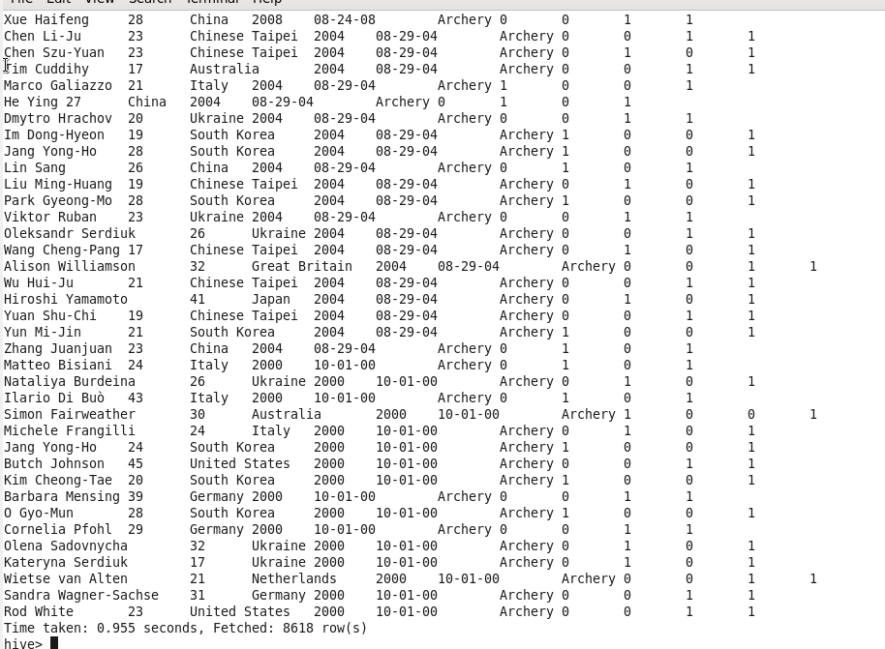

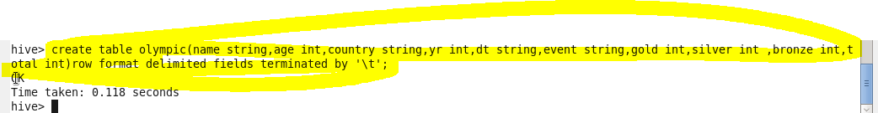

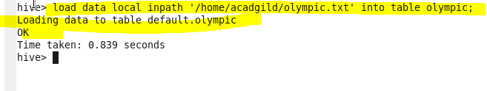

**Q1)**

**Solution 1-**

* **Created a table named olympic and loaded data in it.**
* **Select query to select data where we counted total number of medals where sports is swimming.**
* **We want data from every country so we grouped it on the basis of country.**

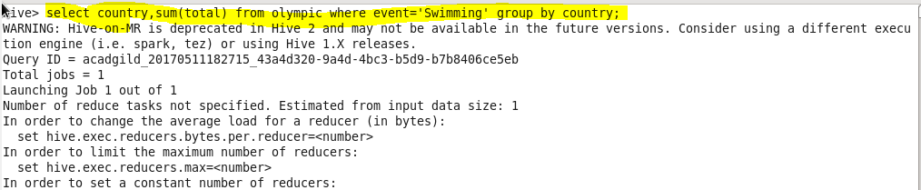

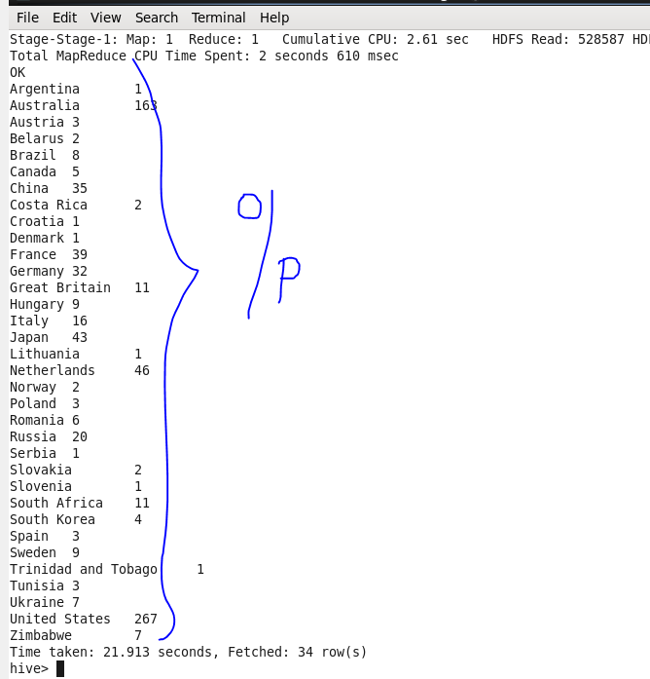

**Q2)**

* **Select query to select data where we counted total number of medals where country is india.**
* **We want data from every year so we grouped it on the basis of year.**

