SKILL-10

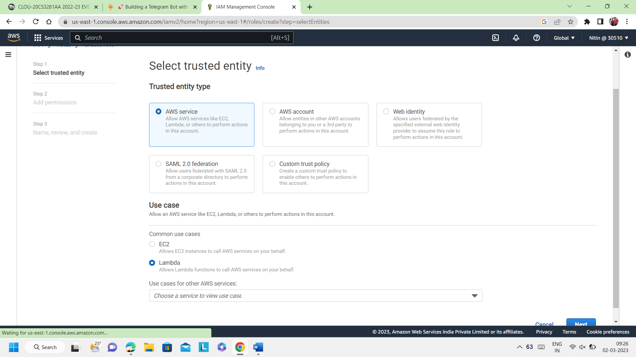

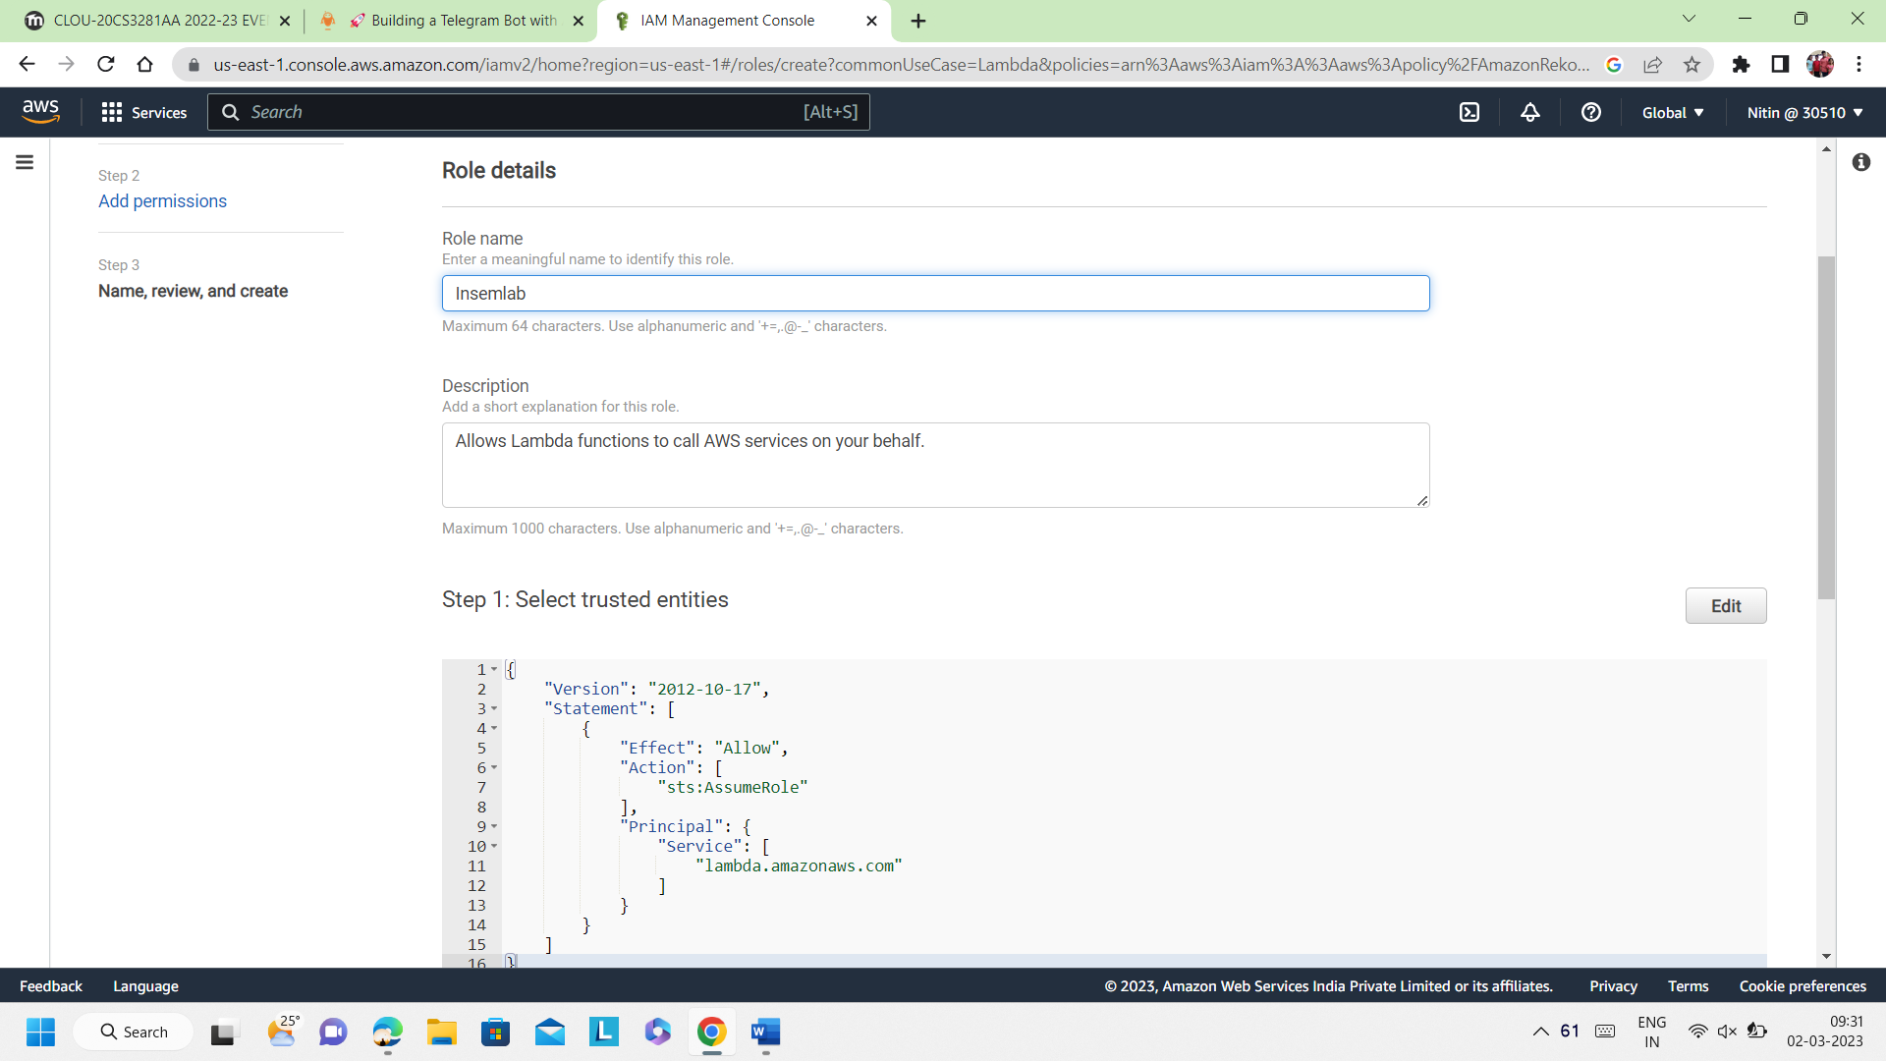

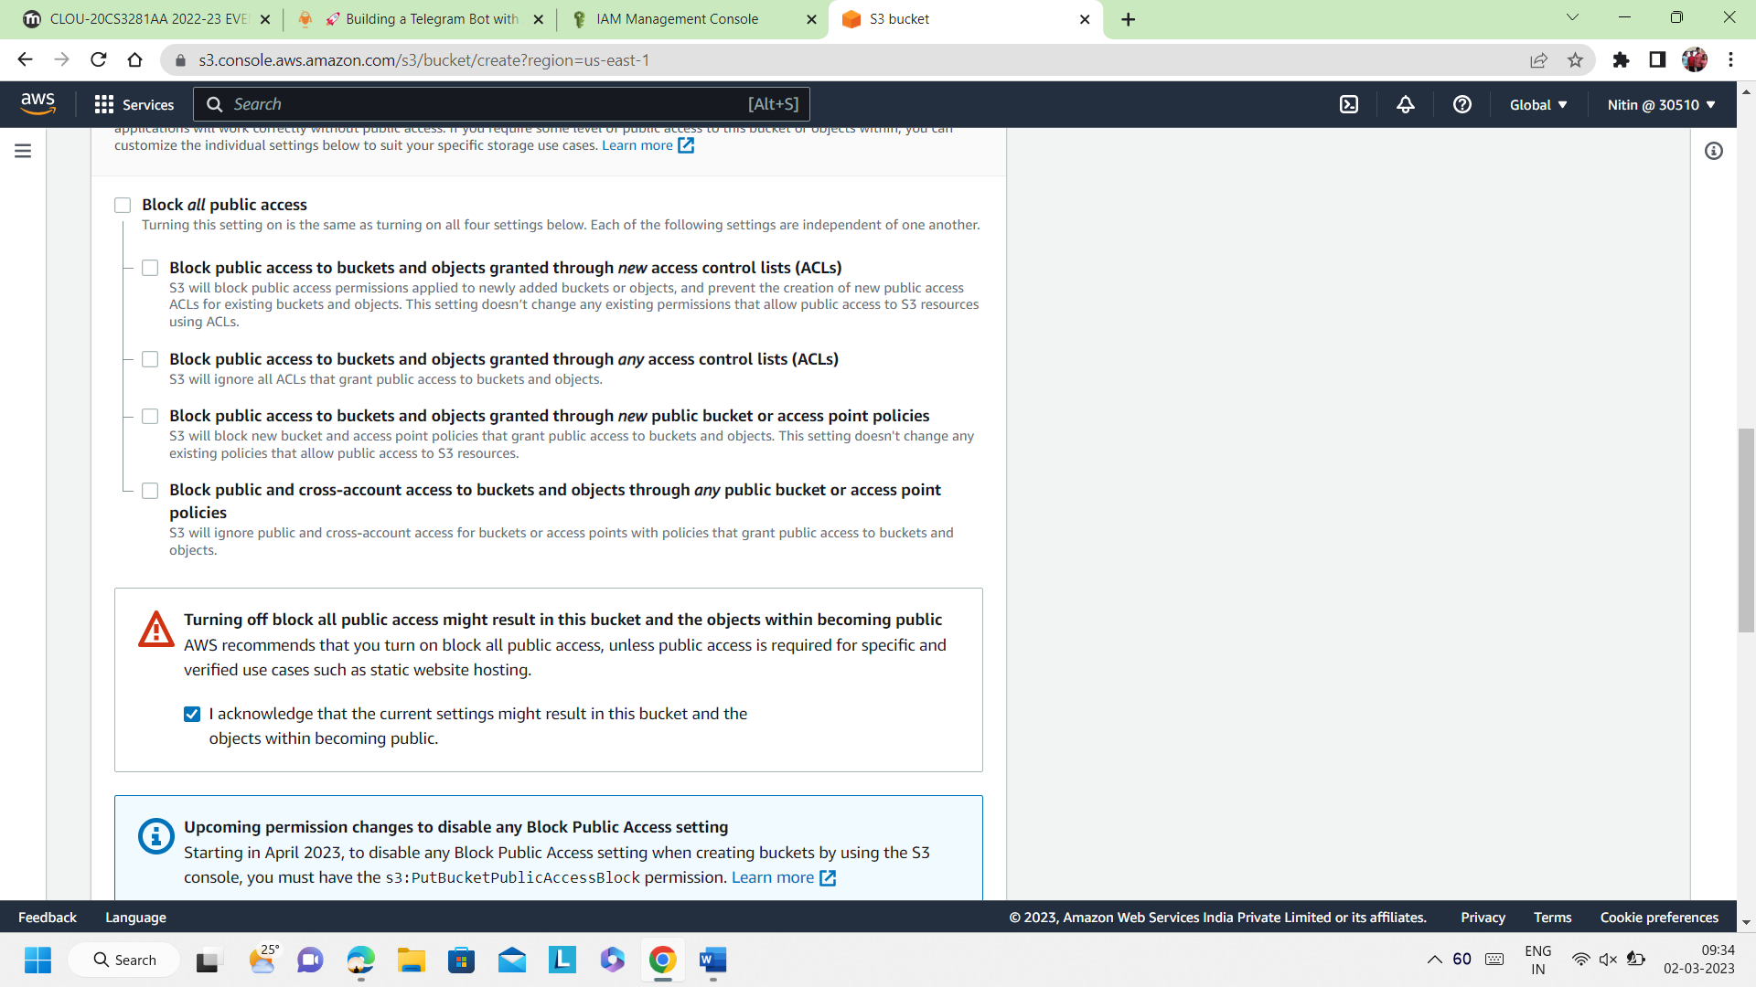

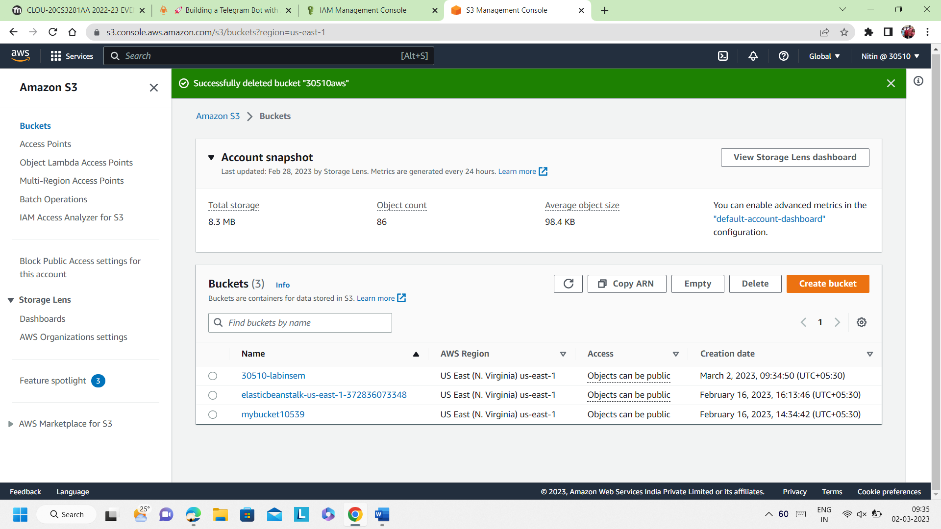

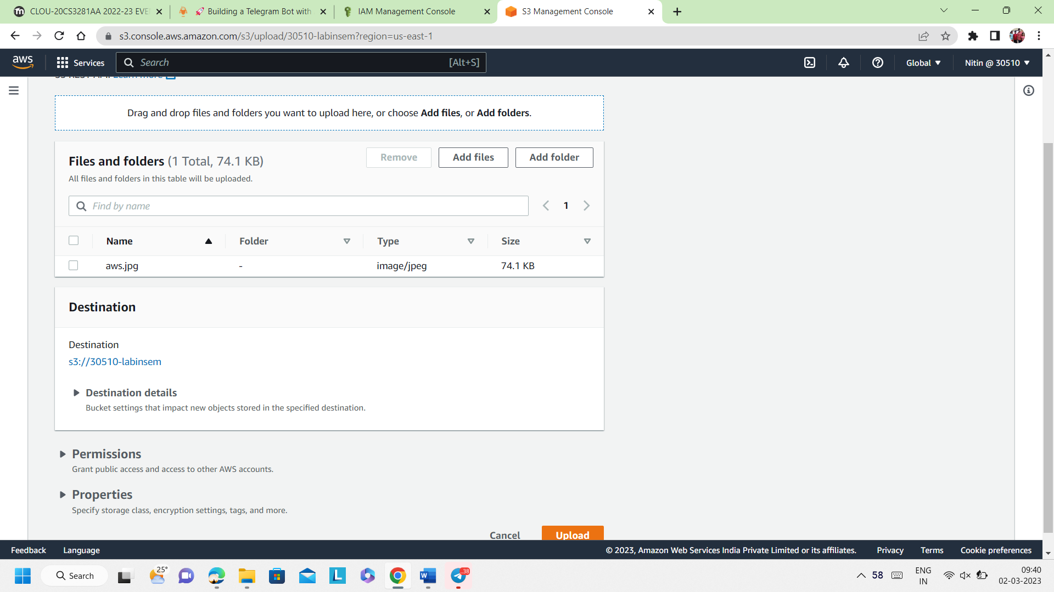

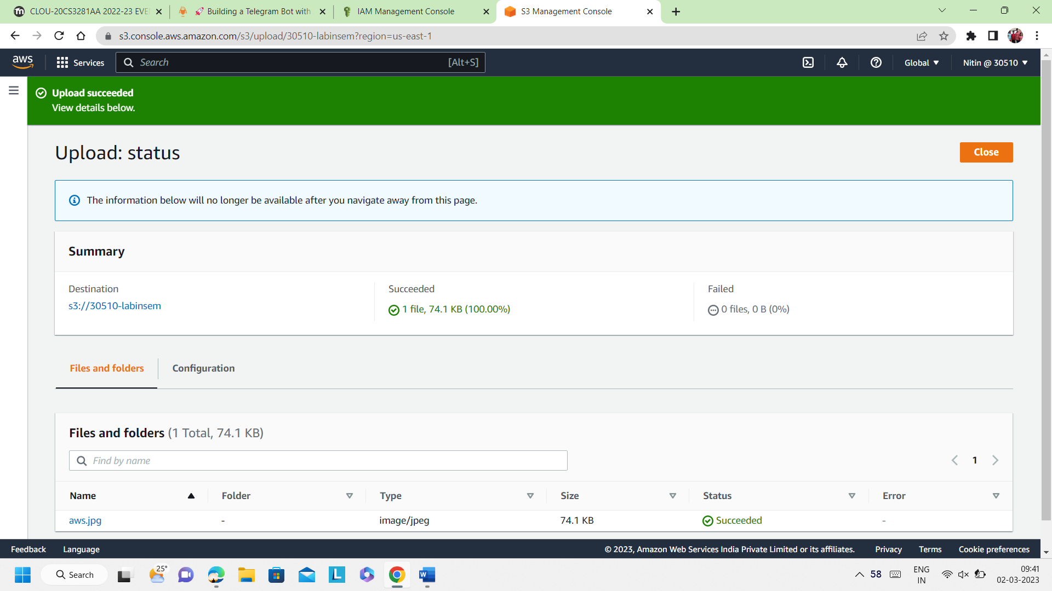

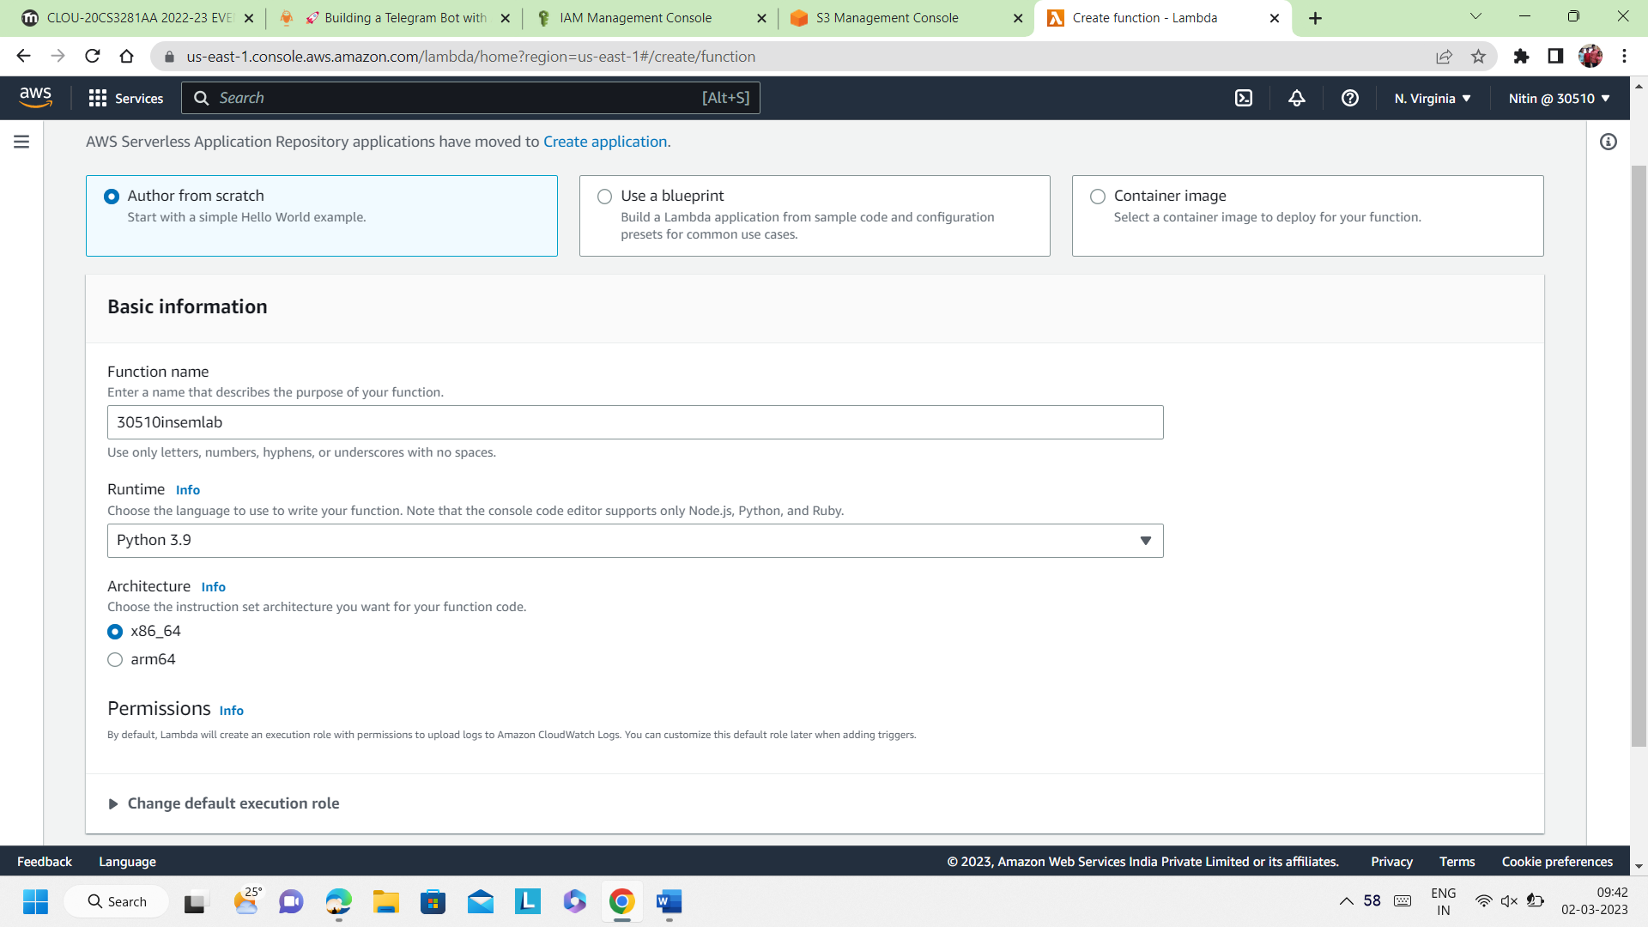

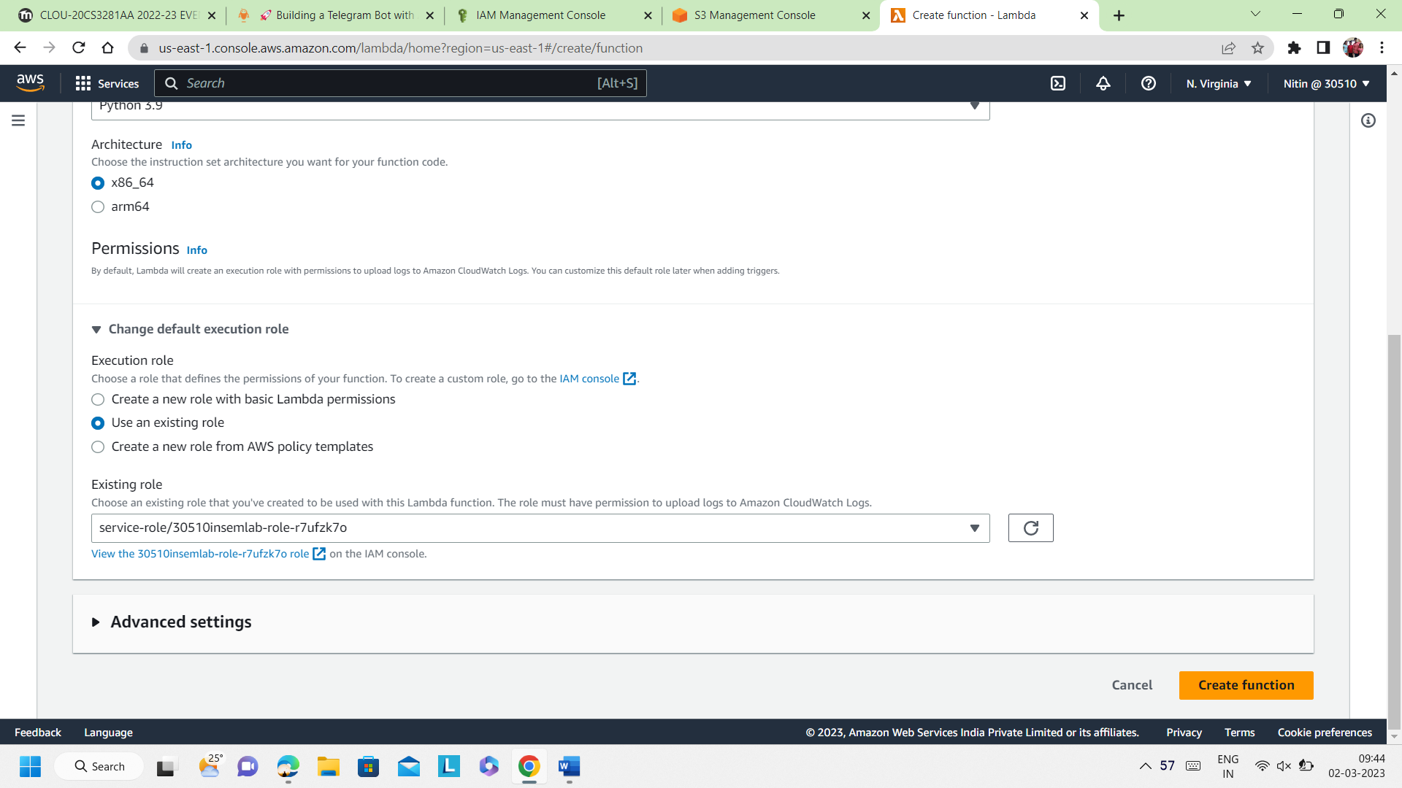

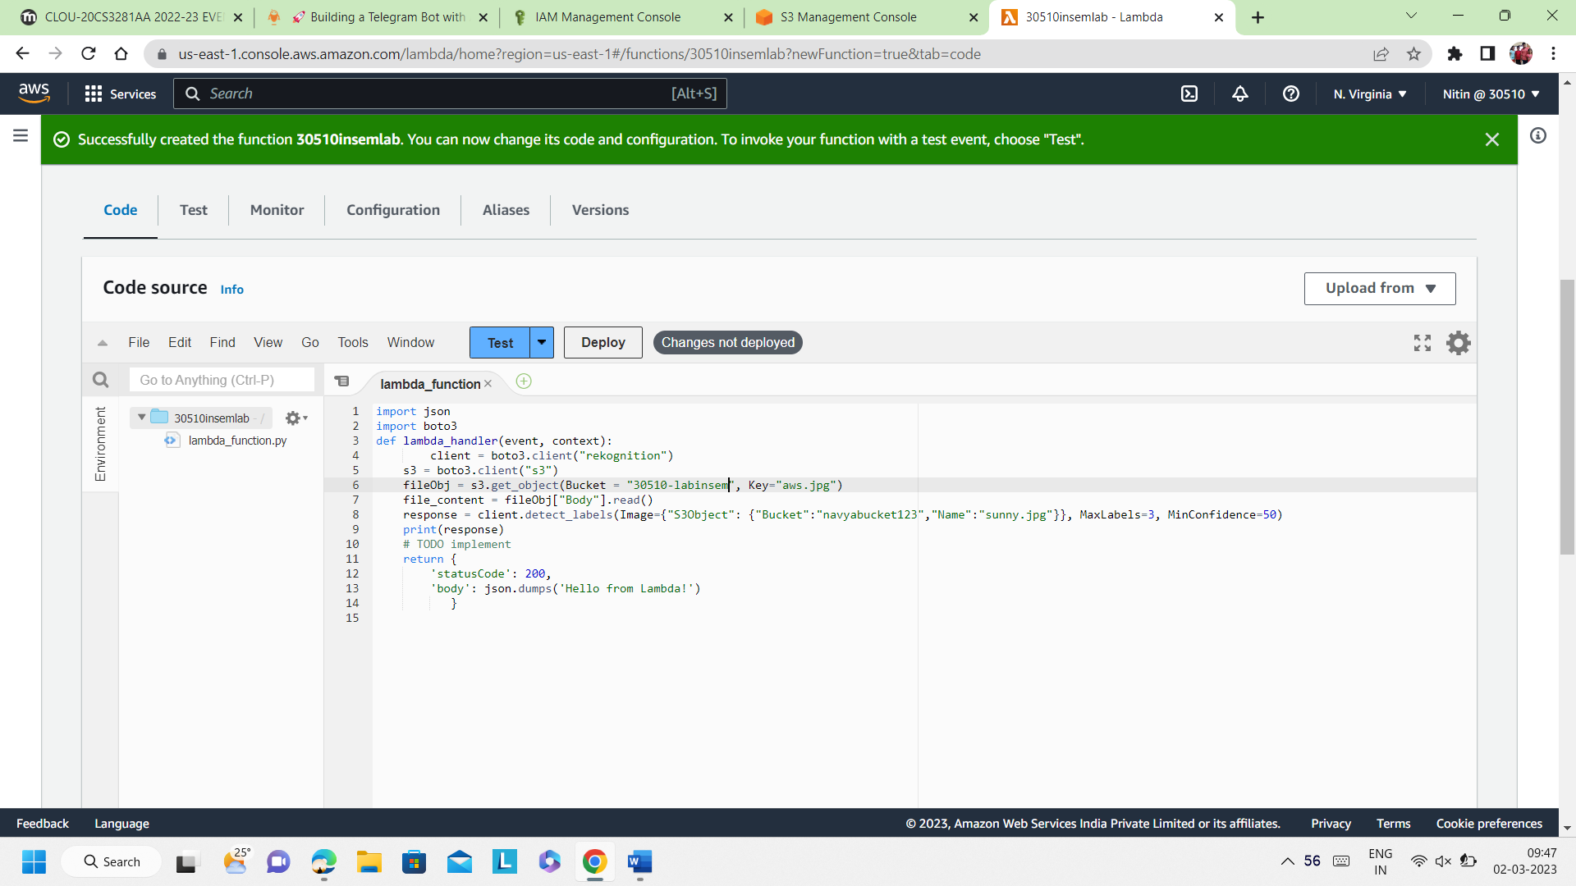

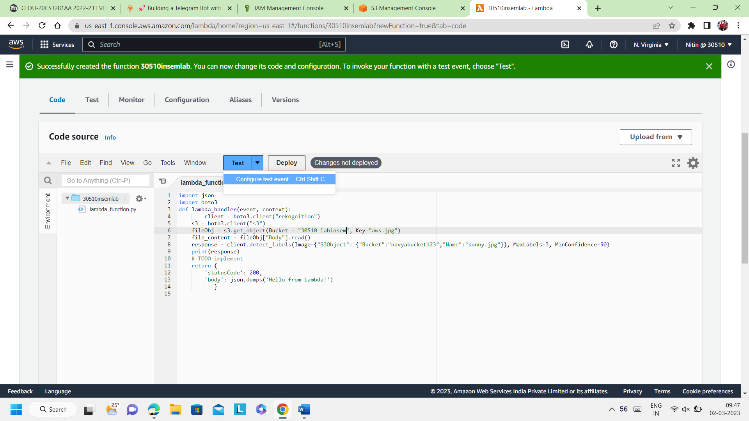

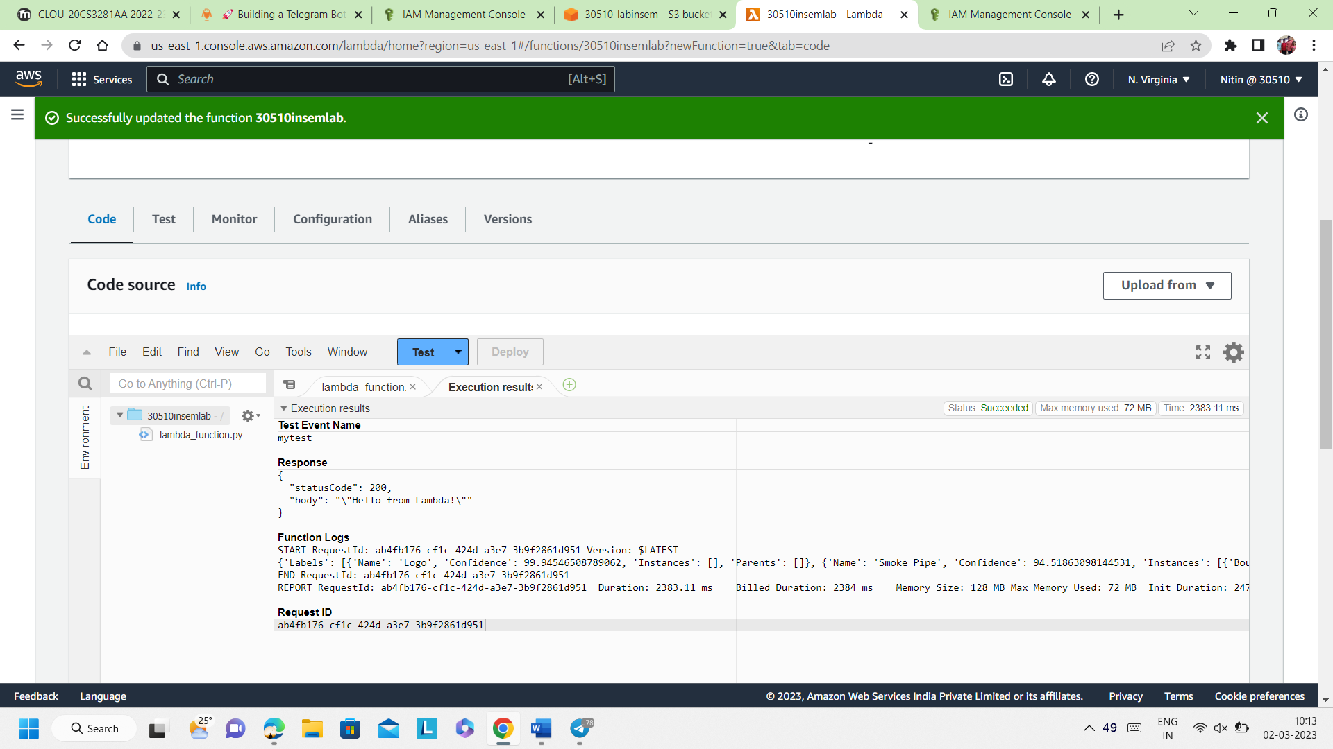

Test Event Name

mytest

Response

{

"statusCode": 200,

"body": "\"Hello from Lambda!\""

}

Function Logs

START RequestId: ab4fb176-cf1c-424d-a3e7-3b9f2861d951 Version: $LATEST

{'Labels': [{'Name': 'Logo', 'Confidence': 99.94546508789062, 'Instances': [], 'Parents': []}, {'Name': 'Smoke Pipe', 'Confidence': 94.51863098144531, 'Instances': [{'BoundingBox': {'Width': 0.9860491156578064, 'Height': 0.989000141620636, 'Left': 0.007504210341721773, 'Top': 0.006456112023442984}, 'Confidence': 94.51863098144531}], 'Parents': []}, {'Name': 'Lawn Mower', 'Confidence': 64.32760620117188, 'Instances': [{'BoundingBox': {'Width': 0.6545031666755676, 'Height': 0.5337409377098083, 'Left': 0.30001240968704224, 'Top': 0.006368040107190609}, 'Confidence': 64.32760620117188}], 'Parents': [{'Name': 'Device'}, {'Name': 'Grass'}, {'Name': 'Lawn'}, {'Name': 'Plant'}, {'Name': 'Tool'}]}], 'LabelModelVersion': '3.0', 'ResponseMetadata': {'RequestId': '44e0cf53-2be3-42b3-acff-ea70cb28918f', 'HTTPStatusCode': 200, 'HTTPHeaders': {'x-amzn-requestid': '44e0cf53-2be3-42b3-acff-ea70cb28918f', 'content-type': 'application/x-amz-json-1.1', 'content-length': '845', 'date': 'Thu, 02 Mar 2023 04:41:52 GMT'}, 'RetryAttempts': 0}}

END RequestId: ab4fb176-cf1c-424d-a3e7-3b9f2861d951

REPORT RequestId: ab4fb176-cf1c-424d-a3e7-3b9f2861d951 Duration: 2383.11 ms Billed Duration: 2384 ms Memory Size: 128 MB Max Memory Used: 72 MB Init Duration: 247.89 ms

Request ID

ab4fb176-cf1c-424d-a3e7-3b9f2861d951