Before microservices - **Monolithic architecture**

1. All software components are combined in single bundle.

2. Same single code base.

3. Change in one component leads to redeployment of whole project

4. Building problem : developers ha to communicate

5. Problem in scaling and cumbersome over time.

**Microservices**

1. Large apps divide into smaller parts.

2. All components have different code base.

3. Communicate with each other through rest apis.

4. Each module managed independently.

5. Handling all different components is complex.

If client or project is small, then monolithic architecture should be used.

**Project demo:**

Making 3 independent services which are having separate DBs. All request from client will come to api gateway then, will come to services. Authentication is provided by OKTA auth.

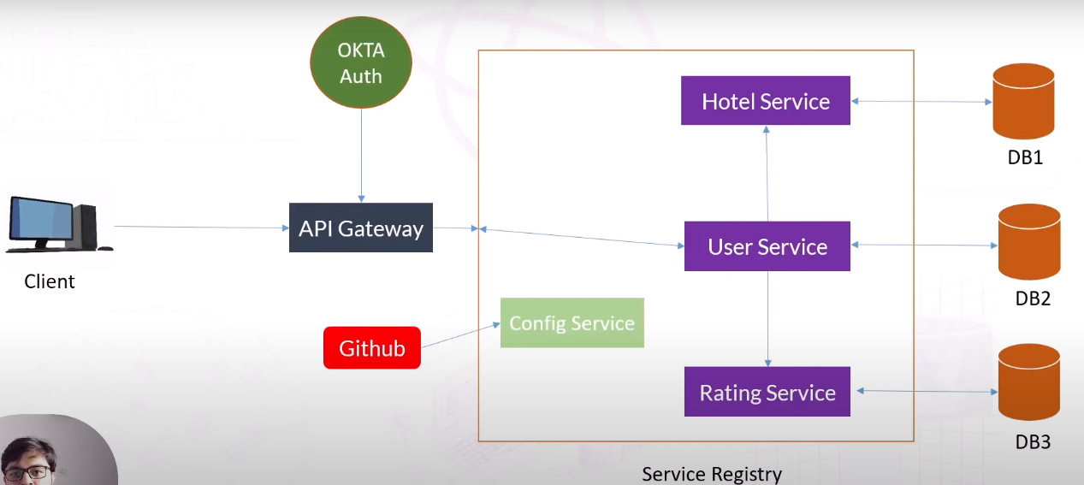

**Service registry**

Will keep track of all services. user, rating and hotel service ports and ip address. Will help to use service-name instead of ip address using service registry. It has info of which service is up or down.

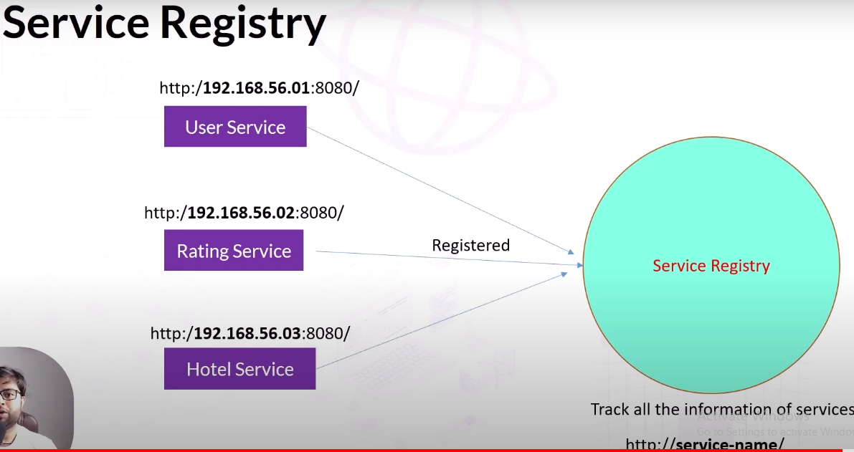

First we are preparing user service, request will come on user service from client. User service will retrieve hotel and rating service info from their respective services.

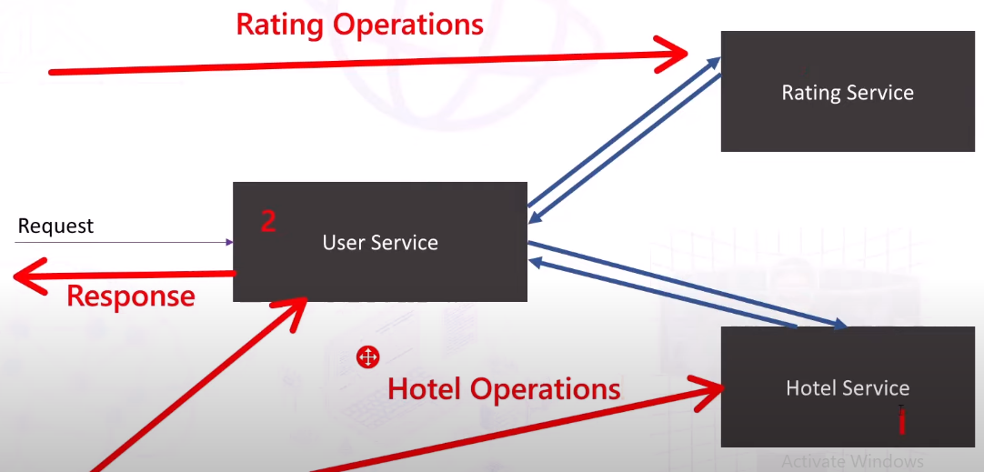

Notes:

1. yml file is used in complex projects. Plus it has tree structure and support multiple datat types. Properties files has key value structure.
2. @Builder -> helps to create object of class and set values in one line by className.builder().fields(setField).build().
3. If pathVariable name and parameter is same then, we do not need to provide name from postman.
4. *# sometimes dialect related error can come when hibernate can not be detected.  
   # Use ctrl+n -> search mysqlDialect*

jpa:  
 hibernate:  
 ddl-auto: update  
 show-sql: true  
 properties:  
 hibernate:  
 dialect: org.hibernate.dialect.MySQLDialect

1. @Transient is used when particular property of entity class should not be stored in DB.
2. If project is loaded manually then. Always pick your parent directory of pom.xml.
3. Manual Exceptions are extended by RUNTIMEEXception and globalExceptionHandler is created with @RestControllerAdvice and @ExceptionHandler(ManualException.class) name.
4. Another project is added in our project by opening + button of maven present at right side of coding area.
5. @Document( “documentname”) is used instead of @Entity for mongoDB.
6. Id is be default autogenerated in mongodb.