WIPRO CAPSTONE PROJECT REPORT

Name | Nitin Yadav
Superset ID | 5388156
Organization | Wipro
Project Type | Capstone Project
Project Name | Automation Testing using Selenium PyTest Framework
 | Automation Testing using Behave BDD Framework
Domain | E- commerce (Myntra)
Module Title | Men Section

SYNOPSIS

The Wipro Capstone Project focuses on automating the Myntra MEN module using two separate automation frameworks: Selenium WebDriver with Python PyTest framework and Behave BDD framework. The automation validates product search, category navigation, product selection, size selection, add to bag functionality, wishlist functionality, filter application, sort functionality, donation selection, and order placement workflow.

The framework was designed using the Page Object Model (POM) architecture to improve maintainability, scalability, and reusability of automation scripts. Screenshots, logs, Allure reports, and reusable utility modules were integrated to support execution tracking, debugging, and reporting.

The project includes both positive and negative testing scenarios using industry-standard automation testing practices. Data-driven testing was also implemented using CSV files to execute multiple test datasets efficiently.

PROJECT DESCRIPTION
The automation framework automates the end-to-end workflow of the Myntra MEN shopping module. The framework performs MEN category navigation, casual shoes selection, product search validation, size selection, add to cart functionality, wishlist validation, filter application, sorting validation, donation amount selection, and order placement verification.
Separate page classes were implemented for MEN module functionalities using Selenium Python Page Object Model (POM) framework. Utility modules were created for driver setup, screenshots, logging, and test data handling to improve code reusability and framework maintainability.

SELENIUM PYTEST FRAMEWORK

TEST STRATEGY
The project uses Selenium WebDriver with Python PyTest framework for automation testing. The framework supports:
- End-to-End Testing
- Positive Testing
- Negative Testing
- UI Functional Testing
- Data-Driven Testing
Tools Used:
- Selenium WebDriver
- Python
- PyTest
- Behave BDD
- Allure Reports
- Logging Module
- CSV Data Handling
- Page Object Model (POM)
- WebDriver Manager

TEST ENVIRONMENT
Component | Details
Operating System | Windows 11
IDE | PyCharm
Browser | Google Chrome
Framework | Selenium WebDriver + PyTest
Programming Language | Python
Design Pattern | Page Object Model (POM)
Reporting Tool | Allure Reports
Test Data Handling | CSV
Version Control | Git & GitHub

FRAMEWORK ARCHITECTURE
Wipro_Myntra_Men_Capstone_Project
│
├── Selenium_project
│ ├── logs
│ ├── pages
│ ├── reports
│ │ ├── allure-results
│ │ └── allure-report
│ ├── screenshots
│ ├── test_data
│ ├── tests
│ ├── utils
│ ├── conftest.py
│ └── requirements.txt
The automation suite includes:
- 1 End-to-End Test Case
- 4 Positive Test Cases
- 2 Negative Test Cases
The End-to-End test validates the complete Myntra MEN shopping workflow from MEN category navigation until Place Order page verification.

SELENIUM TEST CASE SUMMARY
S.No | Test Type | Test Scenario | Expected Result | Status
1 | End-to-End | Complete MEN Shopping Workflow | User successfully reaches Place Order/Login page | Passed
2 | Positive | Search Functionality Validation | Search results displayed successfully | Passed
3 | Positive | Filter Functionality Validation | Puma filter applied successfully | Passed
4 | Positive | Sort Functionality Validation | Better Discount sorting applied successfully | Passed
5 | Positive | Wishlist Functionality Validation | Wishlist/Login popup displayed successfully | Passed
6 | Negative | Invalid Search Validation | No result message displayed successfully | Passed
7 | Negative | No Size Selected Validation | Size selection error message displayed successfully | Passed

END-TO-END FLOW VALIDATION
The End-to-End automation validates the complete business workflow including:
- Website Launch
- MEN Menu Navigation
- Casual Shoes Category Selection
- Product Selection
- Size Selection
- Add to Bag Functionality
- Cart Validation
- Donation Amount Selection
- Total Amount Verification
- Place Order Navigation
- Login Page Redirection Verification

POSITIVE TEST CASES
Positive Test Case 1 – Product Search Functionality
- Validates product search functionality
- Searches valid product “Sneakers”
- Verifies search result page display
- Ensures matching products are displayed successfully
Positive Test Case 2 – Brand Filter Validation
- Validates brand filter functionality
- Applies “Puma” brand filter
- Verifies filter selection successfully
- Ensures filtered products are displayed
Positive Test Case 3 – Product Sorting Validation
- Validates sorting functionality
- Opens sorting options
- Selects “Better Discount” option
- Verifies products are sorted successfully

Positive Test Case 4 – Wishlist Functionality Validation
- Validates wishlist functionality
- Opens selected product
- Clicks Wishlist button
- Verifies login popup display successfully
NEGATIVE TEST CASES
Negative Test Case 1 – Invalid Product Search
- Searches invalid product value
- Validates application handling for invalid search
- Verifies no valid matching products are displayed
- Ensures invalid product search handling works correctly

Negative Test Case 2 – Add To Bag Without Selecting Size
- Opens product page
- Clicks “Add To Bag” without selecting size
- Validates application error handling
- Verifies display of:
“Please select a size”
- Ensures product cannot be added without mandatory size selection

ALLURE REPORTS
- Integrated Allure Reports with PyTest
- Generates professional execution reports
- Displays passed and failed test status
- Captures screenshots during execution
- Maintains execution history
- Displays step-by-step execution flow
- Helps debugging and tracking failures
- Provides detailed execution summary

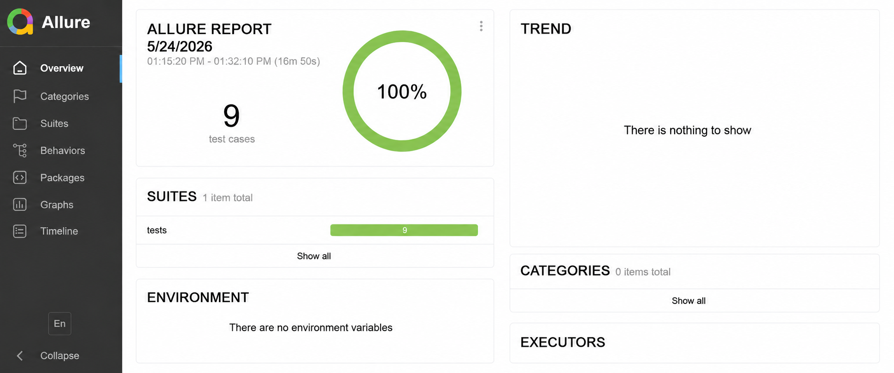

TEST OUTPUTS
The framework automatically captures screenshots during important execution stages including MEN category navigation, product selection page, filter application page, cart page, wishlist popup, donation selection page, and place order/login verification page.
Detailed execution logs are generated using the Python Logging framework for debugging, execution tracking, and failure analysis. Logs and screenshots are attached directly to Allure Reports for better traceability and reporting.
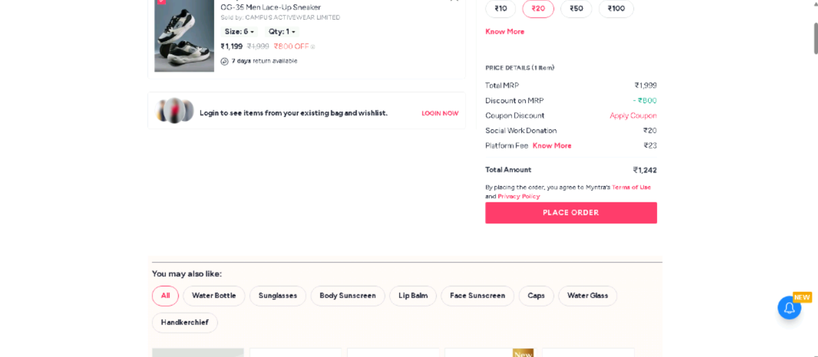
Fig 1: E2E
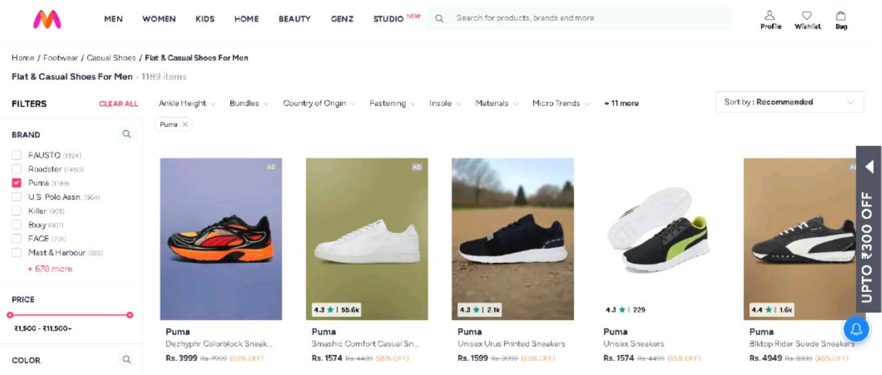
Fig 2: Filter
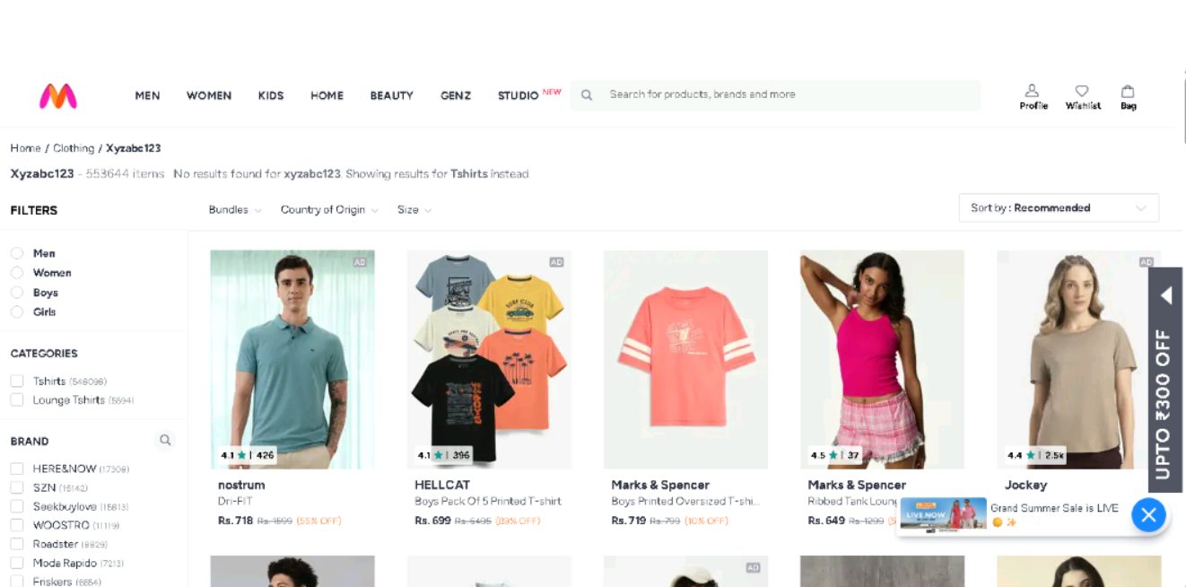
Fig 3: Invalid Search
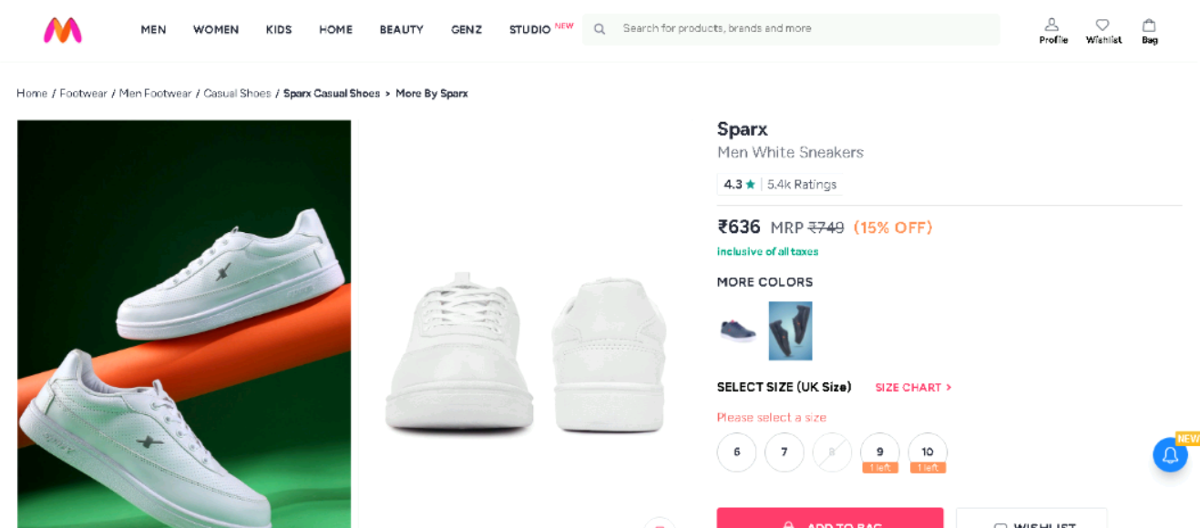
Fig 4: No Size selected

Fig 5: Search

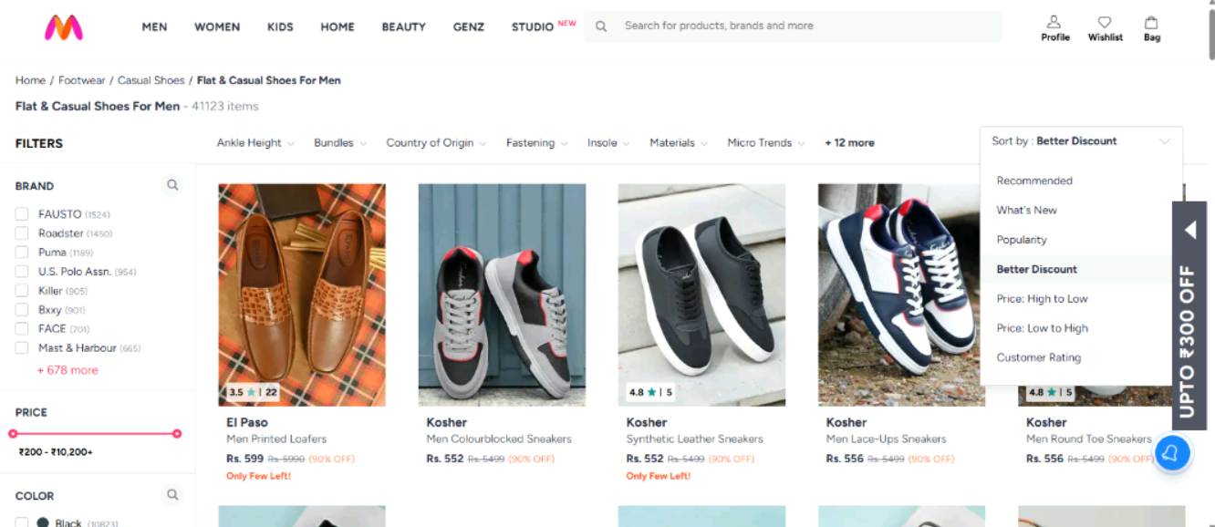
Fig 6: Sort

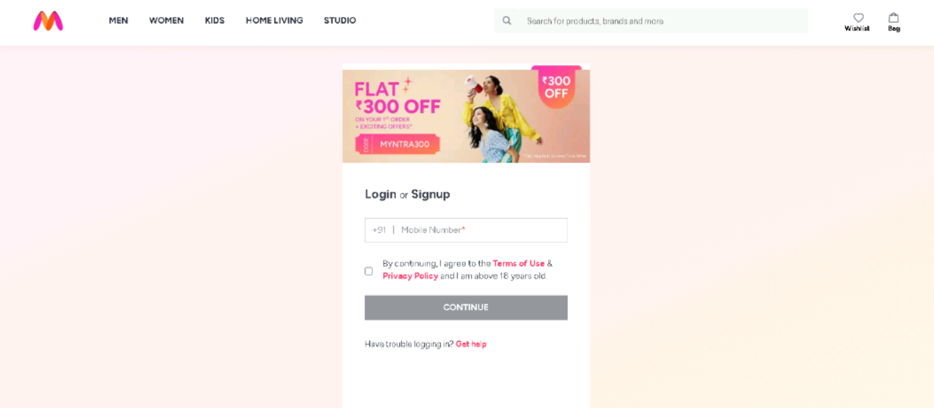
Fig 7: Wishlist

TEST REPORT
- Total Tests Executed: 9
- Tests Passed: 9
- Tests Failed: 0
- Automation Accuracy: 100%

CONCLUSION

The Selenium PyTest automation framework successfully validates the Myntra MEN module using End-to-End, Positive, and Negative testing approaches.
The framework is designed using:
- Selenium WebDriver
- PyTest Framework
- Page Object Model (POM)
- Allure Reporting
- Logging Framework
- Data-Driven Testing
The automation framework improves:
- Test Maintainability
- Reusability
- Scalability
- Reporting Quality
- Automation Reliability
The framework successfully validates critical business workflows including MEN menu navigation, product search functionality, filter validation, product sorting, wishlist functionality, cart validation, donation selection, and place order verification.
All test cases executed successfully with professional reporting, screenshot capture, and detailed execution logs.
Overall, the project demonstrates a practical and professional Selenium automation framework for real-world e-commerce web application testing.

BEHAVE BDD FRAMEWORK
TEST STRATEGY
The project uses Behave BDD framework integrated with Selenium WebDriver for automation testing.
The framework supports:
- End-to-End Testing
- Positive Testing
- Negative Testing
- Behavior Driven Development (BDD)
- UI Functional Testing

TOOLS USED

- Selenium WebDriver
- Python
- Behave BDD
- Gherkin Syntax
- Allure Reports
- Logging Module
- Page Object Model (POM)
- WebDriver Manager
- Git & GitHub

TEST ENVIRONMENT
Component | Details
Operating System | Windows 11
IDE | PyCharm
Browser | Google Chrome
Framework | Selenium WebDriver + Behave BDD
Programming Language | Python
Design Pattern | Page Object Model (POM)
Reporting Tool | Allure Reports
Test Data Handling | CSV
Version Control | Git & GitHub

FRAMEWORK ARCHITECTURE

Wipro_Myntra_BDD_Project
│
├── features
│ ├── positive
│ ├── negative
│ ├── steps
│ └── men_e2e.feature
│
├── logs
├── pages
├── reports
├── screenshots
├── utils
├── environment.py
├── behave.ini
└── requirements.txt

TEST EXECUTION

The automation suite includes:
- 1 End-to-End Test Case
- 4 Positive Test Cases
- 2 Negative Test Cases
The End-to-End test validates the complete Myntra MEN shopping workflow from MEN category navigation until Place Order login redirection validation.

SELENIUM TEST CASE SUMMARY
S.No | Test Type | Test Scenario | Expected Result | Status
1 | End-to-End | Complete MEN Shopping Workflow | User successfully reaches Place Order/Login page | Passed
2 | Positive | Search Functionality Validation | Search results displayed successfully | Passed
3 | Positive | Filter Functionality Validation | Puma filter applied successfully | Passed
4 | Positive | Sort Functionality Validation | Better Discount sorting applied successfully | Passed
5 | Positive | Wishlist Functionality Validation | Wishlist/Login popup displayed successfully | Passed
6 | Negative | Invalid Search Validation | No result message displayed successfully | Passed
7 | Negative | No Size Selected Validation | Size selection error message displayed successfully | Passed

ALLURE REPORTS
- Integrated Allure Reports with Behave BDD Framework
- Generates professional execution reports
- Displays passed and failed scenario status
- Captures screenshots during execution
- Displays step-by-step scenario execution flow
- Helps debugging and tracking failures
- Provides detailed execution summary

TEST OUTPUTS
The framework automatically captures screenshots during important execution stages including product selection page, cart page, wishlist popup, filter application page, and login verification page.
Detailed execution logs are generated using Python Logging framework for debugging and execution tracking.

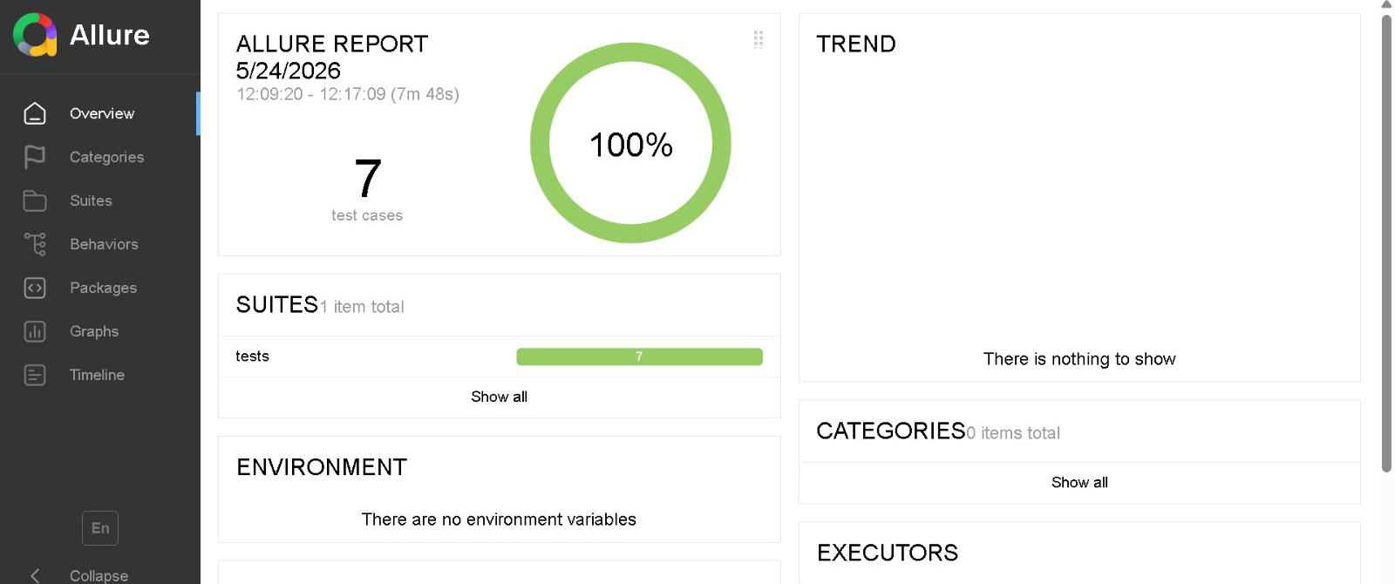

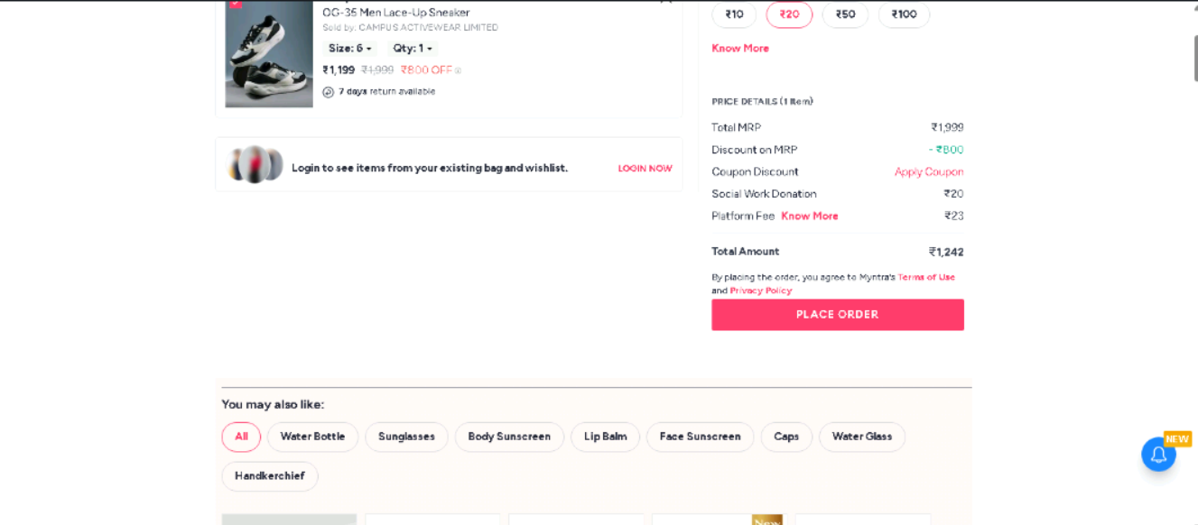
E2E Screenshot

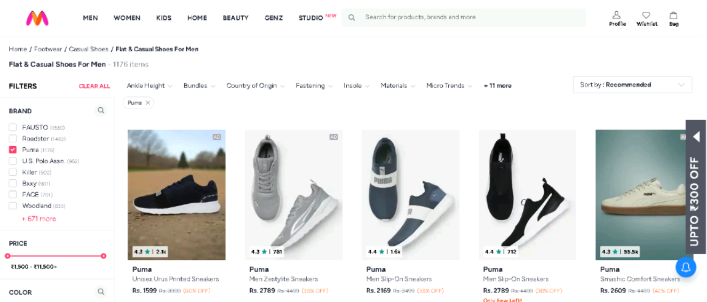
Filter Section

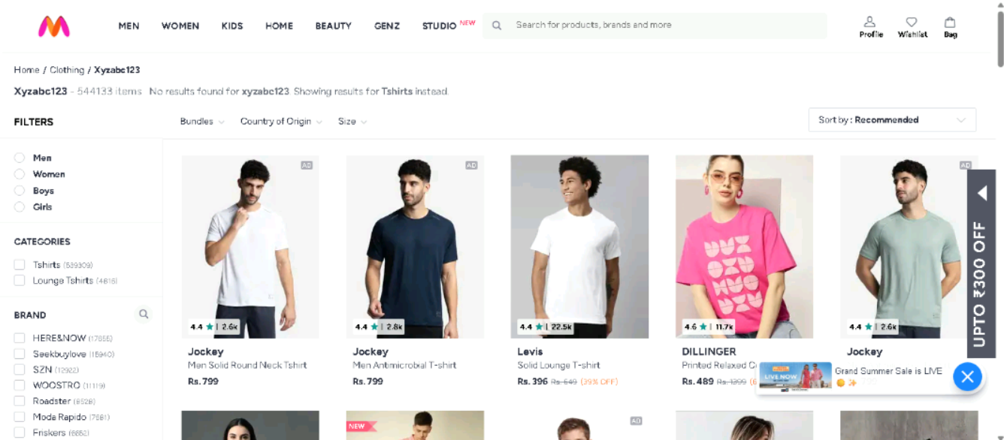
Invalid Search

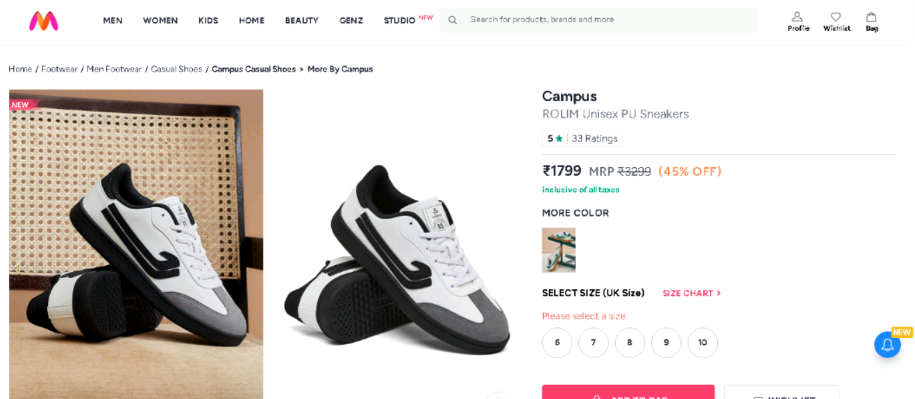
No Size Selected

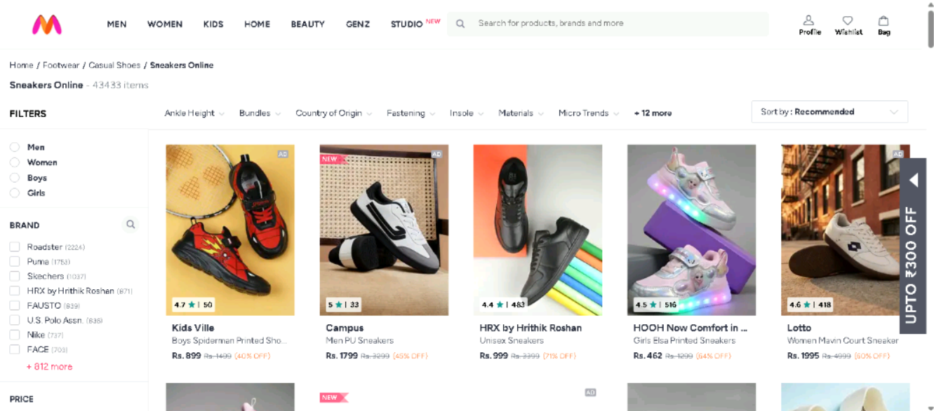
Search

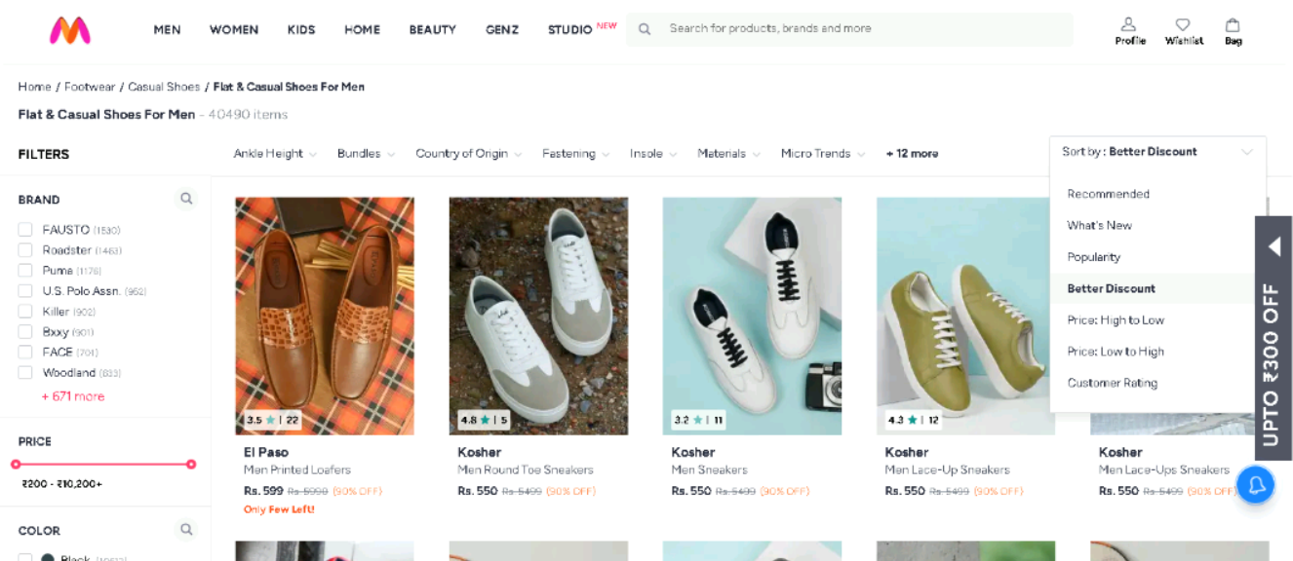

Sort

TEST REPORT
- Total Scenarios Executed: 7
- Scenarios Passed: 7
- Scenarios Failed: 0
- Automation Accuracy: 100%

CONCLUSION
The Behave BDD automation framework successfully validates the Myntra MEN module using End-to-End, Positive, and Negative testing approaches.
The framework is designed using:
- Selenium WebDriver
- Behave BDD Framework
- Gherkin Syntax
- Page Object Model (POM)
- Allure Reporting
- Logging Framework
The automation framework improves:
- Readability
- Collaboration
- Maintainability
- Scalability
- Reporting Quality
- Automation Reliability
The framework successfully validates critical business workflows including MEN navigation, product search, filter validation, sorting validation, wishlist functionality, donation workflow, and place order verification.
All scenarios executed successfully with professional reporting, screenshot capture, and detailed execution logs.
Overall, the project demonstrates a scalable and professional BDD automation framework for real-world e-commerce application testing

