Q:1) what is 2+2 =?

Paragraph: Paragraph here

Sol: description here

A:) 4

B:) 5

C:) 6

D:) 3

Correct: A

Q:1) what is 2+2 =? – This is second language question   
Note – keep question number same as its primary language question

Paragraph: Paragraph here

Sol: description here

A:) 4 second language

B:) 5 second language

C:) 6 second language

D:) 3 second language

Correct: A

Q:2) what is 2+6 =?

Sol:

A:) 4

B:) 8

C:) 6

D:) Eight

Correct: B,D

Q:3) Who is in the picture?

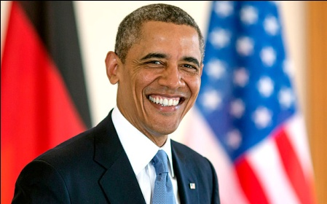

Sol:

A:) Osama

B:) Obama

C:) Arvind

D:) Anil

Correct: B