**ASSIGNMENT -2**

**AGILE METHODOLOGY: JIRA TOOL**

**Create the project for any web application example using agile methodology (SCRUM TEMPLATE).**

**(6 ISSUES)>>>> 4 STORY, 1 TASK, BUG**

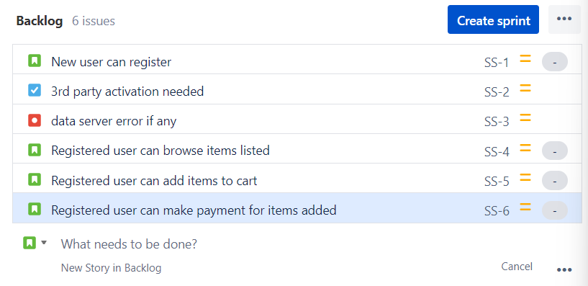

1. **Create components**

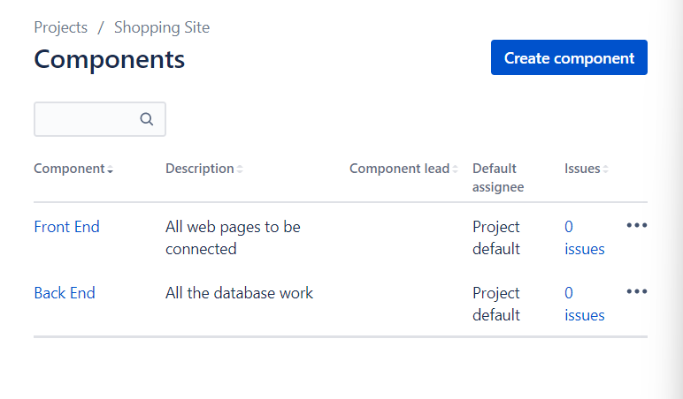

1. **Plan the version with release dates**

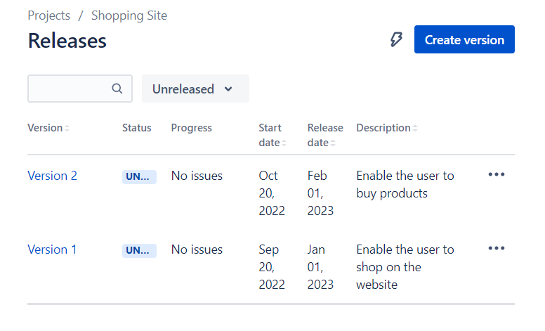

**III.Create sprint backlog, start sprint and complete sprint**

**IV.Create different types of issues in the backlog.**

**-Epic –provide epic link also**

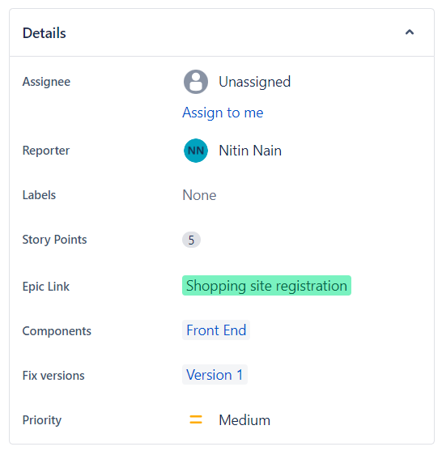

**- Story**

**Initialize story point, Associate with Version, component ---**



**Divide into sub-tasks: Give estimate time**

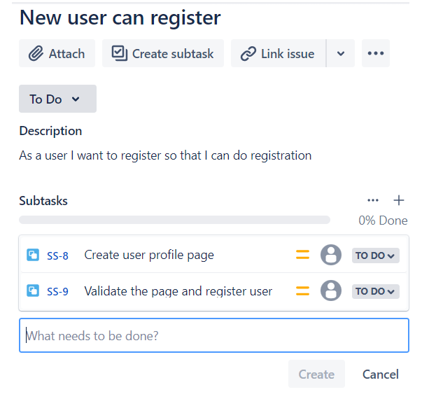

**Give time log work and comment it as well.**

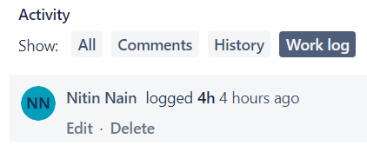

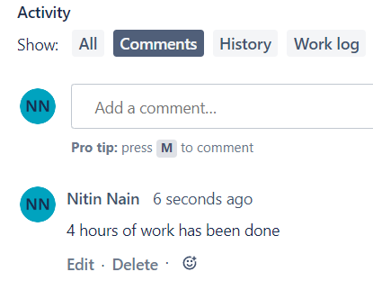

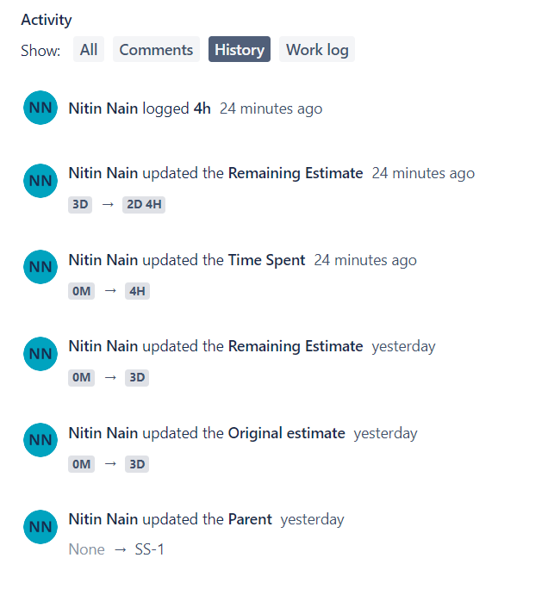

**-Clone the story.**

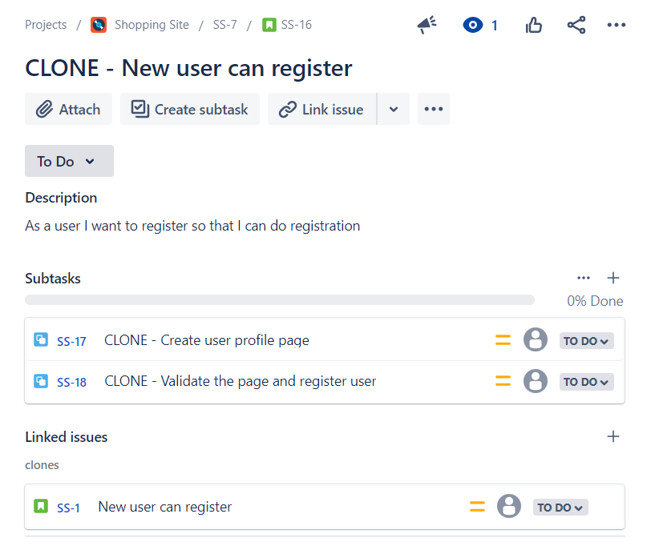

**-task**

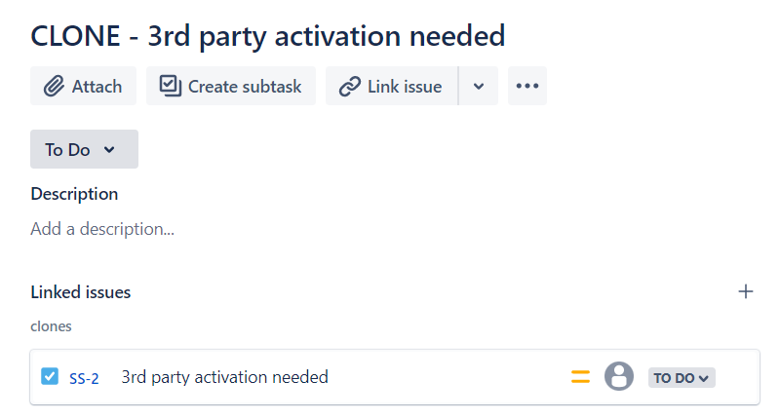

**-bug –**

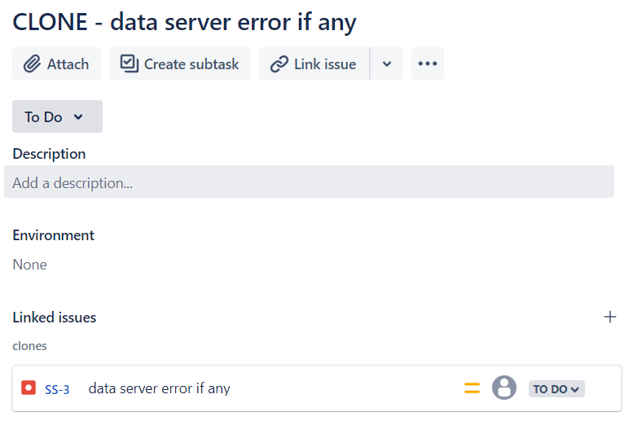

**Link with issues story**

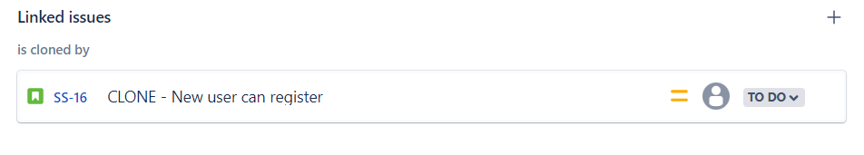

**View workflows also.**

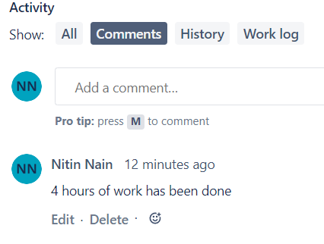

**V. Evaluate burn down, burn up, analyse the sprint report and velocity charts.**

**Submit the screen shoots of Backlog, burn down, burn up, sprint report and velocity charts for the sprint. (From your login only)**