**Q 1 Java program to print welcome message.**

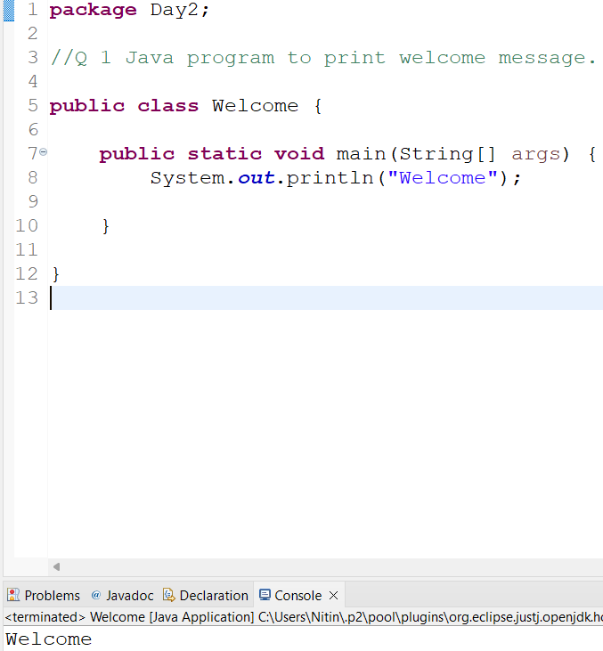

**Q 2 Java program to print sum of  three float numbers**

**package** Day2;

**import** java.util.Scanner;

//Q 2 Java program to print sum of three float numbers

**public** **class** Sum_float {

**public** **static** **void** main(String[] args) {

**float** a;

**float** b;

**float** c;

Scanner s= **new** Scanner(System.***in***);

System.***out***.println("enter first number ");

a=s.nextFloat();

System.***out***.println("enter second number ");

b=s.nextFloat();

System.***out***.println("enter third number ");

c=s.nextFloat();

**float** d=a+b+c;

System.***out***.println("Sum "+ d);

s.close();

}

}

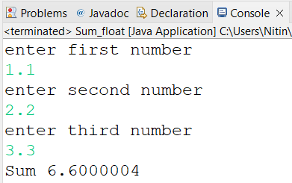

**Q 3 Java Program to Swap Two Numbers**

**package** Day2;

**import** java.util.Scanner;

//Q 3 Java Program to Swap Two Numbers

**public** **class** swap {

**public** **static** **void** main(String[] args) {

**int** a,b,temp;

Scanner s=**new** Scanner(System.***in***);

System.***out***.println("enter the value of a ");

a=s.nextInt();

System.***out***.println("enter the value of b ");

b=s.nextInt();

System.***out***.println("before swapping a="+a+"b="+b);

temp=a;

a=b;

b=temp;

System.***out***.println("after swapping a="+a+"b="+b);

}

}

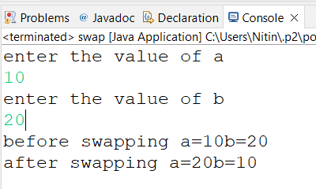

**Q 4 Wap to check if number is even or odd**

**package** Day1;

**public** **class** EvenOdd {

**public** **static** **void** main(String[] args) {

**int** a=11;

**if**(a%2==0)

System.***out***.println("even");

**else**

System.***out***.println("odd");

}

}

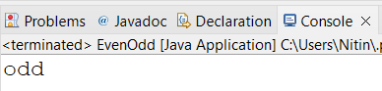

**Q 5 wap to check from three given number  that whether a number is greater than or equal to 20 and less than other numbers .print appropriate message .**

**package** Day2;

//Q 5 wap to check from three given number that whether a number is greater than or equal to 20 and less than other numbers .print appropriate message .

**public** **class** Q5_Assignment {

**public** **static** **void** main(String[] args) {

**int** num=30;

System.***out***.println("num is "+num);

**if** (num<20)

System.***out***.println("number is less than 20");

**else** **if**(num>20)

System.***out***.println("number is greater than 20");

**else**

System.***out***.println("number is equal to 20");

}

}

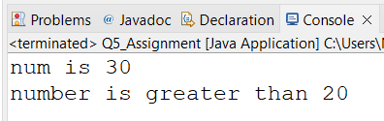

**Q 7 wap to check if sales of a person is greater than 10000 then eligible for bonus   
else not eligible calculate bonus as 20% of sales .**

**package** Day2;

**import** java.util.Scanner;

//Q 7 WAP to check if sales of a person is greater than 10000 then eligible for bonus else not eligible & calculate bonus as 20% of sales .

**public** **class** Sales {

**public** **static** **void** main(String[] args) {

**float** sales;

Scanner s= **new** Scanner(System.***in***);

System.***out***.println("enter sales");

sales=s.nextFloat();

**if**(sales>1000)

System.***out***.println("eligible for bonus");

**else**

System.***out***.println("not eligible");

**float** bonus=(0.2f*(sales));

System.***out***.println("bonus is "+bonus);

s.close();

}

}

**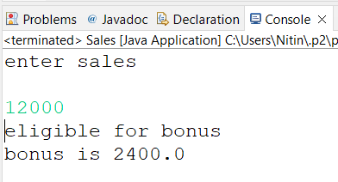  
  
Q 8 wap to check if two given integer value is in range of 18 and 100 print eligible for voting else not eligible .**

**package** Day2;

**import** java.util.Scanner;

//Q 8 wap to check if two given integer value is in range of 18 and 100 print eligible for voting else not eligible .

**public** **class** Voting_age {

**public** **static** **void** main(String[] args) {

**int** age;

Scanner s=**new** Scanner(System.***in***);

System.***out***.println("enter age");

age=s.nextInt();

**if** (age>18 && age<100)

System.***out***.println("eligible for voting");

**else**

System.***out***.println("not eligible for voting");

s.close();

}

}

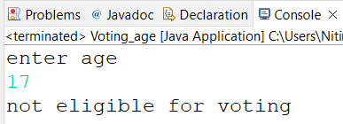

**Q 9 wap to print average of  given five subjects marks of student and check if average >=40 print Pass else print fail  
package** Day2;

//Q 9 wap to print average of given five subjects marks of student and check if average >=40 print Pass else print fail

**public** **class** StudentAverageMarks {

**public** **static** **void** main(String[] args) {

**int** phy=92;

**int** chem=96;

**int** maths=98;

**int** eng=94;

**int** hin=90;

**float** average=(phy+chem+maths+eng+hin)/5;

System.***out***.println("average is "+average);

**if**(average>=40)

System.***out***.println("Pass");

**else**

System.***out***.println("Fail");

}

}

**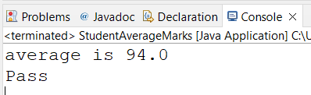  
  
  
Q10 WAP to ask name ,age and salary of an employee and print on console.  
 package** Day2;

**import** java.util.Scanner;

//WAP to ask employee details from user

**public** **class** EmployeeDetails {

**public** **static** **void** main(String[] args) {

String name; //string is a class in java.lang package

**int** age;

**float** salary;

**char** gender;

Scanner s=**new** Scanner(System.***in***);

System.***out***.println("enter name");

name=s.next();//will not accept space between name(e.g. space between name and surname). If you want space then you should go for name=s.nextLine();

System.***out***.println("enter age");

age=s.nextInt();

System.***out***.println("enter salary");

salary=s.nextFloat();

System.***out***.println("enter gender");

gender=s.next().charAt(0);//asking string from user and extracting first character from string and storing it in gender variable

//If we want to display complete gender part then we will take this as a string as we took in name

System.***out***.println("name: "+name+" age: "+age+" salary: "+salary+" gender: "+gender);

s.close();

}

}

**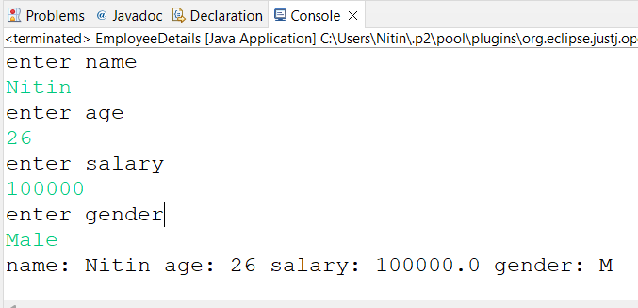  
   
Q 11 wap  that ask two numbers from user and print greater number among two   
 package** Day2;

//Q 11 wap that ask two numbers from user and print greater number among two

**import** java.util.Scanner;

**public** **class** GreaterNumber {

**public** **static** **void** main(String[] args) {

**int** a;

**int** b;

Scanner s=**new** Scanner(System.***in***);

System.***out***.println("enter the value of a");

a=s.nextInt();

System.***out***.println("enter the value of b");

b=s.nextInt();

**if**(a>b)

System.***out***.println("a is greater");

**else**

System.***out***.println("b is greater");

s.close();

}

}

**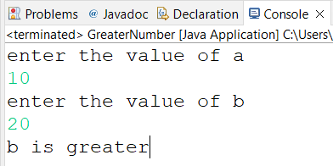  
   
Q 12  wap to ask product name and price of product from user and calculate discount i.e. if price > 2000 then discount is 10 percent of price   
else discount is 7 % of price**

**package** Day2;

**import** java.util.Scanner;

//Q 12 wap to ask product name and price of product from user and calculate discount i.e.

//if price > 2000 then discount is 10 percent of price. else discount is 7 % of price

**public** **class** Q12_Assignment {

**public** **static** **void** main(String[] args) {

String product_name;

**int** product_price;

Scanner s=**new** Scanner(System.***in***);

System.***out***.println("enter product name");

product_name=s.next();

System.***out***.println("enter price");

product_price=s.nextInt();

**if**(product_price>2000) {

**float** discount=.1f*product_price;

System.***out***.println("Discount is 10% of the price which is "+discount);

}

**else** {

**float** discount=.07f*product_price;

System.***out***.println("Discount is 7% of the price which is "+discount);

}

s.close();

}

}

