

Name : DUBEY NITIN SANJAY KUMAR Roll no.: A-32 Batch: AS2

Class : Second Year (SY) 2026-27 Department : Information Technology

Course code: ITXS37 Subject: DSA

Experiment No:3

Aim: Experiment No. 03 infix to postfix

Program

#include <stdio.h>
#include <stdlib.h>
#include <string.h>
#include <ctype.h>

#define MAX 100

char stack[MAX];
int top = -1;
void push(char c)
{
if (top == MAX - 1) {
printf("Stack Overflow\n");
exit(1);
}
stack[++top] = c;
}

char pop(void)
{
if (top == -1) {
printf("Stack Underflow (invalid expression)\n");
exit(1);
}
return stack[top--];
}

char peek(void)
{
return (top == -1) ? '\0' : stack[top];
}

int isEmpty(void)
{
return top == -1;
}

int precedence(char op)
{
switch (op) {
case '^': return 3;
case '*':
case '/':
case '%': return 2;
case '+':
case '-': return 1;
default : return 0;
}
}

int isOperator(char c)
{
return (c == '+' || c == '-' || c == '*' ||
c == '/' || c == '%' || c == '^');
}

int isRightAssociative(char c)
{
return c == '^';
}

void infixToPostfix(const char infix[], char postfix[])
{
int i, k = 0;
char c;

for (i = 0; infix[i] != '\0'; i++) {
c = infix[i];

if (isspace((unsigned char)c))
continue;

if (isalnum((unsigned char)c)) {
postfix[k++] = c;
}
else if (c == '(') {
push(c);
}
else if (c == ')') {
while (!isEmpty() && peek() != '(')
postfix[k++] = pop();
if (isEmpty()) {
printf("Mismatched parentheses\n");
exit(1);
}
pop();
}
else if (isOperator(c)) {
while (!isEmpty() && peek() != '(' &&
(precedence(peek()) > precedence(c) ||
(precedence(peek()) == precedence(c) &&
!isRightAssociative(c)))) {
postfix[k++] = pop();
}
push(c);
}
else {
printf("Invalid character '%c' in expression\n", c);
exit(1);
}
}

while (!isEmpty()) {
c = pop();
if (c == '(') {
printf("Mismatched parentheses\n");
exit(1);
}
postfix[k++] = c;
}
postfix[k] = '\0';
}

int main(void)
{
char infix[MAX], postfix[MAX];

printf("Enter a valid infix expression: ");
fgets(infix, sizeof(infix), stdin);
infix[strcspn(infix, "\n")] = '\0';

infixToPostfix(infix, postfix);

printf("Infix : %s\n", infix);
printf("Postfix : %s\n", postfix);

return 0;
}

Outcome:

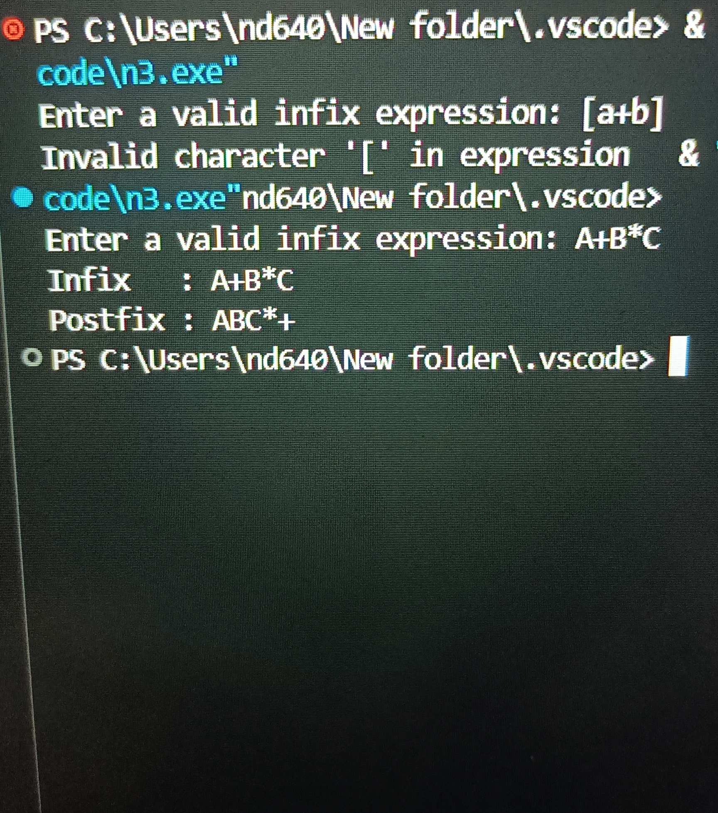

Conclusion: SUCESSFULLY EXCUTED USING STRING

