BREADTH FIRST SEARCH (BFS)
Data Structures / C Programming
Name | Nitin Dubey
Roll No. | 32
Batch | AS2

Aim
To implement Breadth First Search (BFS) traversal of a graph using an adjacency matrix and a queue in the C programming language.
Program
#include <stdio.h>
#define MAX 20
int adj[MAX][MAX], visited[MAX], queue[MAX];
int front = 0, rear = -1;
void bfs(int start, int n) {
int i, v;
visited[start] = 1;
queue[++rear] = start;
while (front <= rear) {
v = queue[front++];
printf("%d ", v);
for (i = 0; i < n; i++) {
if (adj[v][i] == 1 && !visited[i]) {
visited[i] = 1;
queue[++rear] = i;
}
}
}
}
int main() {
int n, i, j, start;
printf("Enter number of vertices: ");
scanf("%d", &n);
printf("Enter adjacency matrix:\n");
for (i = 0; i < n; i++)
for (j = 0; j < n; j++)
scanf("%d", &adj[i][j]);
printf("Enter starting vertex: ");
scanf("%d", &start);
printf("BFS traversal: ");
bfs(start, n);
return 0;
}

VS Code Program and Output
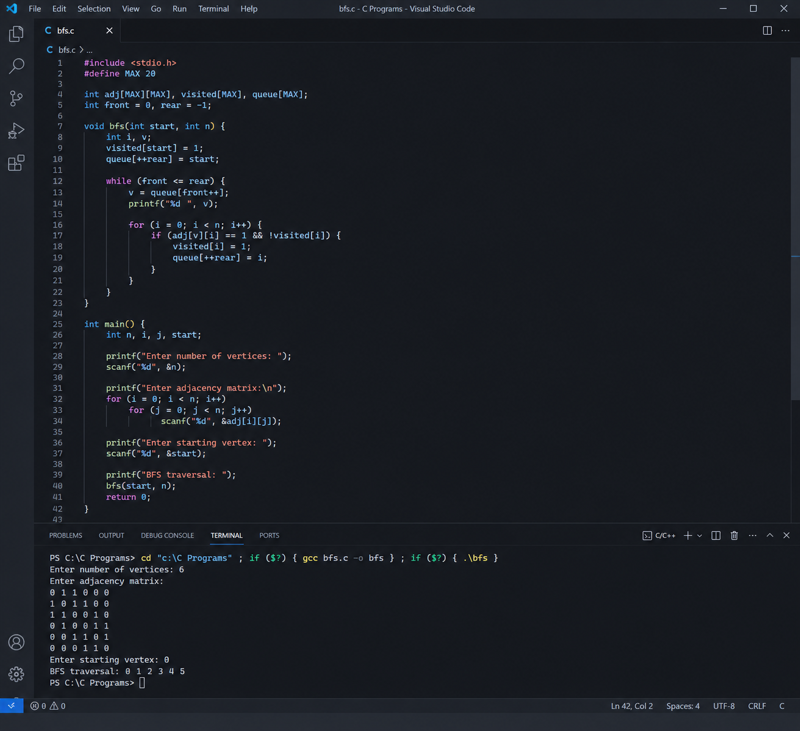
Conclusion
The Breadth First Search algorithm was successfully implemented in C using a queue. The graph was traversed level by level from the selected starting vertex, and the BFS traversal was displayed successfully.

