

Name : DUBEY NITIN SANJAY KUMAR Roll no.: A-32 Batch: AS2

Class : Second Year (SY) 2026-27 Department : Information Technology

Course code: ITXS37 Subject: DSA

Experiment No:1

Aim: Experiment No. 01 (Implementation of Stack using Array )

Program:

#include <stdio.h>
#include <stdlib.h>

#define MAX 10

int stack[MAX];
int top = -1;

int isFull() {
return top == MAX - 1;
}
int isEmpty() {
return top == -1;
}
void push(int temp) {
if (isFull()) {
printf("Stack Overflow! Cannot push more alerts.\n");
return;
}
stack[++top] = temp;
printf("Pushed temperature %dC \n", temp);
}
int pop() {
if (isEmpty()) {
printf("Stack is empty! \n");
return -1;
}
return stack[top--];
}
void clearAllAlerts() {
if (isEmpty()) {
printf("No active alerts to clear.\n");
return;
}
printf("Temperature normalized :\n");
while (!isEmpty()) {
int temp = pop();
printf(" %dC\n", temp);
}
printf("Stack is now empty.\n");
}
void display() {
if (isEmpty()) {
printf("Stack : [ EMPTY ]\n");
return;
}
printf("Stack active alerts: ");
for (int i = top; i >= 0; i--) {
printf("%d ", stack[i]);
}
printf("\n");
}

void checkTemperature(int temp) {
printf("Current Temperature: %dC\n", temp);

if (temp >= 45) {
push(temp);
printf("ALERT: Red Alert!! Extreme Heatwave Danger.\n");
}
else if (temp >= 43) {
push(temp);
printf("ALERT: Orange Alert! Severe Heatwave Warning.\n");
}
else if (temp >= 40) {
push(temp);
printf("ALERT: Yellow Alert. Heatwave Watch.\n");
}
else {
clearAllAlerts();
}

display();
}

int main() {
int n, temp;

printf("Heatwave Alert Prediction System \n");
printf("Enter number of temperature readings to process: ");
scanf("%d", &n);

for (int i = 0; i < n; i++) {
printf("\nEnter temperature reading(C): ");
scanf("%d", &temp);
checkTemperature(temp);
}

printf("Final stack status:\n");
display();

return 0;
}

Outcome:

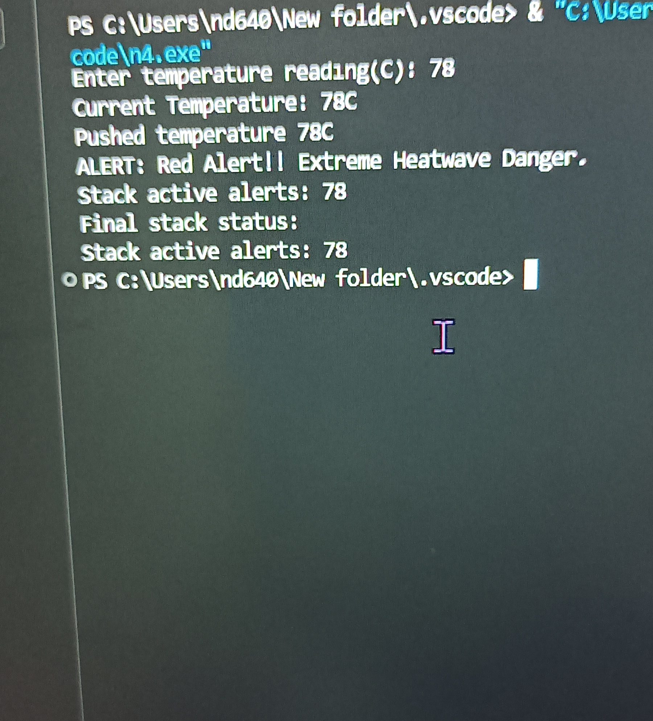

Conclusion: SUCESSFULLY EXCUTED THE STACK USING STRING



