Name : DUBEY NITIN SANJAY KUMAR Roll no.: ______ Batch: ______

Class : Second Year (SY) 2026-27 Department : Information Technology

Course code: ITXS37 Subject: DSA

Experiment No: 2

Aim: Implementation of Queue using Array (Heatwave Alert System)

Program:

#include <stdio.h>

#define MAX 5

int queue[MAX];
int front = -1;
int rear = -1;
void enqueue(int temp, char alert[])
{
if (rear == MAX - 1)
{
printf("Queue is full, cannot add more alerts\n");
}
else
{
if (front == -1)
{
front = 0;
}
rear = rear + 1;
queue[rear] = temp;
printf("Alert Added : %s (Temperature = %d)\n", alert, temp);
}
}
void dequeue()
{
if (front == -1 || front > rear)
{
printf("Queue is empty, no alert to remove\n");
front = -1;
rear = -1;
}
else
{
printf("Removing Alert for Temperature = %d\n", queue[front]);
front = front + 1;
}
}
void clearAllAlerts()
{
printf("Temperature is normal now. Removing all active alerts...\n");
while (front != -1 && front <= rear)
{
dequeue();
}
front = -1;
rear = -1;
printf("All alerts cleared.\n");
}

void display()
{
int i;
if (front == -1 || front > rear)
{
printf("No active alerts\n");
}
else
{
printf("Active Alerts in Queue : ");
for (i = front; i <= rear; i++)
{
printf("%d ", queue[i]);
}
printf("\n");
}
}

int main()
{
int temp;
int choice;

do
{
printf("\n----- Heatwave Alert Menu -----\n");
printf("1. Enter today's temperature\n");
printf("2. Display active alerts\n");
printf("3. Exit\n");
printf("Enter your choice : ");
scanf("%d", &choice);

if (choice == 1)
{
printf("Enter temperature : ");
scanf("%d", &temp);

if (temp >= 45)
{
enqueue(temp, "Red Alert");
}
else if (temp >= 43)
{
enqueue(temp, "Orange Alert");
}
else if (temp >= 40)
{
enqueue(temp, "Yellow Alert");
}
else
{
clearAllAlerts();
}
}
else if (choice == 2)
{
display();
}
else if (choice == 3)
{
printf("Exiting program...\n");
}
else
{
printf("Wrong choice, try again\n");
}

} while (choice != 3);

return 0;
}

Outcome:

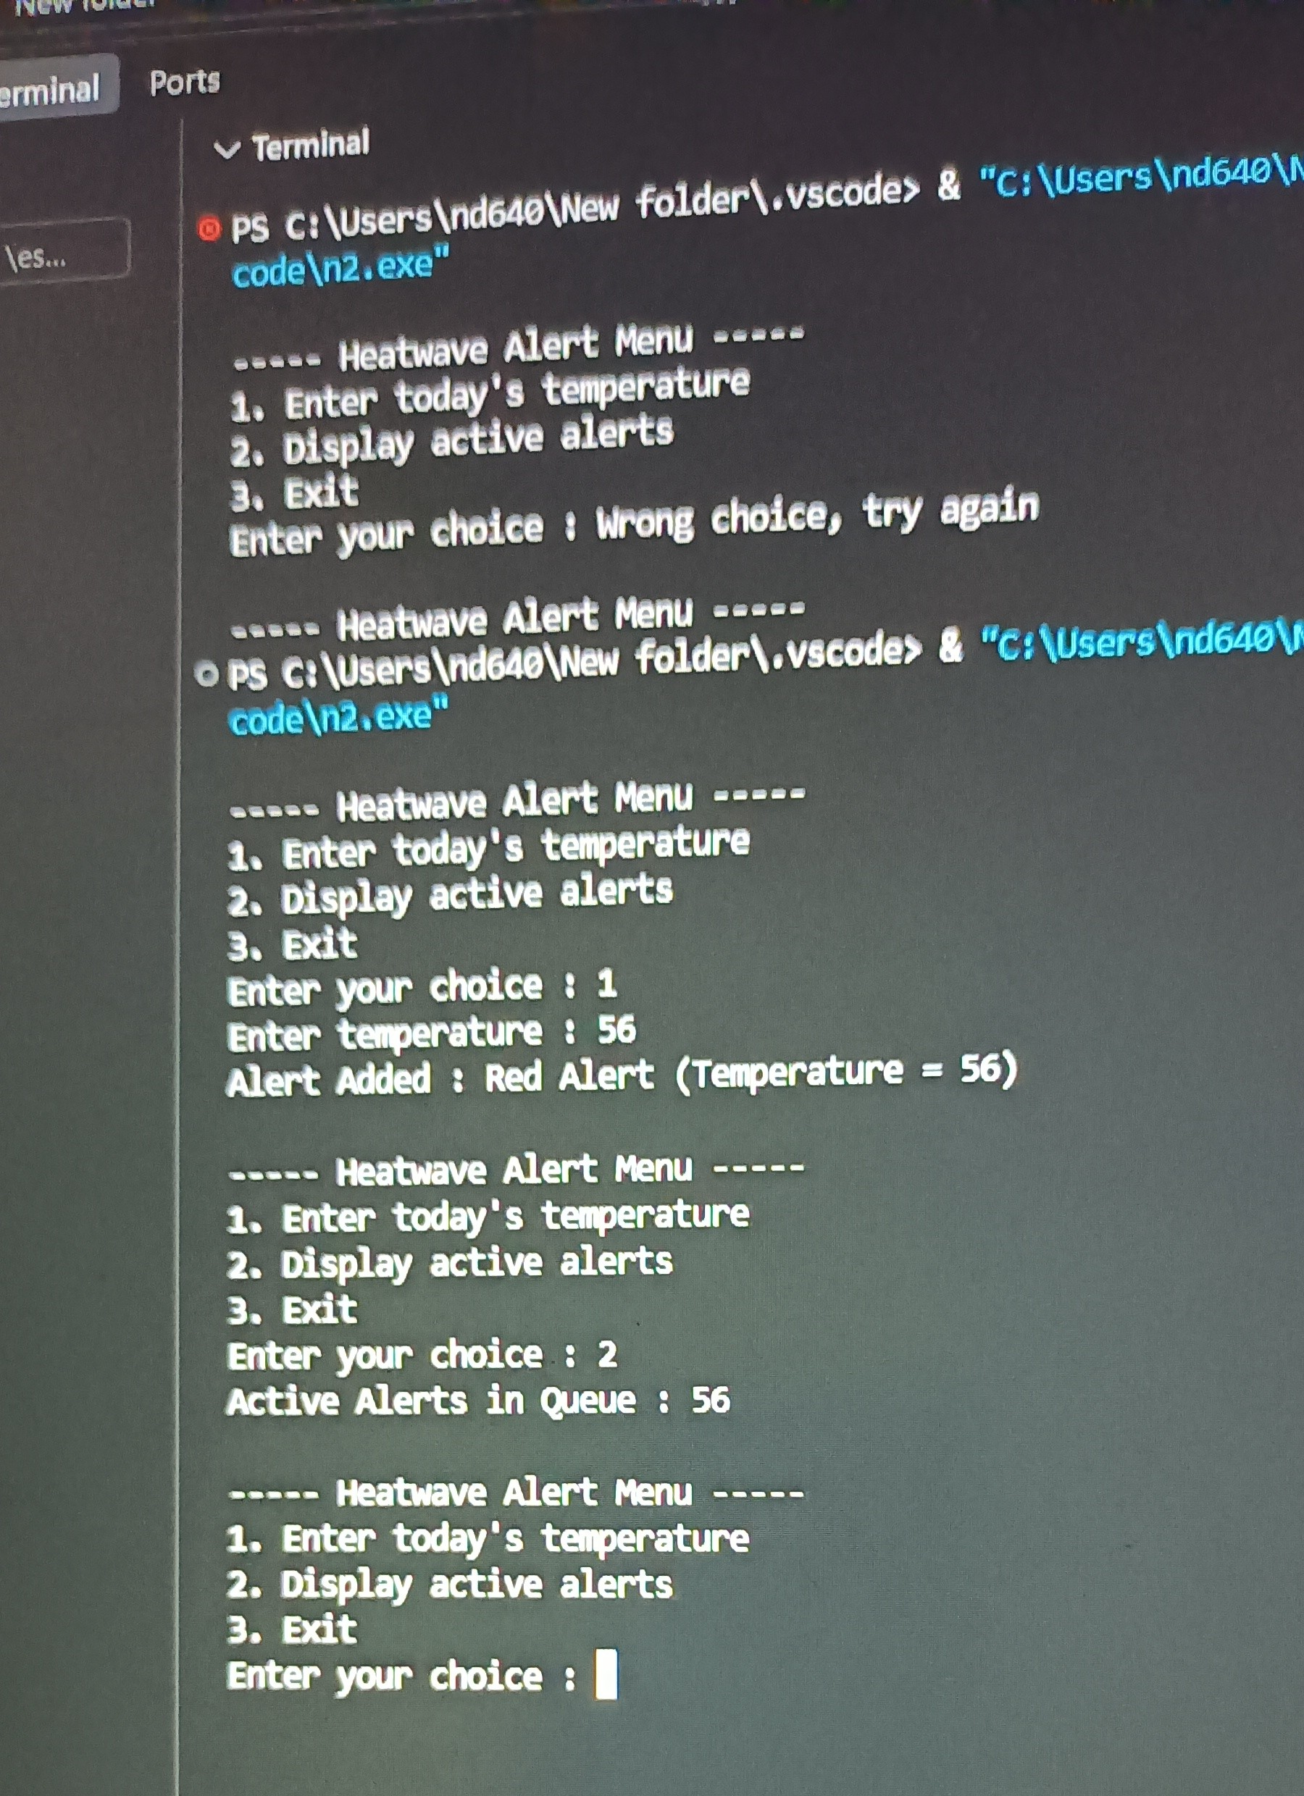

Conclusion: SUCCESSFULLY EXECUTED THE HEATWAVE ALERT SYSTEM USING QUEUE

