NITIN Dubey
AS2 Batch
IT Department
Experiment: Binary Search Tree – Inorder Traversal

AIM
To implement a Binary Search Tree (BST) using dynamic memory allocation and perform insertion of elements followed by inorder traversal.
OPERATIONS PERFORMED
- Create a new BST node using dynamic memory allocation.
- Insert elements into the Binary Search Tree according to BST rules.
- Traverse the BST using inorder traversal.
- Display the elements in sorted order.
PROGRAM
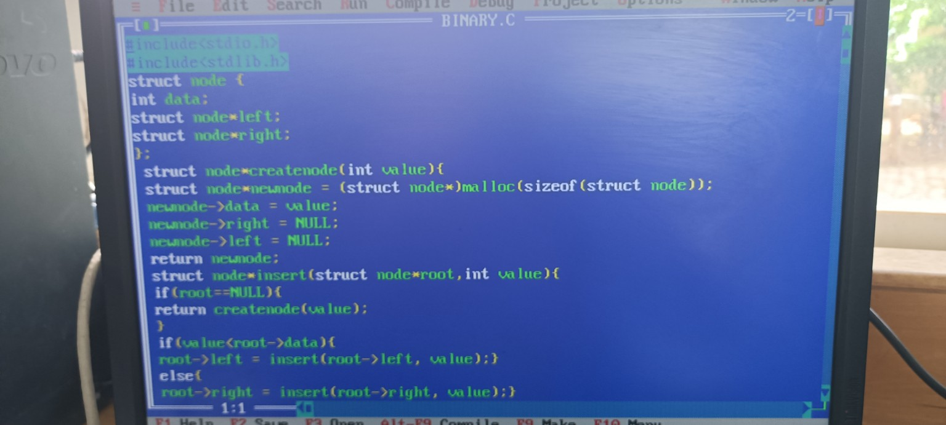

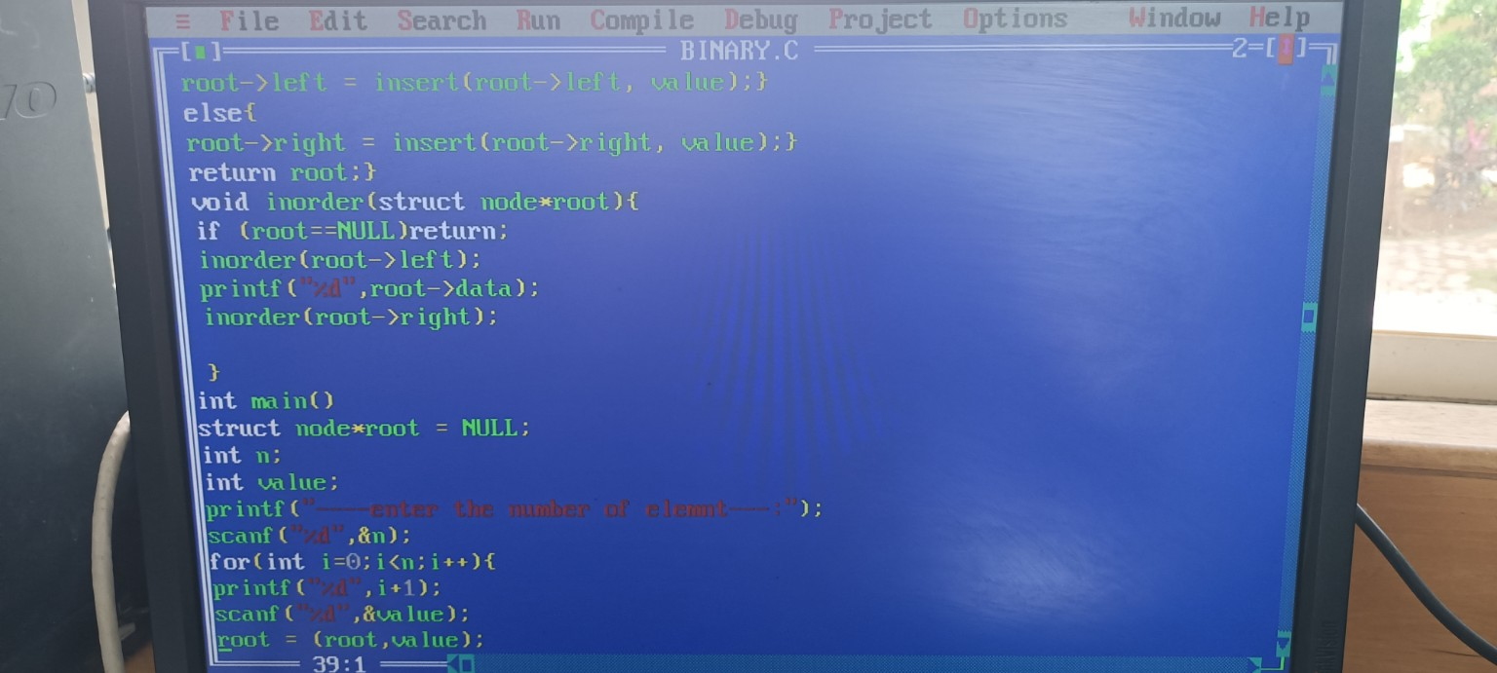

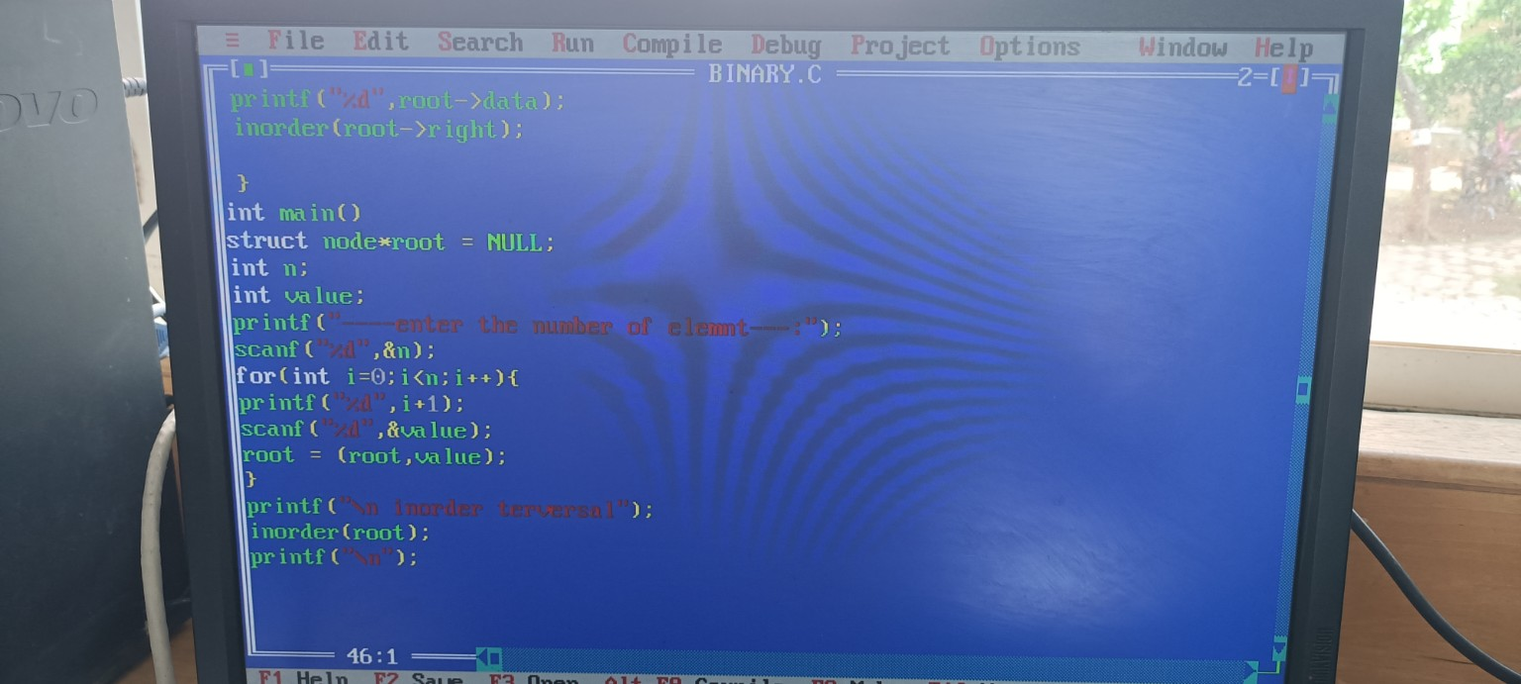

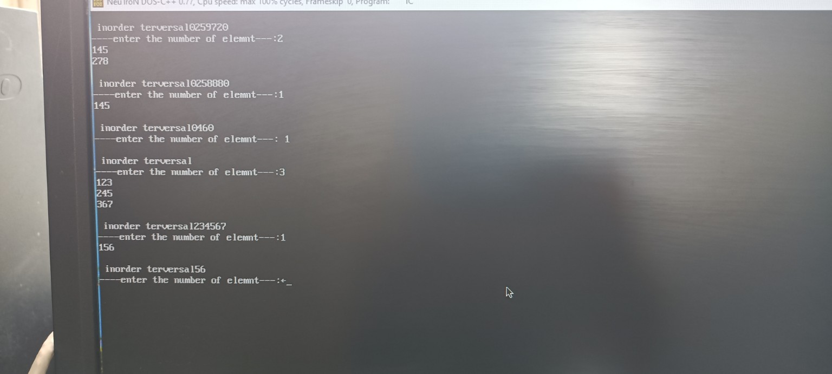

SAMPLE OUTPUT
inorder traversal
enter the number of element---: 3
123
245
367

Inorder traversal output: 123 245 367

The program performs inorder traversal of the Binary Search Tree,
which displays the stored elements in ascending order.
CONCLUSION
The Binary Search Tree operations were successfully performed. The elements were inserted into the BST and inorder traversal was carried out successfully. The traversal displayed the elements in sorted (ascending) order.

