

Name : DUBEY NITIN SANJAY KUMAR Roll no.: A-32 Batch: AS2

Class : Second Year (SY) 2026-27 Department : Information Technology

Course code: ITXS37 Subject: DSA

Experiment No:4

Aim: Experiment No. 04 (Implementation double ended queue using Array )

Program:
#include <stdio.h>

#define MAX 5

int deque[MAX];
int front = -1;
int rear = -1;

int isFull() {
return ((front == 0 && rear == MAX - 1) || (front == rear + 1));
}

int isEmpty() {
return (front == -1);
}

void insertFront(int value) {
if (isFull()) {
printf("Deque Overflow! Cannot insert %d at front.\n", value);
return;
}
if (front == -1) { /* Empty deque */
front = rear = 0;
} else if (front == 0) {
front = MAX - 1; /* Wrap around */
} else {
front = front - 1;
}
deque[front] = value;
printf("Inserted %d at FRONT.\n", value);
}

void insertRear(int value) {
if (isFull()) {
printf("Deque Overflow! Cannot insert %d at rear.\n", value);
return;
}
if (front == -1) { /* Empty deque */
front = rear = 0;
} else if (rear == MAX - 1) {
rear = 0; /* Wrap around */
} else {
rear = rear + 1;
}
deque[rear] = value;
printf("Inserted %d at REAR.\n", value);
}

void deleteFront() {
if (isEmpty()) {
printf("Deque Underflow! Cannot delete from front.\n");
return;
}
printf("Deleted %d from FRONT.\n", deque[front]);
if (front == rear) { /* Only one element */
front = rear = -1;
} else if (front == MAX - 1) {
front = 0; /* Wrap around */
} else {
front = front + 1;
}
}

void deleteRear() {
if (isEmpty()) {
printf("Deque Underflow! Cannot delete from rear.\n");
return;
}
printf("Deleted %d from REAR.\n", deque[rear]);
if (front == rear) { /* Only one element */
front = rear = -1;
} else if (rear == 0) {
rear = MAX - 1; /* Wrap around */
} else {
rear = rear - 1;
}
}

void display() {
if (isEmpty()) {
printf("Deque is empty.\n");
return;
}
printf("Deque elements: ");
int i = front;
while (1) {
printf("%d ", deque[i]);
if (i == rear)
break;
i = (i + 1) % MAX;
}
printf("\n");
}

int main() {
int choice, value;

while (1) {
printf("\n----- Deque Menu -----\n");
printf("1. Insert at Front\n");
printf("2. Insert at Rear\n");
printf("3. Delete from Front\n");
printf("4. Delete from Rear\n");
printf("5. Display\n");
printf("6. Exit\n");
printf("Enter your choice: ");
scanf("%d", &choice);

switch (choice) {
case 1:
printf("Enter value: ");
scanf("%d", &value);
insertFront(value);
break;
case 2:
printf("Enter value: ");
scanf("%d", &value);
insertRear(value);
break;
case 3:
deleteFront();
break;
case 4:
deleteRear();
break;
case 5:
display();
break;
case 6:
printf("Exiting...\n");
return 0;
default:
printf("Invalid choice! Try again.\n");
}
}
return 0;
}

Outcome:

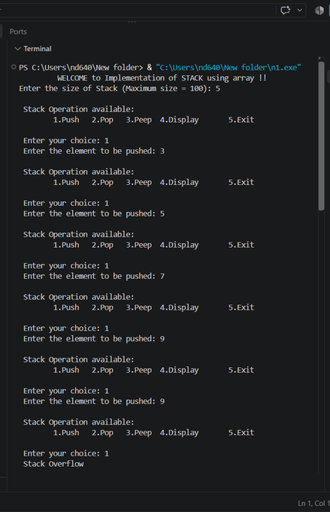

Conclusion: SUCESSFULLY EXCUTED THE DEQUEUE USING STRING

