https://leetcode.com/discuss/interview-question/442377/Maximum-of-Minimum-Values-II/397715

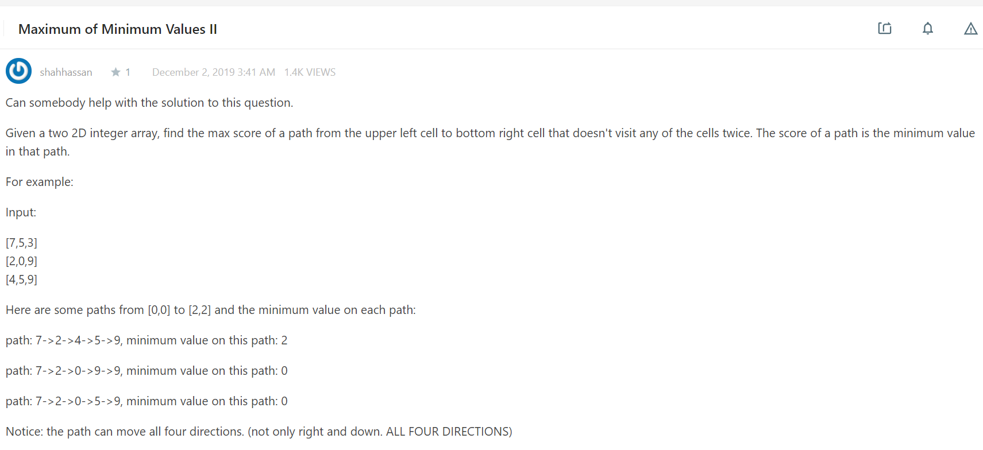

public static void main(String[] args) {

int[][] grid1 = {{1, 7}, {5, 3}};

int[][] grid2 = {{1,2,3}, {7,8,9}, {4,5,6}};

int[][] grid3 = {{7,5,3}, {2,0,9}, {4,5,9}};

System.out.println(getMinMax(grid1));

System.out.println(getMinMax(grid2));

System.out.println(getMinMax(grid3));

}

private static int getMinMax(int[][] grid) {

int[][] dp = new int[grid.length][grid[0].length];

for(int i = 0; i < dp.length; i++) {

for(int j = 0; j < dp[i].length; j++) {

if(i == 0 && j == 0) {

dp[i][j] = grid[i][j];

continue;

}

int top = i > 0 ? dp[i - 1][j] : Integer.MIN_VALUE;

int left = j > 0 ? dp[i][j - 1] : Integer.MIN_VALUE;

dp[i][j] = Math.max(Math.min(top, grid[i][j]), Math.min(left, grid[i][j]));

}

}

return dp[dp.length - 1][dp[0].length - 1];

}