https://aonecode.com/amazon-online-assessment-questions#dl

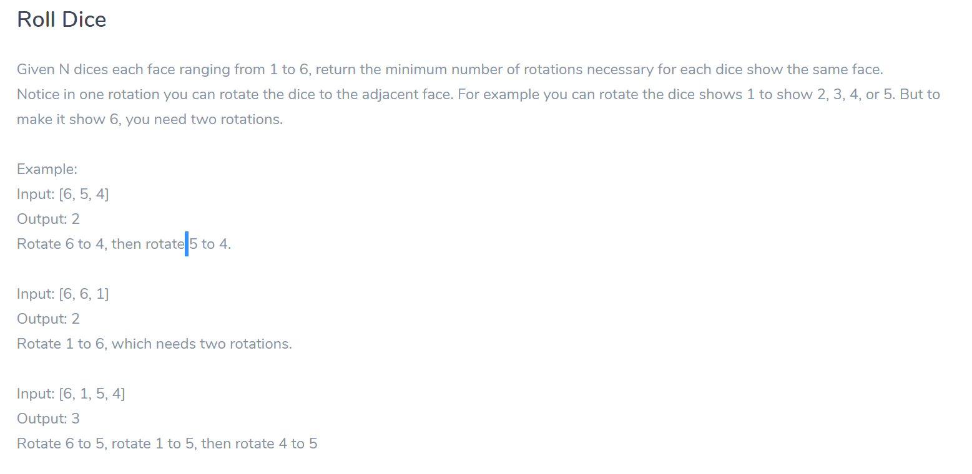

import java.util.\*;

public class DiceProblem {

public static void main(String args[]){

int[] A = {3,4,1,2,4,2,3,5,1,2,3,4,6,2,4,1,5,2};

Map<Integer, Integer> countMap = new HashMap<>();

int rotation = 0;

int diceCount;

int maxDiceNumber = A[0];

int OppositeOfMaxDiceNumber;

int max = 1;

for(int i = 1; i <= 6 ; i++){

diceCount = 0;

for (int value : A) {

if(i == value){

diceCount++;

}

}

countMap.put(i, diceCount);

if(diceCount > max){

max = diceCount;

maxDiceNumber = i;

}

}

if(max == 1){

if(countMap.get(1).equals(countMap.get(6)) && countMap.get(1) != 0 && countMap.get(2) != 0){

maxDiceNumber = 2;

}else if(countMap.get(2).equals(countMap.get(5)) && countMap.get(2) != 0 && countMap.get(3) != 0){

maxDiceNumber = 3;

}else if(countMap.get(3).equals(countMap.get(4)) && countMap.get(1) != 0){

maxDiceNumber = 1;

}else if(countMap.get(2) != 0){

maxDiceNumber = 2;

}else if(countMap.get(5) != 0){

maxDiceNumber = 5;

}else if(countMap.get(6) != 0){

maxDiceNumber = 6;

}

}

System.out.println("Max Dice Number: "+ maxDiceNumber);

OppositeOfMaxDiceNumber = createOpposite(maxDiceNumber);

System.out.println("Opposite Dice Number: "+ OppositeOfMaxDiceNumber);

Iterator it2 = countMap.entrySet().iterator();

while (it2.hasNext()) {

Map.Entry pair = (Map.Entry)it2.next();

System.out.println(pair.getKey() + " = " + pair.getValue());

if((int)(pair.getValue()) > 0 && (int)(pair.getKey()) != maxDiceNumber){

if((int)(pair.getKey()) == OppositeOfMaxDiceNumber){

rotation = rotation + (2 \* (int)(pair.getValue()));

}else {

rotation = rotation + ((int)(pair.getValue()));

}

}

it2.remove(); // avoids a ConcurrentModificationException

}

System.out.println("Number of Minimum Rotations: "+ rotation);

}

private static int createOpposite(int key){

switch (key) {

case 1:

return 6;

case 2:

return 5;

case 3:

return 4;

case 4:

return 3;

case 5:

return 2;

case 6:

return 1;

}

return 0;

}}