TestCases:

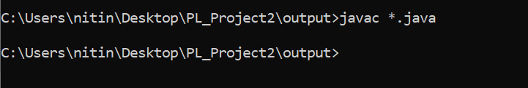

All java files are compiled successfully.

**Let Val:**

let val x=6 in let fun f(x)=3 in x end end;

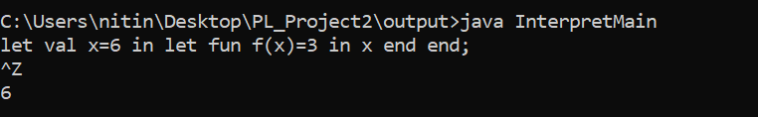

**Let Fun:**

let fun add(x) = x + x in add(2) end;

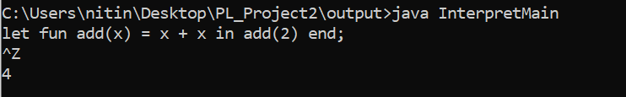

**SeqExp:**

{1+2;3+5*6+7};

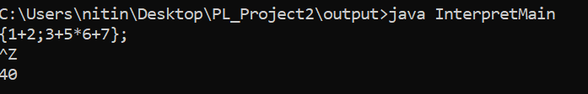

**IfExp:**

if 1<2 then true else false;

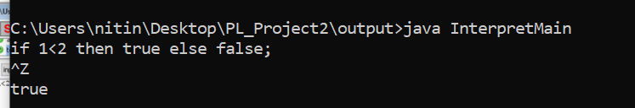

**While Exp:**

let fun f(x) = ( while x = 1 do x := x- 1 ) in f(1) end;

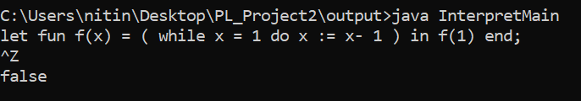

**Not Exp:**

!false;

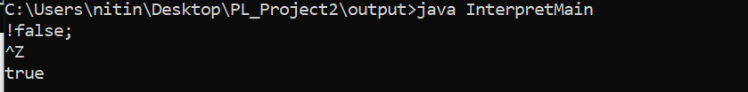

**Unbound Exception:**

n=2+2;

