HPA
is a built-in Kubernetes controller that automatically adjusts the number of Pod replicas in a Deployment, ReplicaSet, or StatefulSet based on observed resource utilization.
horizontally (adding or removing Pods) to handle traffic spikes efficiently while saving costs when demand is low.
HPA runs as a continuous control loop (by default, checking metrics every 15 seconds) within the Kubernetes Controller Manager
[ Metrics Server / Prometheus ]
│ (Polls every 15s)
▼
[ HPA Controller ] ──(Calculates ratio)──► [ Target Deployment ] ──► (Scales Pods Up/Down)

Resource Metrics: Standard system resources like CPU and Memory utilization. [1, 2]
Internal application metrics exposed from within the cluster (e.g., HTTP requests per second or response latency)
External Metrics: Metrics from systems outside the cluster (e.g., AWS SQS queue depth or GCP Pub/Sub messages). [1, 2]
Autoscaled deployment screenshot
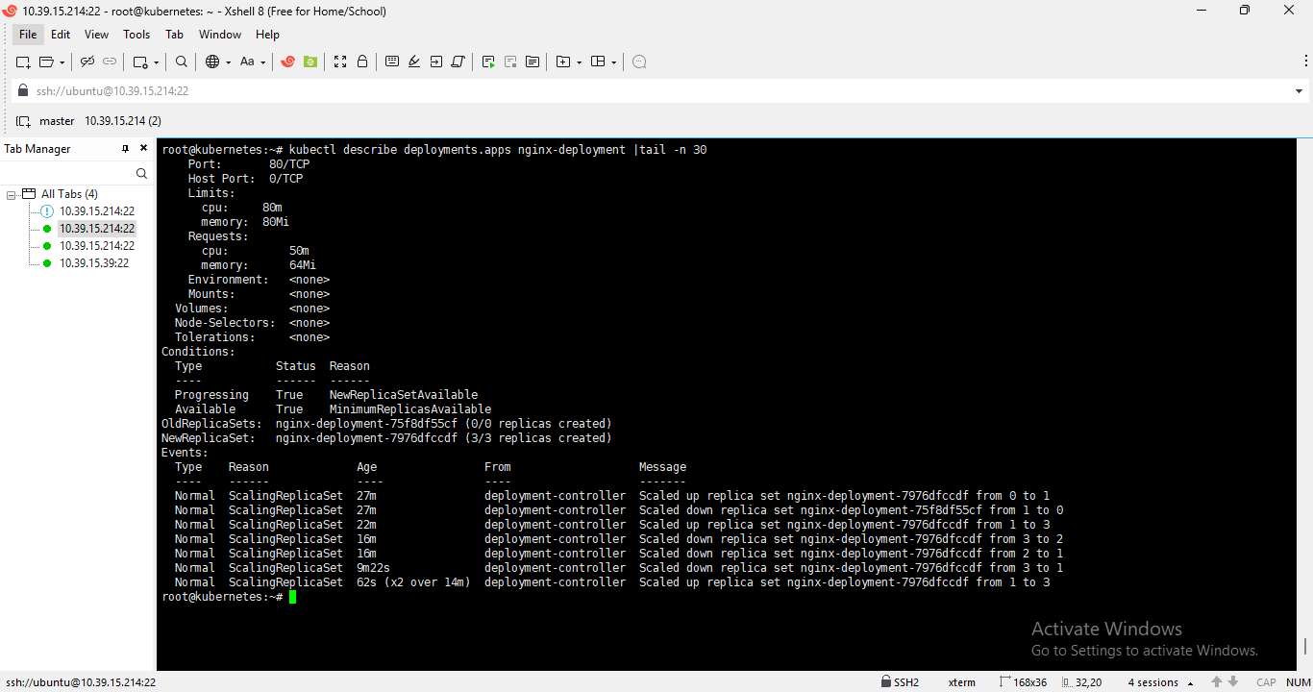

Nginx main deployment yaml
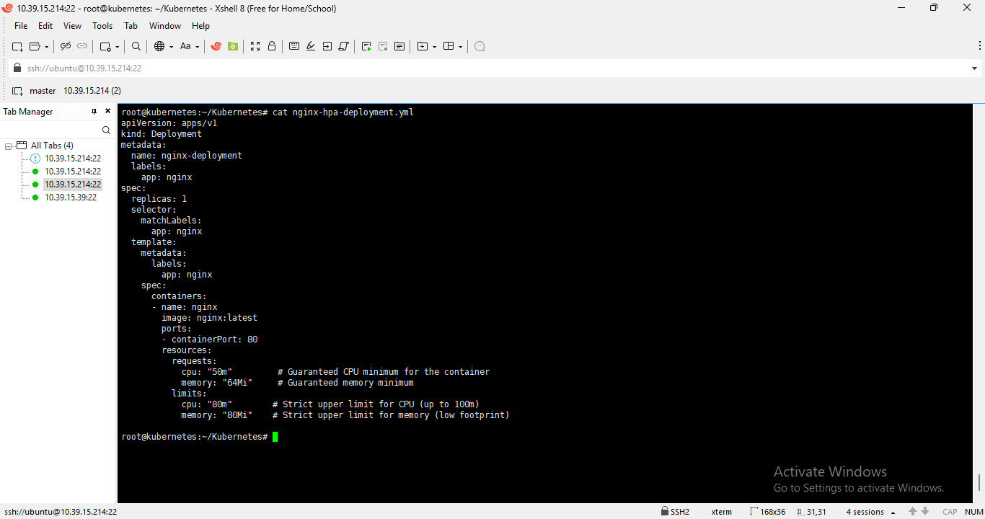

HPA yaml file
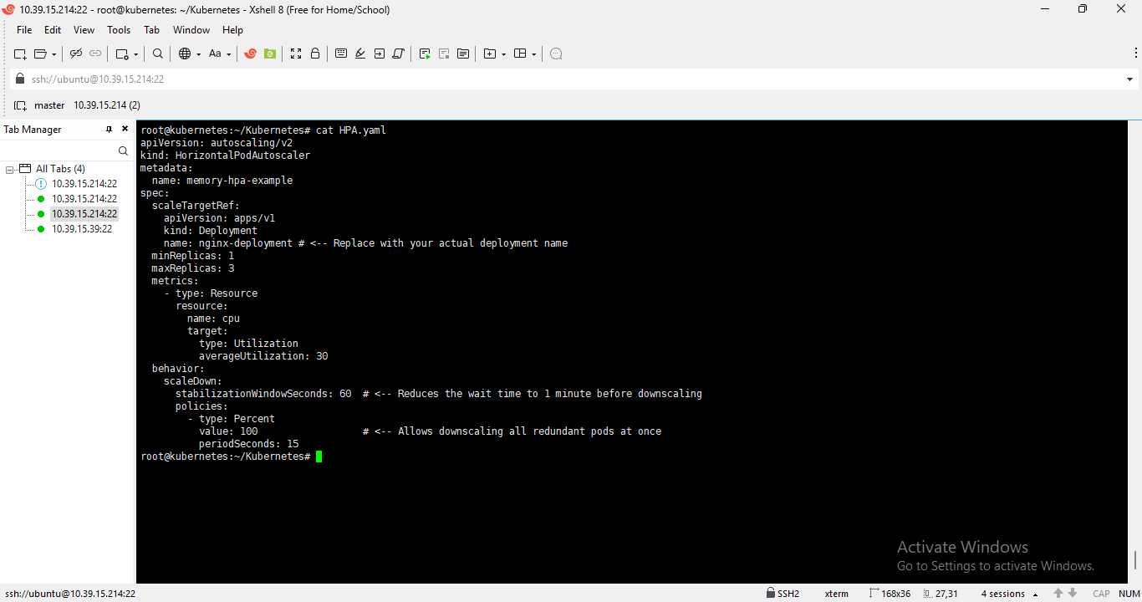

Run the yes command to put load on cpu of first pod of nginx-deployment
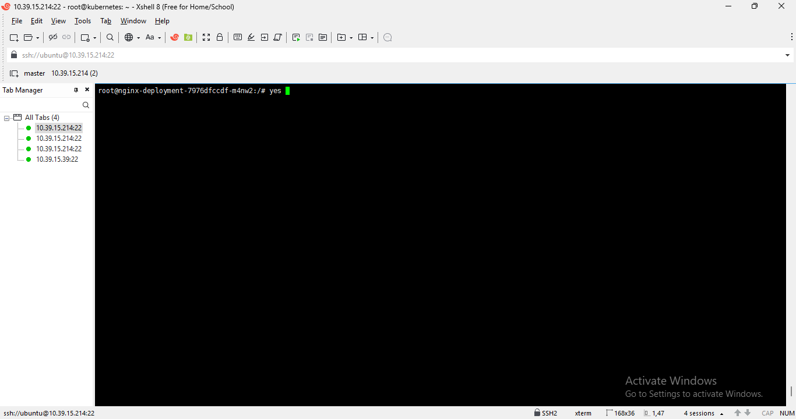

Metrics server will monitor the load on cpu and memory
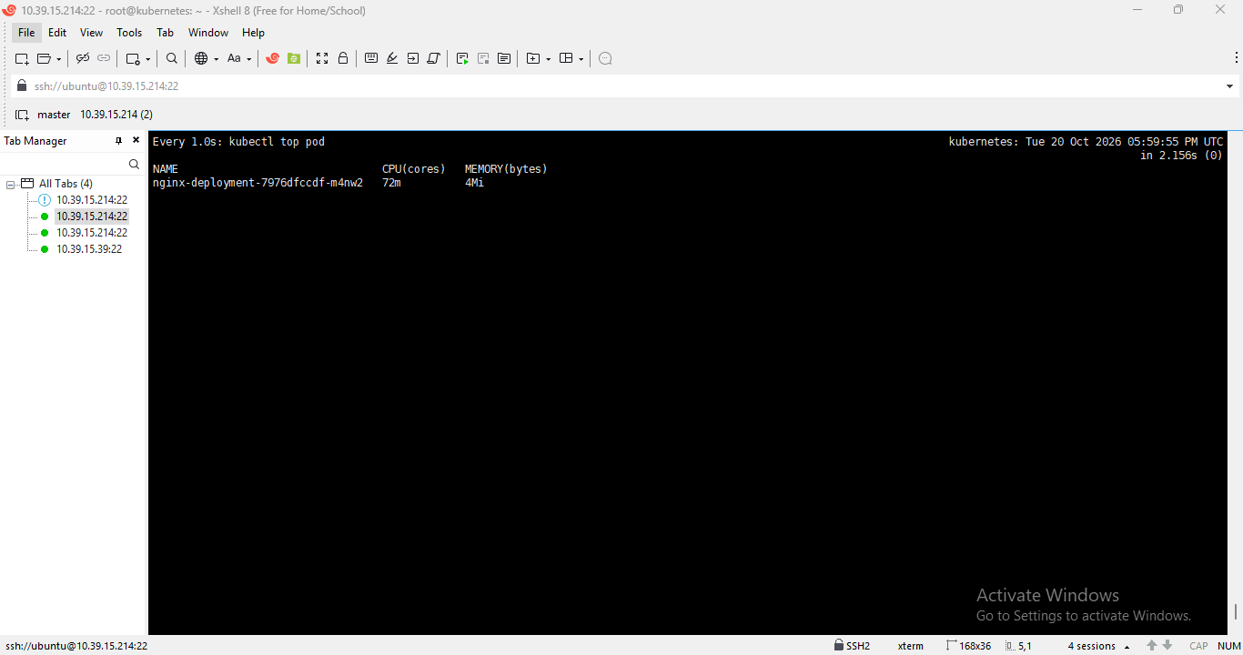
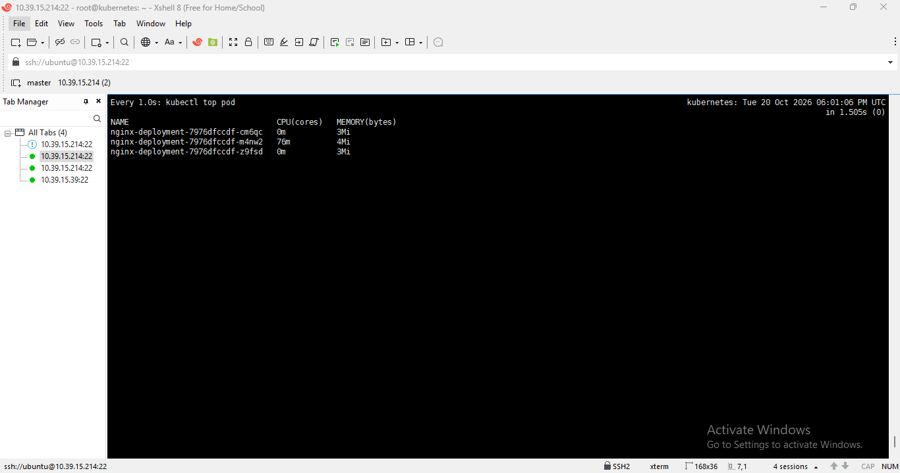
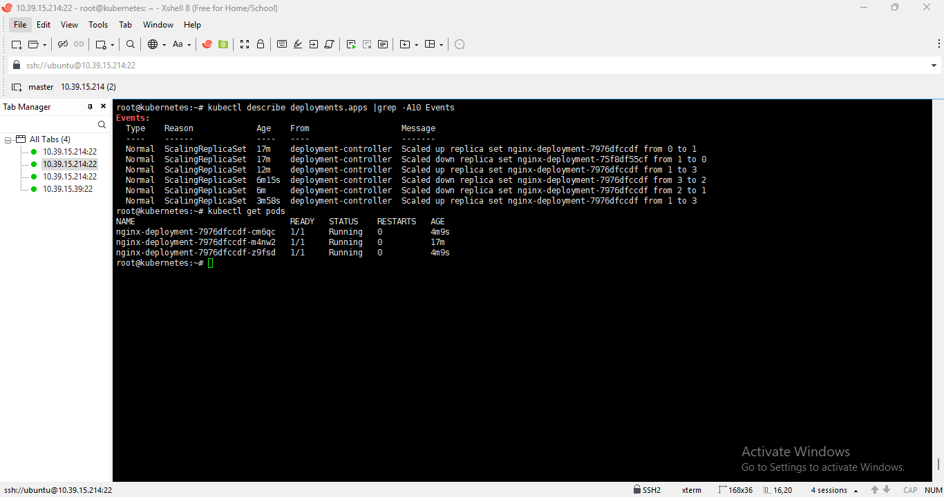
When we stopped the yes commad on the pod ,deployments pods will get automatically downscaled to 1 as we had mentioned value:100 means totally delete pod when threshold is within specified resource limit ie. Cpu is within limit ,so behaviours parameters from HPA.yaml work for downscale of deployments.
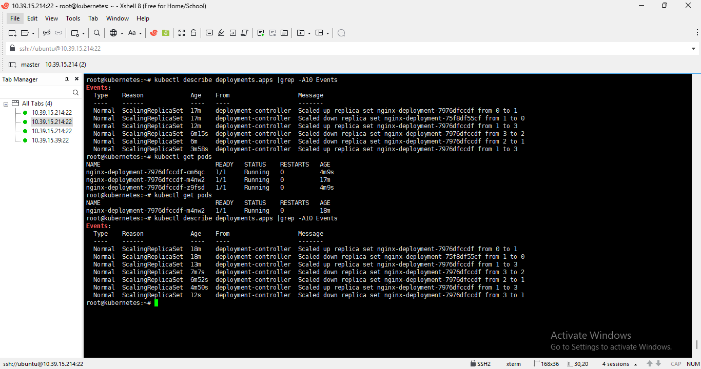
Kubelet agent will check monitor pods and will update to controller manager for desired state and the controller manger will forward updates to Scheduler ,kubelet agent will schedule new pods as per the updates and deleted as per the thresholds are within limits in yaml files.

