Simulation in Arena- Final Project

A Simulation Study of Operations at Great Clips 213 Calhoun St, Cincinnati, OH 45219

Submitted By:

Nitin Sharma

M12383432

Submitter to:

Dr. W. David Kelton

Professor

University of Cincinnati

Abstract

The aim of the project is to understand and simulate operations at Great Clips, find any performance issues and suggest solutions

1. **INTRODUCTION**

Great Clips is a barber shop located at 213 Calhoun St, Cincinnati. This project aims to provide a simulation of operations and services at great clips and assess performance measures like average and maximum customer waiting time, customer balking and reneging as well as resource utilization. Project also deals with cost accounting of balking and reneging customers and tries to find a better solution.

1. **OVERVIEW OF MODEL STRUCTURE AND ASSUMPTIONS**

Just like any other business, Great Clips has its share of complexity. Although model tries to replicate as many features and processes as feasible, many of the processes are simplified. Below are few points briefing general overview of this simulation:

1. Data is collected for a single day and replications are done for same day. A total of 100 replications are done for the statistical analysis.
2. There are four regular resources at great clips (names are Mariah, Sarah, Cherry and James). Mariah also acts as manager.
3. Although there are online as well as walk-in customers, it doesn’t serve any objective of this model as they are treated same. For this reason, I have clubbed them together as “customer”.
4. As generally happens in barber shops or many other queues, some customers may choose to leave without service either at time of entering (by assessing queue length) or after some time(depending on total time waited - reneging). Both scenarios are included and are used to calculate revenue.
5. About 90% of customers get only haircut done, the second most frequent service is Styling which gets 7% customers. Rest of the services are clubbed into “Others”. The price for haircut is $14, styling $45 and Other is average of remaining all which is around $15.
6. Although Mariah works for 10 hours a day, I have scheduled her for all 12 hours as receptionist as well as all other services because balking and reneging logic (block panel- seize module) does not accept sets but individual resource.
7. All time units are in minutes.
8. **DATA GATHERING AND DISTRIBUTION**
9. On a given day, footfall at great clips vary by time of day, mornings are relaxed while afternoons are busy. To most accurately simulate entity creation, I have used Nonstationary Poisson process. Below is the data for a typical day (Hourly data from 9 AM to 9PM)



**(Table 3.1)**

1. Service time for haircut is different for each resource. Distribution is fitted based on collected data for each resource.
2. **Mariah : TRIA(7.5,10,14.5)**

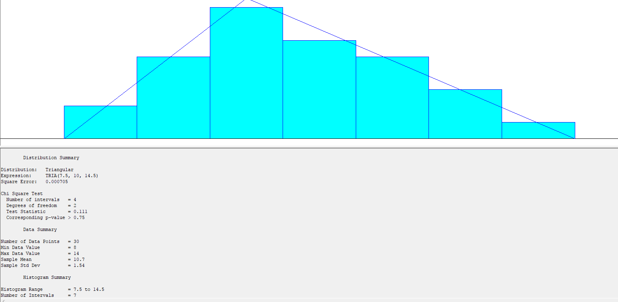

**Figure(3.1)**

1. **Sarah : TRIA(9.5,17,20.5)**

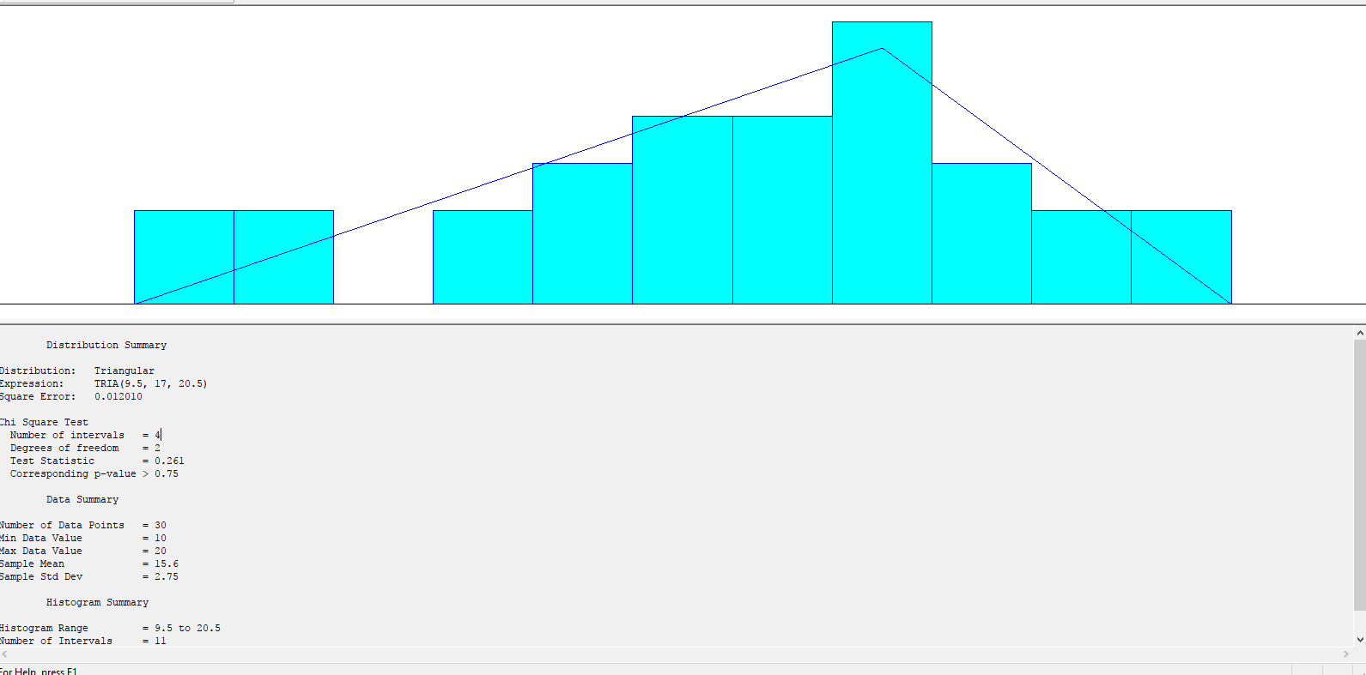

**Figure(3.2)**

1. **Cherry: 11.5+WEIB(4.94,2.15)**

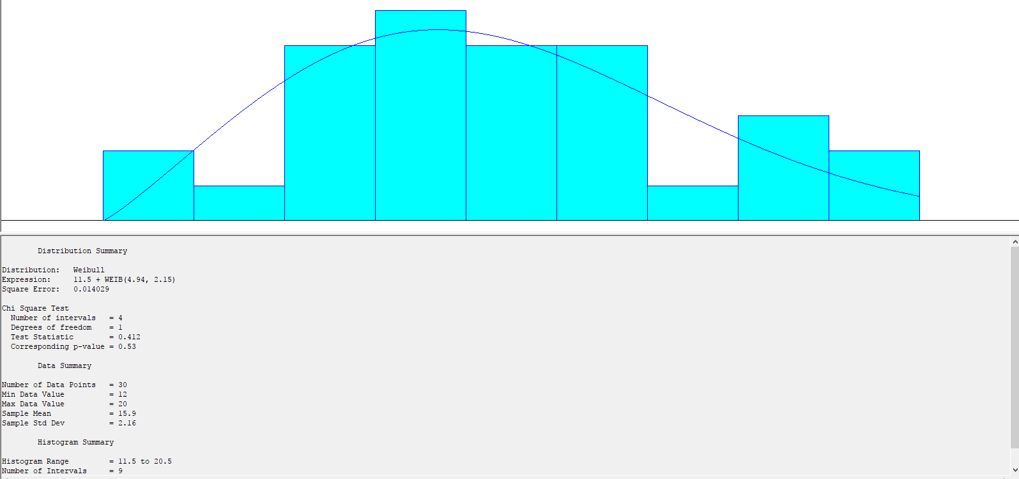

**Figure(3.3)**

1. **James: 15.5+12*BETA(1.09,1.27)**

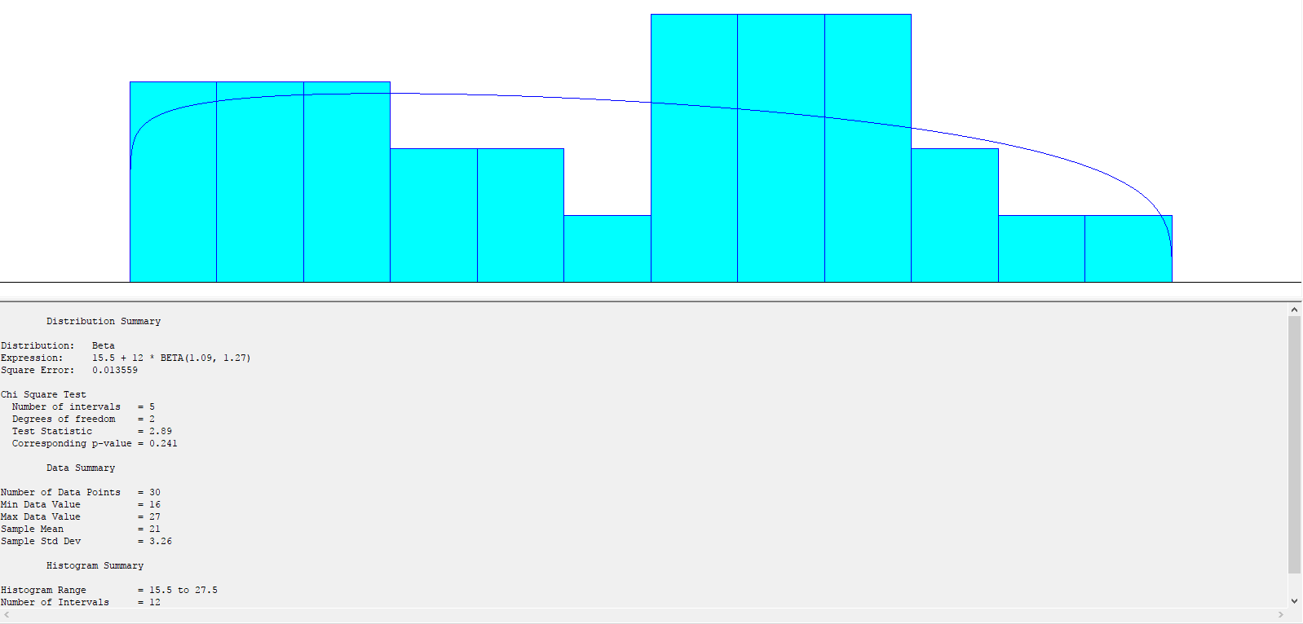

**Figure(3.4)**

1. **Identical distribution is used for all the resources for below services**

**Styling :** UNIF( 25, 40)

**Other:** UNIF(15,25)

**Billing:** UNIF(1,2)

**Reception:** TRIA(.25,.75,1) (Only Mariah)

1. **DESCRIPTION OF KEY MODULES**

An overview of the design is given below.

Entities (customers) are created using nonstationary Poisson process. A record module is used to count the number of customers entering the shop. Record module is followed by an assign module where many attributes and variables are assigned to the entity which are mainly used in balking and reneging logic and recording time in the system.

A set of modules and logics are used to dispose customers which are intolerant to queue length and/or waiting time. The Orange block area covers this logic (Balking and Reneging).

Once customers reach at reception, they release resource and also increment TotalWIP variable which tracks count of customers in system (later used to terminate simulation and flush out all the customers in line, after service).Next is a decide module which sends customers to different services depending on probability.

Since the service time for Haircut depends on the resource selected, below steps are taken to use service time based on resource. (Same process followed for other services too to make it uniform throughout but since there is no difference in service time for rest of the services, this doesn’t make any difference for now)

An expression is created to store service time in the same order as defined in set 1 Haircut(see figure 4.1). An attribute is created to save the position of the resource selected (see figure 4.2). A delay module uses delay time based on the position of resource selected from set 1 Haircut(see figure 4.3).

After service, same resource completes billing and then gets released by using Set Index defined in previous steps(see figure 4.4).

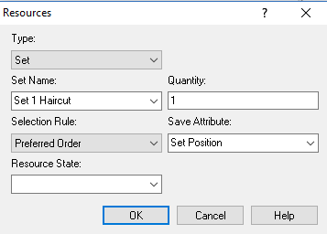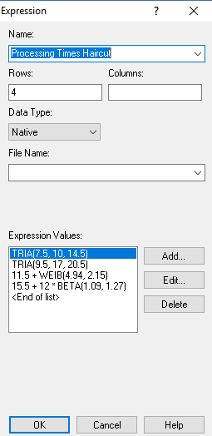

**Figure (4.1) Figure (4.2)**

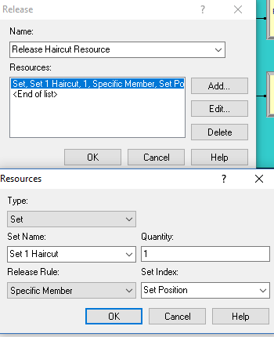

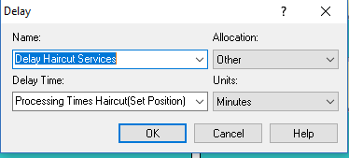

**Figure (4.3)**

**Figure (4.4)**

Customer count for each service is recorded as well as total time. Before leaving system, entity goes through an assign module where it Decrement TotalWIP variable. Entity exits after this step.

**Termination logic:** Great Clips runs from 9 AM to 9 PM. Any customer entering by 9 PM is entertained but no new customers are accepted. Cutoff logic is used to set “Entities per Arrival” to zero at time 720. **Termination condition: TNOW >= 720.0 && Total WIP == 0**

Priority for reception seize is set to 1 while other services priority is 2.

1. **Some output metrics from base scenario (scenario 1, 100 replications)**

**Instantaneous Utilization**

|  |  |
| --- | --- |
| **Resource Name** | **Instantaneous Utilization** |
| Mariah | 0.8911 |
| Sarah | 0.3841 |
| Cherry | 0.2508 |
| James | 0.5215 |

**Table (5.1)**

**Average Total Time in System – LoS**

|  |  |
| --- | --- |
| **Service type** | **Average waiting time** |
| Haircut | 36.86 Minutes |
| Styling | 55.10 Minutes |
| Other | 38.73 Minutes |

**Table (5.2)**

**Average Customer waiting time:**  19.83 minutes

**Maximum average customer waiting time:** 70.09 minutes

1. **Scenario Description**
   1. **Base scenario:** Compute revenue based on 100 replications.

Calculation of revenue.

|  |  |  |  |  |
| --- | --- | --- | --- | --- |
|  | Mariah | Sarah | Cherry | James |
| Hourly wages | 17 | 12 | 14 | 12 |
| Number of hours working | 12 | 6.5 | 6 | 8 |
| Total wages | 204 | 78 | 84 | 96 |
|  |  |  |  |  |

**Table (6.1)**

**Total wages** in base scenario : $462

**Opportunity cost:** Estimated opportunity cost for each customer who walks out without service is taken as $8

**Billing profit:** 14*NC(Total Haircut) + 45*NC(Total Styling)+15*NC(Total Other Services)

|  |  |  |  |
| --- | --- | --- | --- |
|  | Haircut | Styling | Other |
| Rates | 14 | 45 | 15 |

**Table (6.2)**

**Statistics:**

**Total Revenue =** 14*NC(Total Haircut) + 45*NC(Total Styling)+15*NC(Total Other Services)

-462 - 8*(NC(Renege Customers)+NC(Customer Balks))

**Percent Rejected** = 100 * (NC(Renege Customers)+NC(Customer Balks)) /NC(Count Customers Enter)

* 1. **Alternate Scenario:** In alternate scenario, to reduce reneging and balking, capacity of Mariah is increased by 1 and effect of this change on revenue is measured.

**Total wages** in alternate scenario : $462+$204 = $668

**Total Revenue =** 14*NC(Total Haircut) + 45*NC(Total Styling)+15*NC(Total Other Services)

-668 - 8*(NC(Renege Customers)+NC(Customer Balks))

**Percent Rejected** = 100 * (NC(Renege Customers)+NC(Customer Balks)) /NC(Count Customers Enter)

1. **Comparing Total Revenue and Percent Rejected using Output Analyzer**

Comparing both scenarios using output analyzer, we can see that there is difference in mean for total revenue as well as percent reject. Total Revenue increases in scenario 2 **( Figure (7.1) )** and Percent reject decreases in scenario 2 ( **Figure (7.2) )**. Reason for this change is, count of balking and reneging customers gets reduced which reduces penalty cost and increases revenue.

Mean Total Revenue in Scenario 1: $736(710,763)

Mean Total Revenue in Scenario 2: $820(789,850)

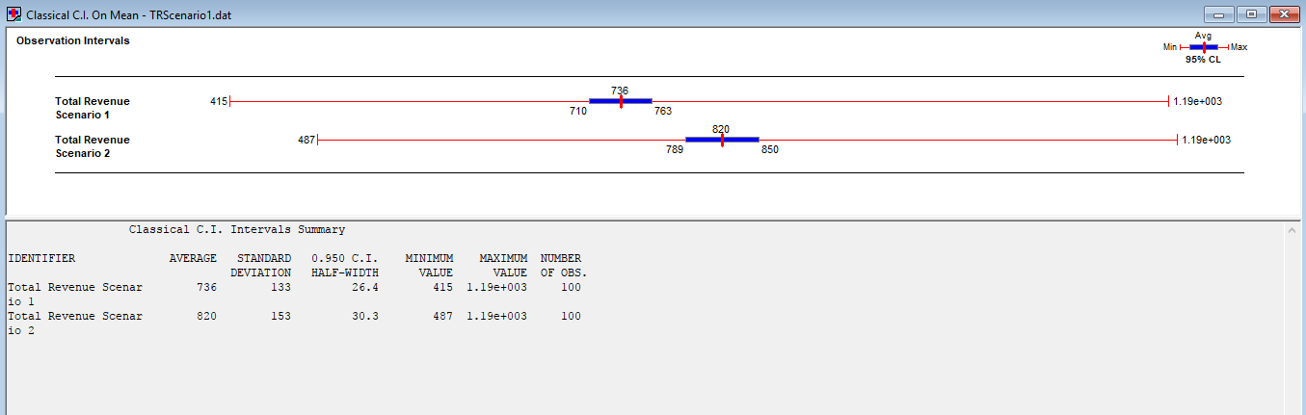

**Figure (7.1)**

Mean Percent rejected in Scenario 1: 20.5(19.6,21.5)

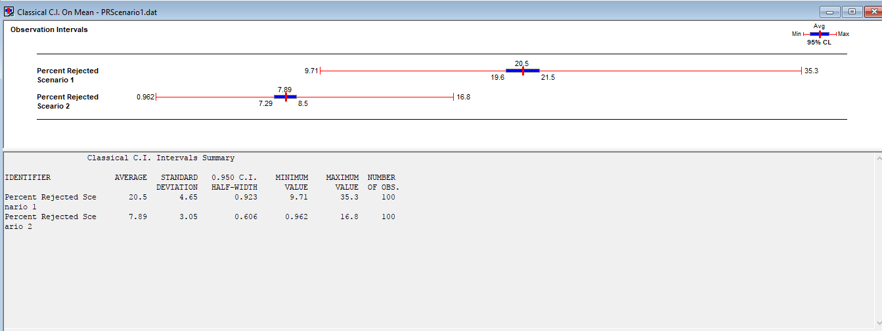Mean Percent rejected in Scenario 2: 7.89(7.29,8.5)

**Figure (7.2)**

1. **SUMMARY**

As we can see from the statistical analysis from output analyzer, **Scenario 2(Alternate Scenario)** works better in terms of increased revenue as well as reduced number of percent rejected customers. To implement this scenario, Great Clips needs to employ one more resource throughout the day(or two resources covering half day each) which in return will increase revenue as well as reduce percent rejected.

Another benefit of **scenario 2** is, it reduces average waiting time below 15 minutes for all types of queues(considering confidence interval, otherwise scenario 1 also shows average wait time below 15 minutes). Great Clips tries to achieve this metric everyday and this is their one of the top priorities. Scenario 2 helps achieving this metric more promisingly.

**Scenario 1**

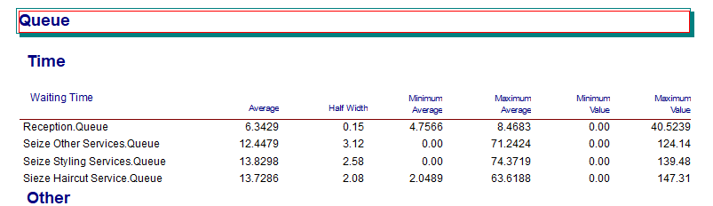

**Scenario 2 (Alternate Scenario)**

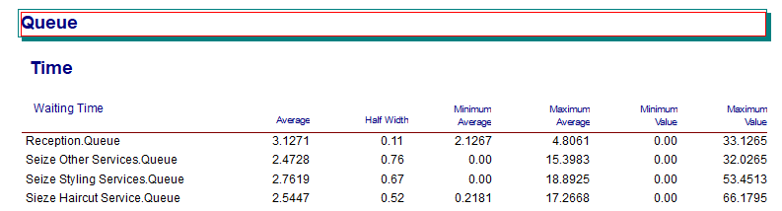

1. **CONCLUSION**

Based on 100 replication and statistical analysis, it is safe to say, adding one new resource helps increasing revenue. A more intense study can be done by comparing effect of shift change on revenue.

Below Is a picture of completed model.

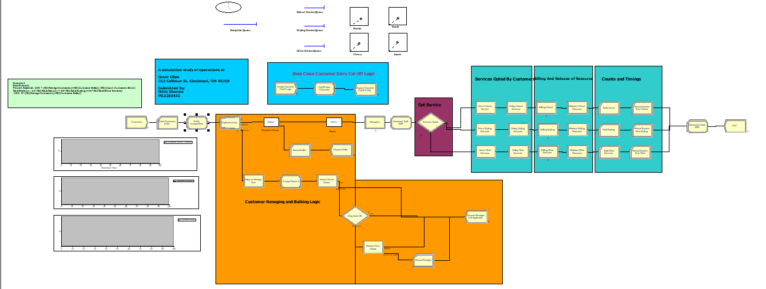

**Figure (9.1)**

**Citations:**

Chapter 9, Book – [Simulation with Arena](https://www.amazon.com/Simulation-Arena-W-David-Kelton/dp/0073401315)

By W David Kelton, Randall P Sadowski, Nancy B Zupick