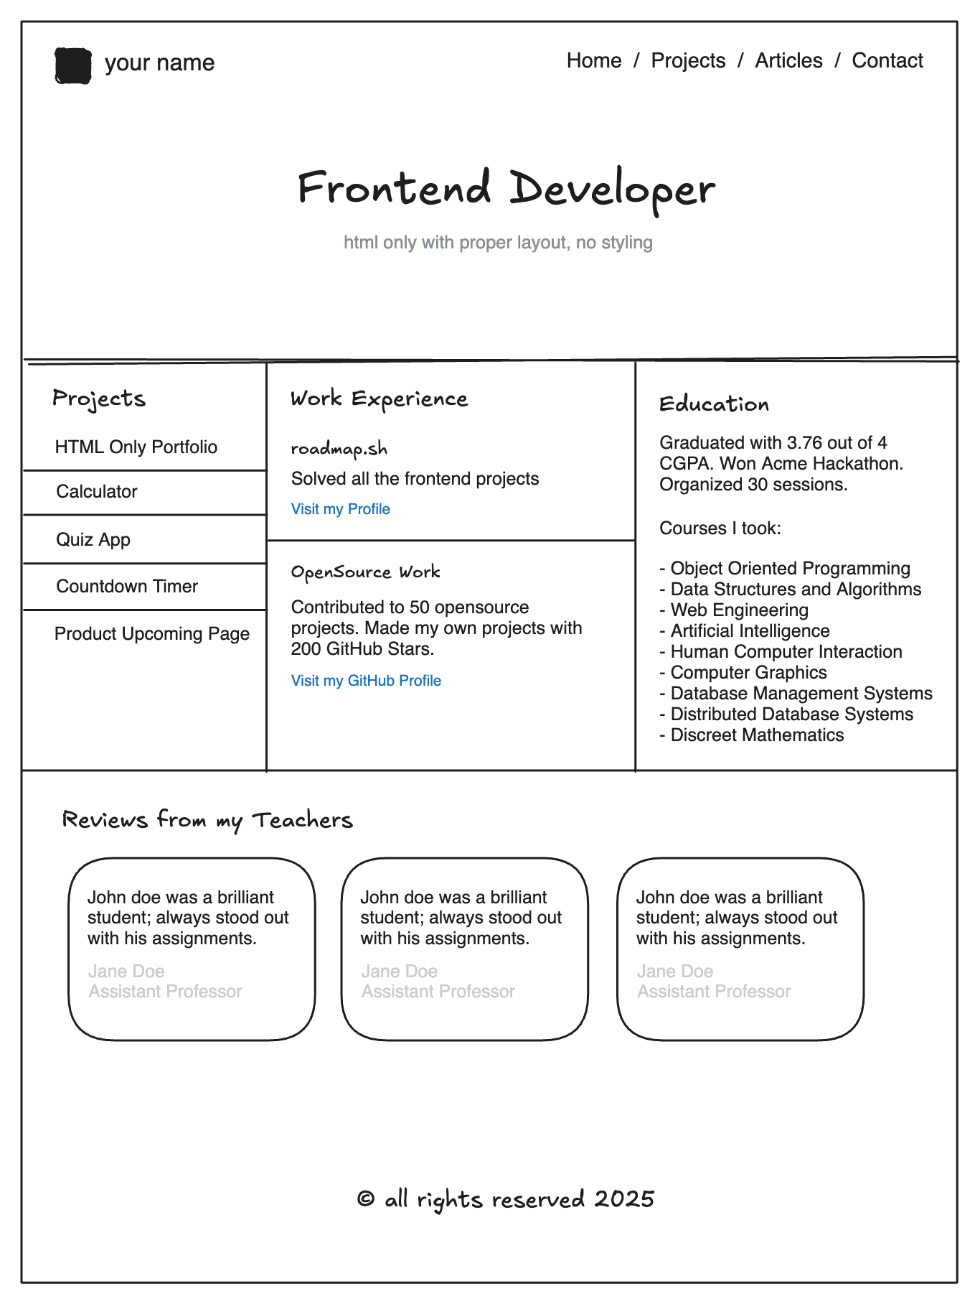
Note :- Create this page using BootStrap, apply color styles as per ur analysis.

