DESIGN ARCHITECTURE
Azure Bastion Deployment to Remove Public RDP Access
Secure administrative access using Azure Bastion and private VM networking
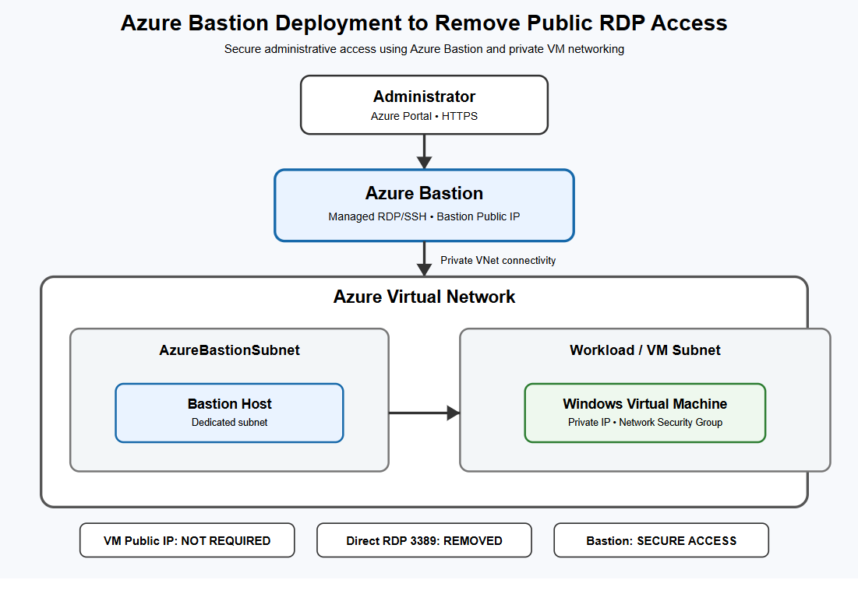
Figure 1. Proposed Azure Bastion secure-access architecture
1. Architecture Overview
The proposed architecture uses Azure Bastion as the managed administrative access layer for a Windows Virtual Machine. The VM is deployed inside an Azure Virtual Network and uses private network connectivity. The design removes the need for a public IP address on the VM for RDP administration.
2. Architecture Components
- Administrator / Azure Portal: The administrator starts the remote management session through the Azure Portal using HTTPS.
- Azure Bastion: Provides managed RDP/SSH access and acts as the controlled public entry point for administrative connectivity.
- Azure Virtual Network: Provides the private network boundary connecting Azure Bastion and the workload VM.
- AzureBastionSubnet: Dedicated subnet used for the Azure Bastion deployment.
- Workload / VM Subnet: Contains the Windows Virtual Machine and its private network interface.
- Windows Virtual Machine: The target workload, accessed through a private IP address in the final design.
- Network Security Group: Controls network traffic and helps prevent unnecessary inbound exposure, including unrestricted public RDP.
3. Secure Connection Flow
1. The administrator signs in to the Azure Portal.
2. The administrator selects the Windows VM and chooses the Bastion connection option.
3. Azure Bastion provides the managed RDP session.
4. Bastion communicates with the VM over private VNet connectivity.
5. The VM does not require a direct public IP address for this administrative path.
6. NSG rules provide additional network-level traffic control.
4. Security Design
The key security objective is to remove direct Internet-to-VM RDP exposure. In the final design, the VM public IP is not required and direct public RDP access is removed. Azure Bastion provides the administrative access path while the workload remains on private networking.
5. Expected Result
The completed deployment should demonstrate that the Windows VM can be administered through Azure Bastion while remaining without a direct public IP. The final Azure configuration should be supported by real screenshots captured from the student's own Azure environment.

