Wireframe Documentation

Credit Card Default Prediction

Homepage

1. Input boxes are placed on homepage.

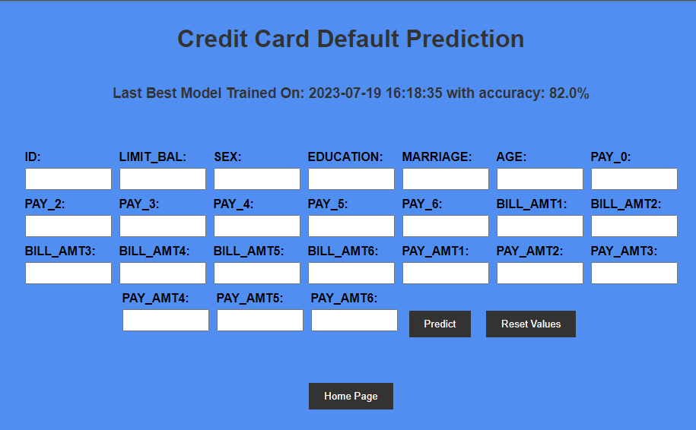

1. User can see last trained model information with accuracy of model.
2. User can only input integer values as per SRS document.
3. After filling inputs , user can click predict button.
4. Output will be shown as Default or Non Default.