**1. What exactly is []?**

Ans.

[] is used to define lists , which is one of the data types in python.

**2. In a list of values stored in a variable called spam, how would you assign the value 'hello' as the third value? (Assume [2, 4, 6, 8, 10] are in spam.)**

Ans.

spam[2] = 'hello'

**Let's pretend the spam includes the list ['a', 'b', 'c', 'd'] for the next three queries.**

**3. What is the value of spam[int(int('3' * 2) / 11)]?**

Ans. 'd'

**4. What is the value of spam[-1]?**

Ans. 'd'

**5. What is the value of spam[:2]?**

Ans. ['a', 'b']

**Let's pretend bacon has the list [3.14, 'cat,' 11, 'cat,' True] for the next three questions.**

**6. What is the value of bacon.index('cat')?**

Ans. 1

**7. How does bacon.append(99) change the look of the list value in bacon?**

Ans. [3.14, 'cat,' 11, 'cat,' True,99]

**8. How does bacon.remove('cat') change the look of the list in bacon?**

Ans. [3.14, 11, 'cat,' True,99]

**9. What are the list concatenation and list replication operators?**

Ans. For concatenation operator is +

For replication operator is *

**10. What is difference between the list methods append() and insert()?**

Ans. Append is used to add element as last value in list while insert is used to add value in between list using index value.

**11. What are the two methods for removing items from a list?**

Ans. pop() method is used to delete element on specific index.

remove() method is used to delete first element with specific keyword.

**12. Describe how list values and string values are identical.**

Ans. Characters in the string can be accessed as we can access elements in list.

we can access string elements but we can not change strings as strings are immutable but we can change list values/ elements wherever we want.

**13. What's the difference between tuples and lists?**

Ans. Tuples are immutable or unchangeable group of elements enclosed in ().

Lists are mutable or changeable group of elements enclosed in [].

**14. How do you type a tuple value that only contains the integer 42?**

Ans.

a = (42,)

15. How do you get a list value's tuple form? How do you get a tuple value's list form?

Ans. Using type function.

**16. Variables that "contain" list values are not necessarily lists themselves. Instead, what do they contain?**

Ans. Sets or tuples.

**17. How do you distinguish between copy.copy() and copy.deepcopy()?**

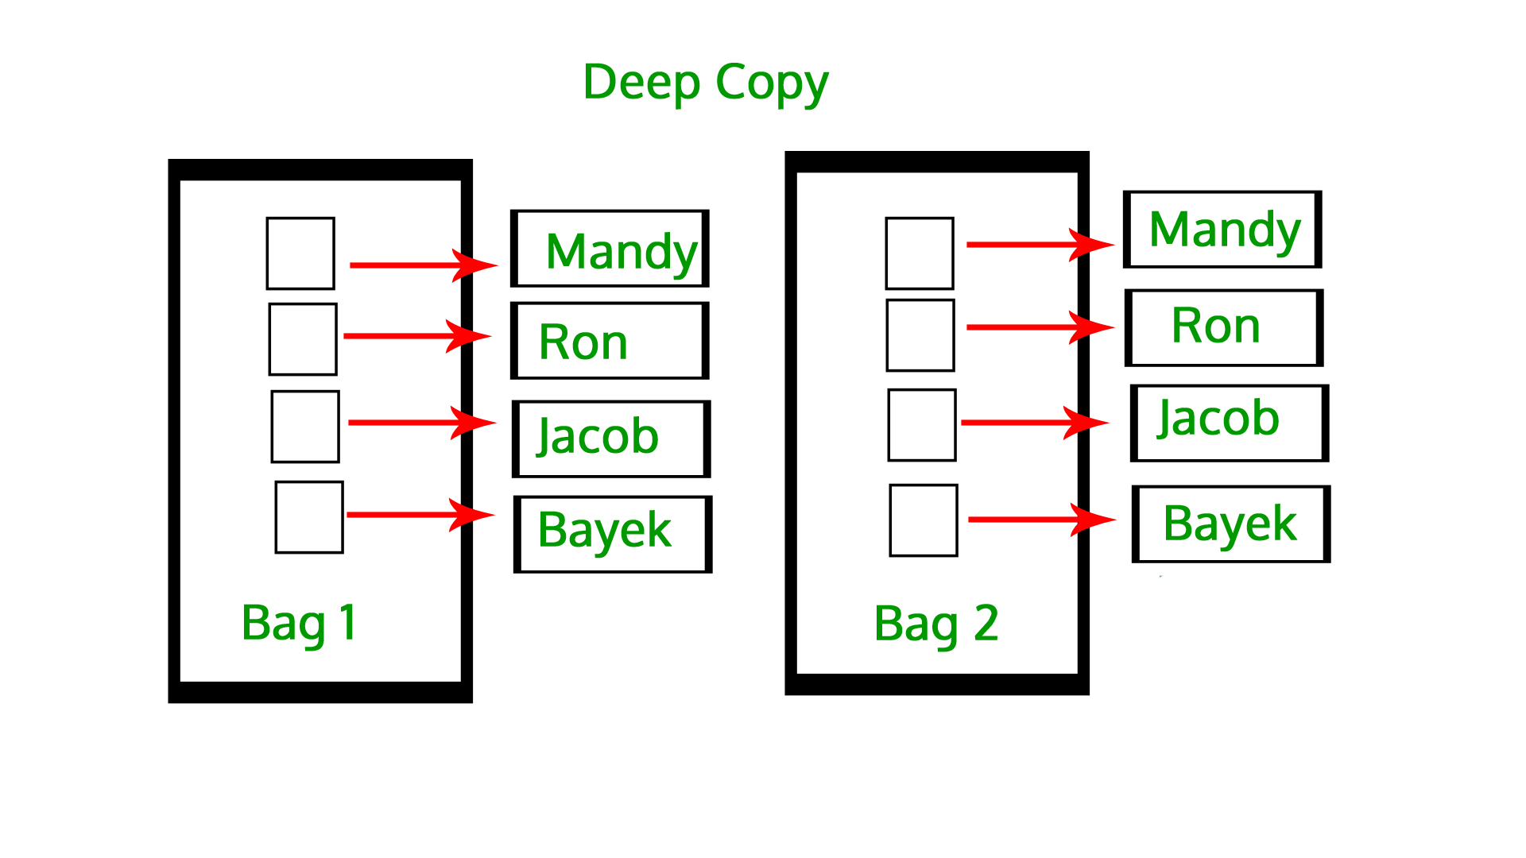

## What is Deep copy in Python?

A deep copy creates a new compound object before inserting copies of the items found in the original into it in a recursive manner. It means first constructing a new collection object and then recursively populating it with copies of the child objects found in the original. In the case of deep copy, a copy of the object is copied into another object. It means that any changes made to a copy of the object do not reflect in the original object.

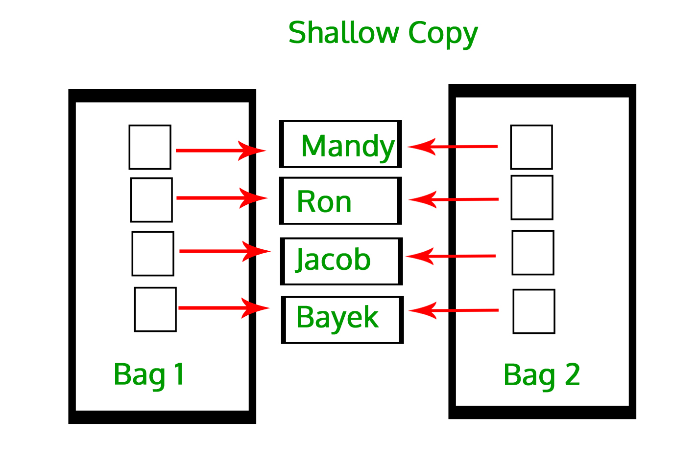

## What is Shallow copy in Python?

A shallow copy creates a new compound object and then references the objects contained in the original within it, which means it constructs a new collection object and then populates it with references to the child objects found in the original. The copying process does not recurse and therefore won’t create copies of the child objects themselves. In the case of shallow copy, a reference of an object is copied into another object. It means that any changes made to a copy of an object do reflect in the original object. In python, this is implemented using the “copy()” function.