Wireframe Documentation

Mask Wear Detector with Computer Vision

Homepage

1. User change app model from ‘Choose the App Mode’ dropdown on sidebar.

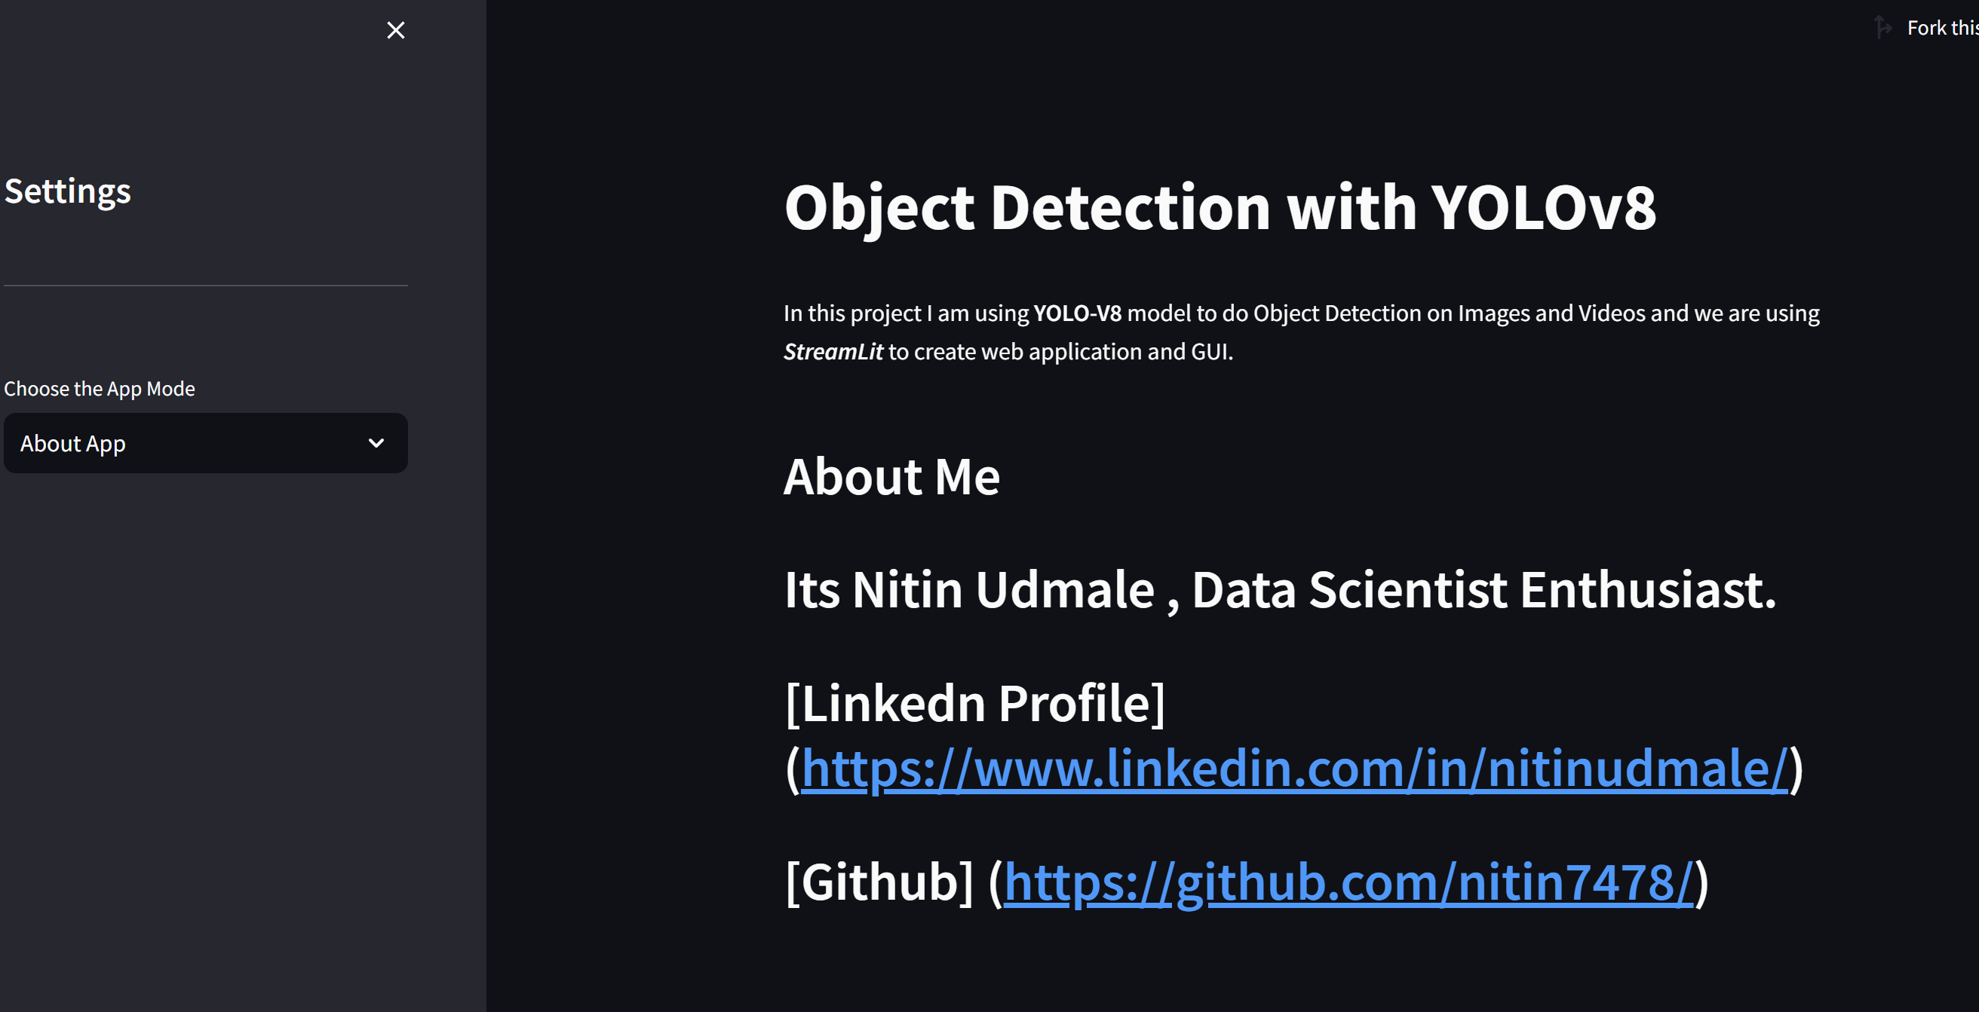

1. Run on Image Mode.

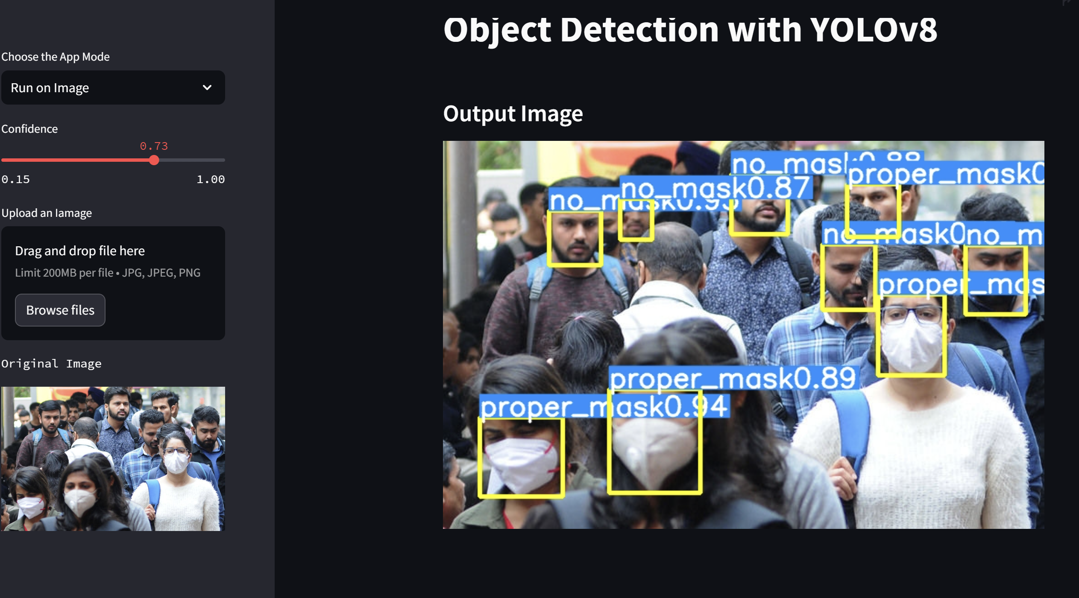

1. User can set threshold(confidence value), can upload any image. And view bounding boxes and prediction labels on right side output image.
2. Run on Video Model. User can Upload .mp4 , .avi , .mov extension video files. Use can see kpis on webpage such as frame rate of output , width and height of input video. Results will be shown on right side frame , which will include bouneding boxes as well as labels with confidence value.

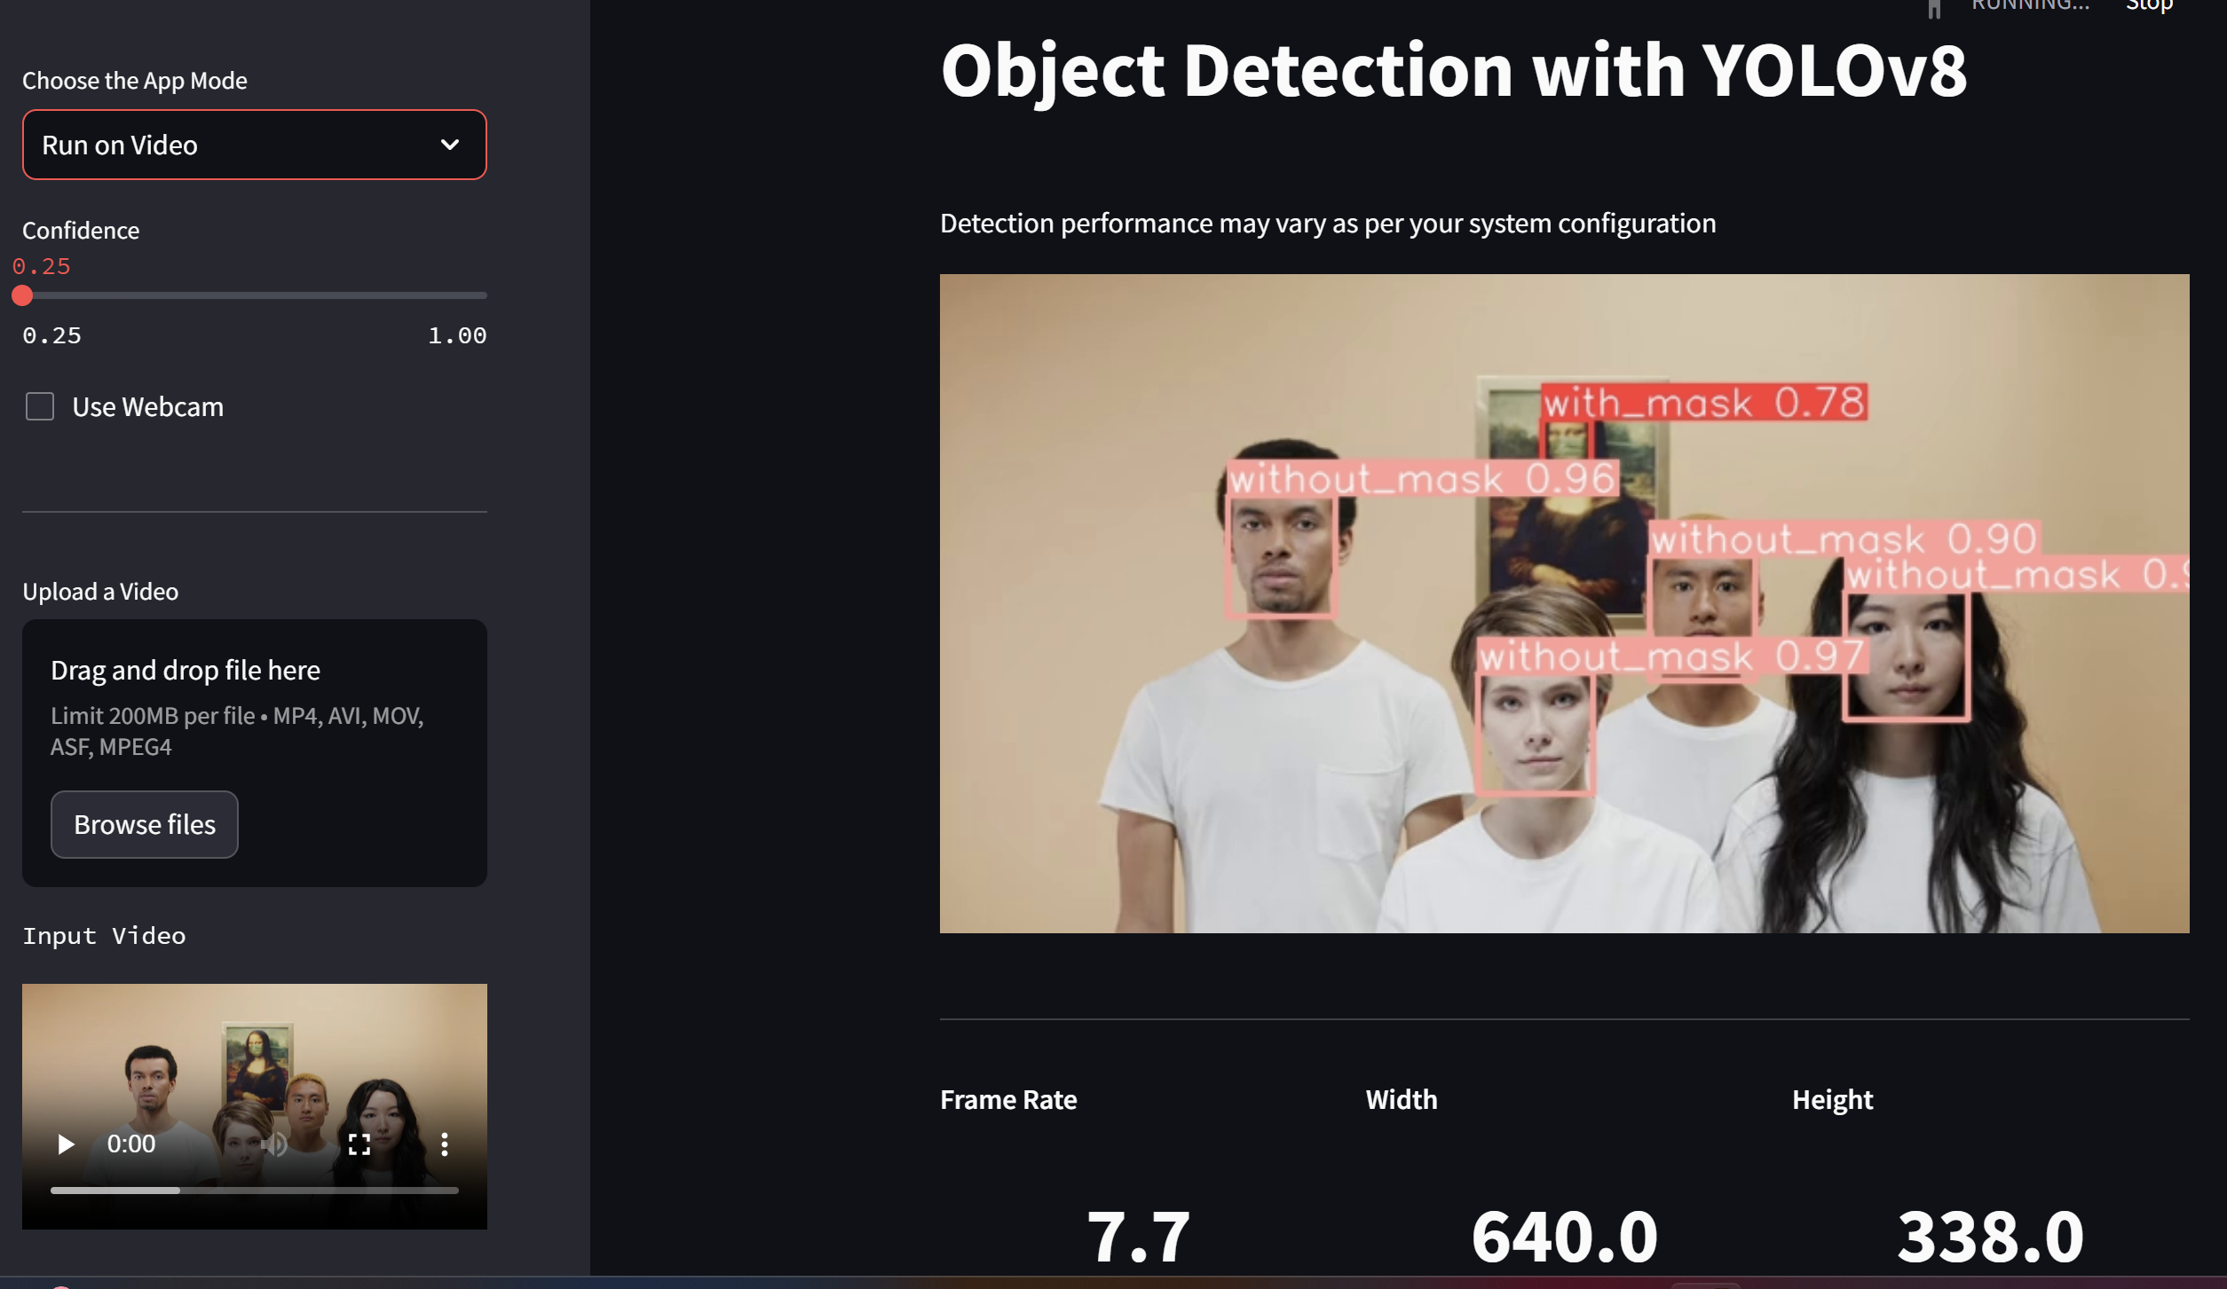

1. Video processing output will depend on systems processing capacity.

Homepage Address :