**PIZZA SALES SQL QUERIES**

1. **KPI’s**
2. **Total Revenue**

**The sum of the total price of all pizza orders.**

-> select sum(total_price) from pizza_sales;

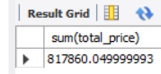

1. **Average Order Value**

**The average amount spent per order ,calculated by dividing the total revenue by the total number of orders.**

-> select sum(total_price)/count(distinct order_id) from pizza_sales;

**-**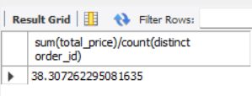

1. **Total Pizzas Sold**

**The sum of the quantities of all pizzas sold.**

->select sum(quantity) from pizza_sales;

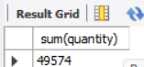

1. **Total Orders**

**The total amount of orders placed .**

-> select count(distinct order_id) from pizza_sales;

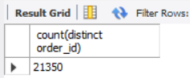

1. **Average Pizzas Per Order**

**The average number of pizzas sold per order,calculated by dividing the total number of pizzas sold by the total number of orders.**

-> select sum(quantity) / count(distinct order_id) from pizza_sales;

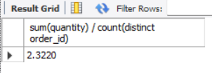

1. **DAILY TRENDS FOR TOTAL ORDERS**

**A bar chart is required to be created so that it displays the daily trends of total orders over a specific time period. This chart help us to identify any patterns or fluctuations in order volumes on a daily basis.**

**->** select dayname(order_date),count(distinct order_id) from pizza_sales group by dayname(order_date);

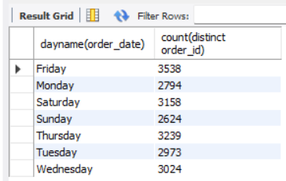

1. **HOURLY TRENDS FOR TOTAL ORDERS**

**A line chart is required to be created that illustrates the hourly trend of total orders throughout the day .This chart will allow us to identify peak hours or periods of high order activity.**

-> select hour(order_time),count(distinct order_id) from pizza_sales group by hour(order_time);

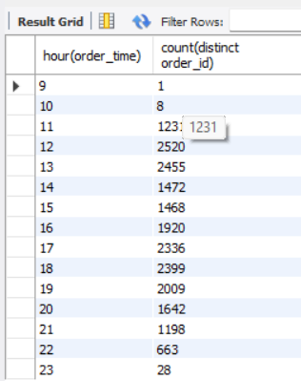

1. **PERCENTAGE OF SALES BY PIZZA CATEGORY**

**A pie chart is required to be created that shows the distribution of sales across different pizza categories . This chart will provide insights into the popularity of various pizza categories and their contribution to overall sales.**

**->** select pizza_category,sum(total_price)/(select sum(total_price) from pizza_sales)*100

from pizza_sales group by pizza_category;

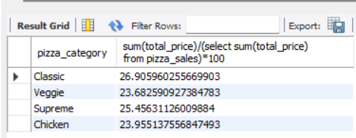

1. **PERCENTAGE OF SALES BY PIZZA SIZE**

**A pie chart is required to be generated that represents the percentage of sales attributed to different pizza sizes. This chart will help us understand customer preferences for pizza sizes and their impact on sales.**

**->** select pizza_size,sum(total_price)/(select sum(total_price) from pizza_sales)*100

from pizza_sales group by pizza_size;

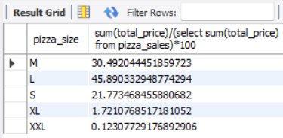

1. **TOTAL PIZZAS SOLD BY PIZZA CATEGORY**

**A funnel chart is required to be created that presents the total number of pizzas sold for each pizza category. This chart will allow us to compare the sales performance of different pizza categories.**

* select pizza_category, sum(quantity) from pizza_sales group by pizza_category;

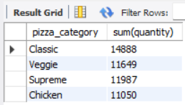

1. **TOP 5 BEST SELLERS BY TOTAL PIZZAS SOLD**

**A bar chart is required to be created highlighting the top 5 best-selling pizzas based on the total number of pizzas sold. This chart will help us identify the most popular pizza options .**

-> select pizza_name , sum(quantity) from pizza_sales group by pizza_name order by sum(quantity) desc limit 5 ;

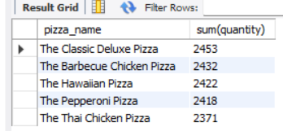

1. **BOTTOM FIVE WORST SELLERS BY TOTAL PIZZAS SOLD**

**A bar chart is required to be generated showcasing the bottom 5 worst-selling pizzas based on the total number of pizzas sold. This chart will enable us to identify underperforming or less popular pizza options .**

->select pizza_name , sum(quantity) from pizza_sales group by pizza_name order by sum(quantity) limit 5 ;

