**SALES DATA**

1. **Problem Statement for SQL(MS SQL Server)**
2. **Sales By Product line**

-> select productline , sum(sales) as 'Sum of Sales' from sales_data group by productline order by sum(sales) desc ;

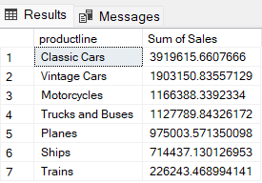

1. **Sales By Year**

-> select year_id,sum(sales) as 'Sum of Sales' from sales_data group by year_id order by sum(sales) desc;

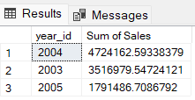

1. **Sales By DealSize**

->select dealsize,sum(sales) as 'Sum of Sales' from sales_data group by dealsize order by sum(sales) desc;

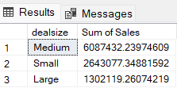

1. **Best Month for Sale in each Year**

-> select top 1 month_id,year_id,sum(sales) as 'Total_sales' from sales_data where year_id=2003 group by month_id,year_id order by sum(sales) desc ;

-> select top 1 month_id,year_id,sum(sales) as 'Total_sales' from sales_data where year_id=2004 group by month_id,year_id order by sum(sales) desc ;

-> select top 1 month_id,year_id,sum(sales) as 'Total_sales' from sales_data where year_id=2005 group by month_id,year_id order by sum(sales) desc ;

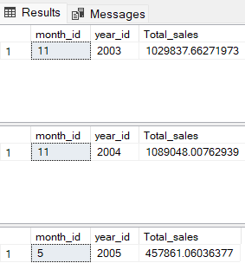

1. **Top 3 Customers on the basis of Sales as per Product line**

with

cte1 as

(select productline,customername,sum(sales) as 'Total_sales' from sales_data group by productline,customername)

select * from (select *,row_number() over(partition by productline order by total_sales desc) as 'top3_customers' from cte1) A

where top3_customers<=3;

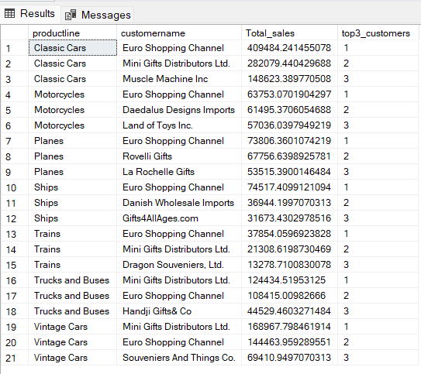

1. **Top 3 Customers on the basis of total number of orders as per Product line**

with

cte2 as

(select productline,customername,count(ordernumber) as 'frequency' from sales_data group by productline,customername)

select * from (select *,row_number() over(partition by productline order by frequency desc) as 'top3_customers' from cte2) B

where top3_customers<=3;

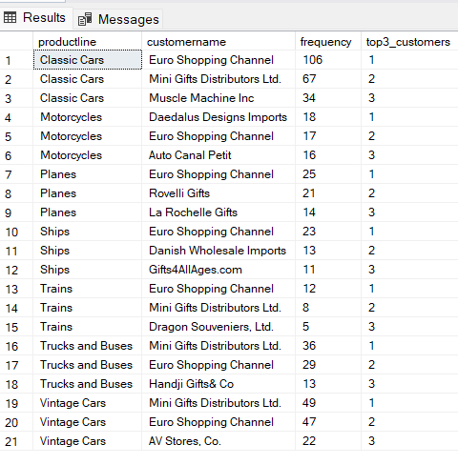

1. **Problem Statements (Graphical representation/Visualization)**
2. **A Packed bubble chart is required to be created that illustrates the total revenue of each Product line.**
3. **A Packed bubble chart is required to be created that shows the total revenue of each year.**
4. **A Pie Chart is required to be generated that represents the total revenue in respect to deal size.**
5. **A Bar Chart is required to be created that represents the month wise total sales of each year .**
6. **A Horizontal Bar Chart is required to be created highlighting the total revenue generated from each country.**
7. **A Horizontal Bar Chart is required to be created highlighting the revenue generated from each customer country wise.**

**The following Dashboard which is made in Tableau Public answers all the problem statements mentioned above interactively.**

**Dashboard link** - [Sales_dashboard | Tableau Public](https://public.tableau.com/app/profile/nitin.bajaj7964/viz/Sales_dashboard_16954595414000/SalesDashboard?publish=yes)

