NETAJI SUBHAS UNIVERSITY OF TECHNOLOGY

CDCSC05 : Database Management System

PROJECT FILE



Samman Sarkar

2021UCD2114

CSDS

RAILWAY MANAGEMENT SYSTEM

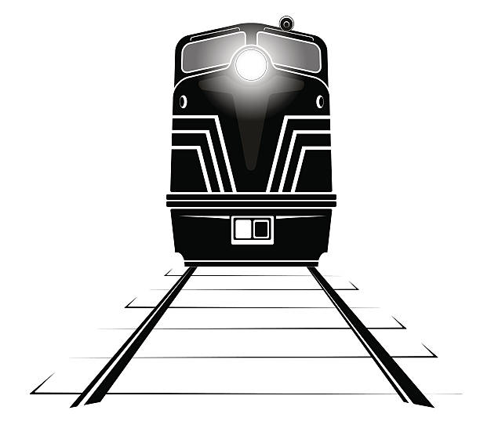

Entity–relationship model

Description

Entity–relationship model

An entity–relationship model describes interrelated things of interest in a specific domain of knowledge. A basic ER model is composed of entity types and specifies relationships that can exist between entities.