1. **Research programme**

Top of Form

**Specific aims and objectives of your proposed urgent grant application (maximum 10,000 characters including spaces).\***

Info about Specific aims and objectives of your proposed urgent grant application (maximum 10,000 characters including spaces).

* You should describe and motivate the urgent need to secure data/research material. What is the purpose of securing data/research material? Explain also possible consequences if the data/research material is not secured.
* You should motivate how the project relates to one or more of **Formas areas of responsibility**– environment, agricultural sciences and spatial planning.
* You should describe and motivate the **scientific relevance** of the project (including references).

**Max length:**10000 characters

Bottom of Form (4 page 1500 words)

**Purpose of the study**

Peatlands comprise 30% of the present day soil organic carbon pool and are one of the biggest carbon reserves in the terrestrial ecosystem5. They play an important role in the global carbon cycle, as a persistent long-term CO2 sink and a moderate source of methane (CH4). At present, only a few large-scale Dynamic Global Vegetation Models (DGVM) and land surface models (LSM) have incorporated peatland dynamics to hindcast Holocene peat carbon accumulation and apply them to predict responses of these ecosystems to future climate change (see Table 1). To assess how well the models perform and to have a systematic study of the fate of peat carbon under fast future climate change, various established peatland groups come together and have initiated a study to intercompare their peatland models. We have been invited in the model intercomparision study in which we will perform hindcast and future experiments with our established state-of-the-art peatland-vegetation model (LPJ-GUESS) at contrasting climate-warming scenarios.

The purpose of this study is to minimize the uncertainty surrounding peatland carbon balance at different time scales. We will run the model at 1 to 1-degree resolution across the pan-Arctic area for the last 12000 years. Our mechanistic peatland model, which annually accumulates peat, has showed promising results both at local and regional scales. However, running this model at this fine-scale requires significant amount of resources and data storage. Therefore, we are in urgent need of human as well as computing resources to fulfill above objectives and our commitment in this community effort. The main findings of this study will be conveyed to major international authorities working to curb the CO2 emission and mitigate climate change, particularly Intergovernmental Panel of Climate Change (IPCC). Failing to contribute in this project not only create a knowledge gap but also deprive the policy-makers with the clear and conclusive findings of the peatland dynamics which could enable them to take concrete steps in order to protect peatlands for sequestering carbon.

**Background and scientific relevance of the project**

The main aim of the study is to review the current state-of-the-art peatland models that can be applied at global/hemispheric scale and to evaluate the contribution of northern peatlands (>30°N) to the global carbon cycle in historical past (1860-2005) and in the future (2006-2300). The specific objectives of the study are:

The study will focus on (1) performance of peatland models (agreement, disagreement); (2) historical and future CO2 fluxes from northern peatlands; (3) identifying the role of peatlands in mitigating climate change under different warming scenarios

On these lines, we plan a research project (SIMULATE-PEAT) which focuses on running established peatland version of LPJ-GUESS, a dynamic global vegetation model (DGVM; see Table 1) at fine-resolution (Smith, et al. 2001, Chaudhary, et al. 2017a). In the first part of the study, the model will be run with two contrasting scenarios and the remaining two mild-warming scenarios will be performed in the later part of the study. These model simulations explore the role of peatlands in future climate and will become a part of major scientific reports and policy briefs. The focus of this study will be on the pan-Arctic region above (> 30°N) as majority of the peatlands (more than >80 percent) are present in this area. The effects of changes in hydrological and structural conditions in future peatland dynamics will also be evaluated. This study will provide the most up-to-date peatland and permafrost extent for the coming century and reduce current uncertainties related to carbon exchanges from the peatlands. The study will also help in identifying the vulnerable regions to high carbon emissions and will evaluate their direct consequences on vegetation and hydrology.

Organizations such as Swedish Environmental agencies can benefit from the outputs of this study, as our results will have the potential to influence policy on the importance of peatland protection from a climate change perspective and influence regional planning when thinking about land use and management policy. This work builds on my previous research work on modelling peatland-permafrost dynamics and terrestrial-climate feedbacks. The proposed project has the potential to make a step change progress in the field of peatland and Earth science. Our modelling results will help in government decision making in what level we need to protect our peatlands.

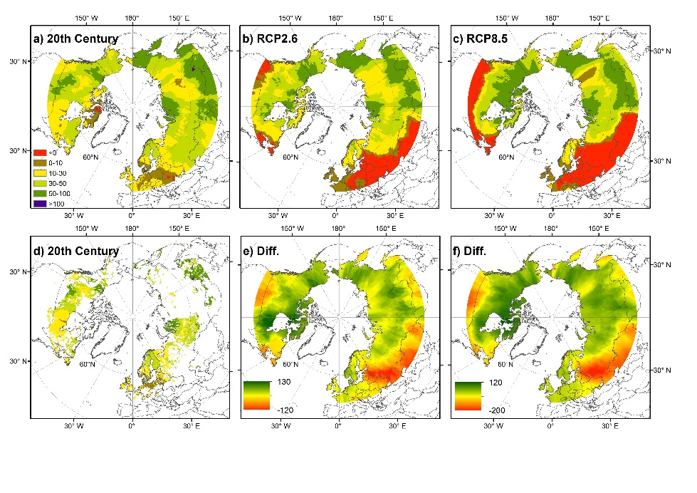  **Fig.3** a) Net carbon accumulation rates (in g C m-2 y-1, average 1990–2000), b) following the RCP2.6 scenario (Exp26; average 2091–2100), c) following the RCP8.5 scenario (Exp85; average 2091–2100)

The international community estimated that around one trillion tonnes of Carbon (1000 PgC) can be emitted by the end of the century to limit the global temperature rise to 2 degree Celsius above pre-industrial level. We have already burnt through more than 50% of the allocated budget, emitting 515 PgC since the industrial revolution (1861-1880), leaving 485 PgC in the budget. We are not clear how these climate sensitive ecosystems will behave in the future and will they provide options to delay the effects of climate by effectively managing these systems. If we continue to emit the CO2 at this rate, we will burn out 1000 PgC by 2045. To achieve this goal, early and large-scale carbon emission reductions are immediately required to prevent any catastrophic damages. Peatlands are an important ecosystem type which not only store a huge amount of carbon (Yu 2012) (i.e. almost twice the size of the world’s forest) but have been playing a significant role in buffering the effects of climate change and have a big role to play in supporting climate adaptation and resilience (Leifeld*, et al.* 2018) in coming decades. If they continue to take up carbon in the future, their conservation could be a simple, inexpensive and reliable mitigation option (Martin*, et al.* 2009).

**Formas areas of responsibility**

The project comes fulfill two of the **Formas areas of responsibility – environment and spatial planning.** The proposed project mainly comprises the environmental dimension, and has major implications for the economy and society. First, this study will provide a better understanding of the role of peatland processes in limiting climate warming. Second, the study results can be used to predict the most probable demarcation of peatland and permafrost extent for the coming century and to reduce current uncertainties regarding CO2 emissions from peatlands. Third, the study will help in identifying the ‘hotspots’ in the pan-Arctic region and other geographical areas that are vulnerable to high carbon emissions and permafrost degradation and will evaluate their direct consequences for plant ecology and hydrology. The project will, therefore, address United Nations (UN) sustainable development goals 13 (Climate change) and 15 (Biodiversity, forests and desertification).

The infrastructure and transportation corridors established over permafrost areas are highly vulnerable to changing climate conditions. My earlier studies (Chaudhary*, et al.* 2017b, Chaudhary*, et al.* 2020) have highlighted that the total permafrost area will shrink and in many regions it may disappear by the end of the 21st century. This proposed study will further advance my previous research and demarcate areas that are extremely sensitive to excessive warming, which could result in the complete or partial disappearance of permafrost with implications for damage to built infrastructure (roads, buildings, communications). Hence, the results of my study will also address UN SDG 9 and SDG 13 UN (Infrastructure and Climate change).

the CPU hours and data storage area in order to contribute to this proposed study.

Beyond a baseline, a carbon budget needs milestone dates in the future with acceptable emission volumes tagged to those dates. The effort to mitigate emissions is seen as critical today if the nations of our planet intend to achieve the lower or upper limit Paris targets to which all have agreed. Setting an upper limit on CO2 emissions is only one of a total of 6 greenhouse gases that we need to mitigate. Some of the others such as methane (CH4) could be addressed with shorter timelines through changes to industrial practices resulting in more rapid reductions in total emissions. This has a benefit for nations struggling with CO2 which is a much harder greenhouse gas to deal with. **Carbon budget deadlines for CO2 can have longer timelines if other greenhouse gases are reduced sooner.**

Executing a strategy to achieve lower carbon emissions can only start when you know the current numbers. Then the government can set carbon-limits on different greenhouse gas emissions and monitor overall results by measuring amounts in the atmosphere. Less will mean the carbon limit policy is working. If it is not then governments need to get more granular. This can be done by monitoring greenhouse gas emissions at every smokestack and tailpipe, or by determining specific carbon emission content in fuels when combusted at the point of production. Granular would require far greater regulatory oversight.

One way or the other, every nation and its citizens have to make a choice. Do nothing and neither the 1.5 or 2-degree limits will be achievable. At current greenhouse gas emission annual contributions, climatologists see 4 to 4.5-degrees as the rise in global warming by the end of the 21st century. Remember, that is a mean temperature calculation and unevenly distributed over the globe. In places closer to the poles, a mean of 4.5 degrees will turn into an average rise of 15 Celsius or more in places like Alaska, northern Canada, Scandinavia, and Siberia. We have yet to produce models to show us what that will mean to the flora and fauna that live in these areas of the planet. Nor do we know what that will mean to changes in the permafrost and the greenhouse gases we know that are trapped in this no longer permanently frozen ground.

They are able to store the equivalent of around 10 years of the CO2 emissions that come from human activity.

To achieve this objective, the major peatland modelling groups will run their models and submit the model outputs.

their importance to the global climate cycle is known, there are a number of crucial questions surrounding their role that remain a mystery.

For the project, Dr Gallego-Sala will research four key questions - what controls the geographical distribution of peatlands in the tropics; how large is the tropical peatland CO2 sink and what are its main climatic drivers; how large is the methane flux in tropical peatlands; and what is the overall carbon balance of tropical peatlands and how will this change in the future.

The study  will give scientists a comprehensive understanding of the role of tropical peatlands in the global carbon cycle - allowing their inclusion in earth system models - and informing management decisions to optimise provision of multiple ecosystem services.

peatlands are extremely important carbon stores and also methane emitters, and we must focus our efforts in understanding these inaccessible but wonderful ecosystems better”.

**Project description (maximum 10,000 characters including spaces).\***

Info about Project description (maximum 10,000 characters including spaces).

* You should describe the project performance, including work packages and time plan
* You should explain the research methods and the collection of the data/research material.

The main aim of **SIMULATE-PEAT** is to identify and explore important drivers that are responsible for modulating carbon fluxes at peatland sites. In addition, this community project will also determine the influences of different warming scenarios on carbon fluxes. **SIMULATE-PEAT** focuses on running an established peatland version of the dynamic vegetation model, LPJ-GUESS at different warming scenarios. These simulations will be used to increase our current understanding of the factors responsible for carbon sequestration and will identify the fate of peatland carbon stock in the warming world. The current model has been employed in a number of global change impact and feedback studies at regional and global scales (Chaudhary*, et al.* 2017b, Chaudhary*, et al.* 2020). In this research project, I will improve, update and run the LPJ-GUESS model based on simulation protocol which is described below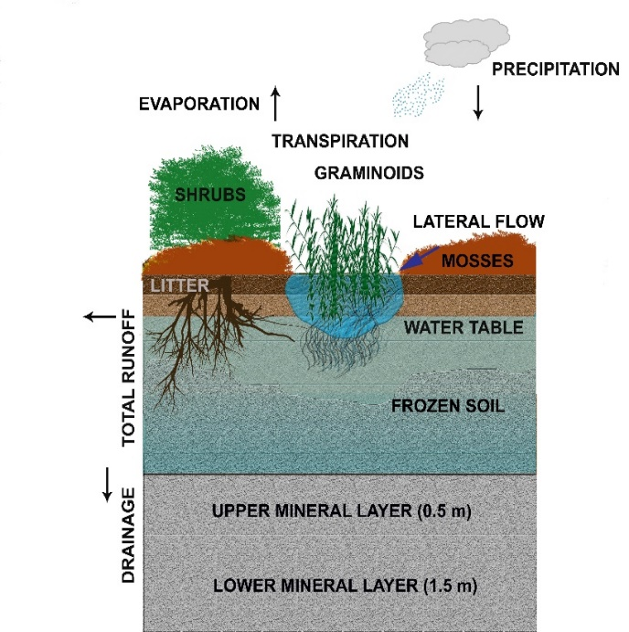:

**Work Package 1- Model simulations at pan-Arctic scale (Month 12–18, Month 31–36 and Month 53–60).**

organizing group. First, I will run the established peatland version of LPJ-GUESS, a dynamic global vegetation model at a fine-resolution (1 degree) (Smith, et al. 2001, Chaudhary, et al. 2017a). I will investigate their implications on climate warming on peatland carbon balance under two contrasting RCP scenarios. We will focus on the period 2080-2100 (recent future) which will be compared with the period 1991-2010 (recent past). Climate change signals will be determined by subtracting the future from present simulations. The present finding will set a stage for the already ongoing project where the peatland feedbacks will be calculated as a difference between the future and present with and without feedback (PVF-NoPF) simulations and identify the regions where the model is not sufficiently capture the observed patterns.

**Key Model - LPJ-GUESS** is a second-generation DGVM (Smith*, et al.* 2001), which simulates vegetation structure and composition in response to a changing climate from local to global scales. It is a process-based model of vegetation dynamics incorporating the physiological changes and biogeochemistry of terrestrial ecosystems. LPJ-GUESS will be used as a modelling tool for the proposed project. This model has been applied in more than 200 published studies and evaluated against datasets across many ecosystem types including the pan-Arctic region. Recently, the multi-layer peat accumulation and permafrost functionalities have been included (Chaudhary*, et al.* 2017a) (see Fig. 1) and the current version of the model will be further developed to include microbial CH4 biogeochemistry and advanced hydrological schemes. The new model will minimize the recent uncertainties related to anoxic carbon exchanges and peatland management practices. Later, this comprehensive model will be applied at the larger scale to carry out impact studies for the Nordic region.

Other Models:

**Fig. 1. A schematic diagram showing the LPJ-GUESS peatland structure and functioning**

In this work package, I will perform the simulations in based on the simulation protocol prepared by the

Work Package 2 – Model evaluation and additional experiments.

Observations, reanalysis and satellite-based, and gauge-based datasets will be used to evaluate the model simulations. Simulated near-surface temperature, precipitation, and LAI will be compared with observations within the 1991–2010 time period. Annual and seasonal surface temperature and precipitation will also be compared with the gridded observations from the CRU TS3.2340. The rain gauge data are upscaled in the Global Precipitation Project that can provide additional information to evaluate the model. GIMMS-AVHRR and MODIS-based LAI3g41 will be used to evaluate LAI simulations. ERA-interim is a reanalysis dataset42 that gives the information on the state of the atmosphere, and land conditions from 1989 to 2013. The dataset contains multiple types of data such as temperature, precipitation, evapotranspiration, global radiation, water balance, and water vapour. Peatland locations and extent will be evaluated with PEATMAP developed by Xu, et al. 43, global CH4 simulations will be compared with global CH4 budget44 from 2000–2012 and observations of C accumulation rates for pan-Arctic region will be extracted from Loisel et al. 6 and Chaudhary, et al. 9 (see Table 3 in that paper). The results of this WP will overlap with the above WPs (see Fig. 1 and Table 2) and presents the effects of peatland-mediated feedbacks on regional and global climate. Under this WP, one unique study is planned where I compare the outputs of other community ESMs with the improved and updated EC-EARTH, hence, there will be 3+1(4) paper outputs (see Table 2) addressing all the three aims and my hypotheses.

Methodology

All simulations should be performed at 1°x1° spatial resolution, for regions above 30°N

Below is a flowchart demonstrating the simulation protocol.

All models should do the S1 simulations (use fixed peatland extent of Xu et al., 2018), S2 simulations are for models that can simulate peatland extent dynamically.  
  
We have been invited to submit our simulation for this proposed study. However, we lack resources to run our model at such fine scale. Running more than 4000 points requires

Natural disturbance, i.e, fires, should be disabled from simulations. Anthropogenic land-use change should be kept fixed or disabled.

Peatlands are important C reserves in terrestrial ecosystem and cover 3% of the terrestrial globe (4 × 106 km2)13. Since the Holocene, they have stored around 350-500 Petagrams [109] of C (PgC), comprising around 30% of present-day soil organic C pool5. They have the potential to

Work Package 1

* 1. **Potential Impact of the proposed research**

The three main pillars of sustainability are economy, society, and environment. Alteration in any one of these pillars directly affects the others. The proposed project mainly comprises the environmental dimension, and has major implications for the economy and society. First, this study will provide a better understanding of the role of peatland-centric feedbacks and peatland processes at regional and global scales by including their representations in regional and global ESMs. Second, the study results can be used to predict the most probable demarcation of peatland and permafrost extent for the coming century and to reduce current uncertainties regarding CH4 emissions from the peatlands. Third, the study will help in identifying the ‘hotspots’ in the pan-Arctic region and other geographical areas that are vulnerable to high C emissions and permafrost degradation and will evaluate their direct consequences to plant ecology and hydrology. The project will, therefore, address United Nations (UN) sustainable development goals 13th (Climate change) and 15th (Biodiversity, forests and desertification).

The infrastructure and transportation corridors established over permafrost areas are highly vulnerable to changing climate conditions. My earlier study (Chaudhary et al. 2017)[32](https://prisma.research.se/Application/Details/b9ecbad8-22b3-442e-b18b-a8b90181de28?pageIndex=1#_ENREF_30) have highlighted that the total permafrost area will shrink and in many regions it may disappear by the end of the 21st century. This proposed study will further advance my previous research and demarcate areas that are extremely sensitive to excessive warming, which could result in the complete or partial disappearance of permafrost. Hence, the results of my study will also address the 9th and 13th UN goals (Infrastructure and Climate change).