BOEING 747 – Amazon – Maruti Cars Factory – Mc Donalds etc.

All are different in their streams and work

But something is common in-between them.

What????

CODE (and a lot of it)

For your reference

A BOEING 747 has more lines of code then it does parts including nuts and bolts.

BOEING 747 = Approx 4 Million LOC

Most Games = Approx 6 Million LOC

Just the huge software they are….

Just think

1 LOC/min * 60 min/hr * 40 hrs/week = 2400 LOC/week

Let us suppose we have 50 wk/yr

So 2400 LOC/wk/SE * 50 wk/yr = 1,20,000 LOC per year/ per SE is expected to write individually.

Now if need to write 20,00,000 lakh (2 million) LOC in a year then how many coders we needed?

2*10^6 LOC/ 1.2 * 10^5 LOC/yr/SE = Approx 17 Software engineers

That means we needed 17 SE to complete this task within time.

So two things for sure we needed by this figure above is that:

* Anyhow we need teamwork for the same.
* We need some design/ plan to for an efficient and effective software

Now let’s talk for a company named Amazon.com/ Amazon.in you can choose anyone of them for this discussion.

* One large website, which is truly complex.
* One small software upgrade. Easy???
* One 90 min outage. Priceless???

No not exactly. It was estimated to cost $2.8 million of lost revenue they have to bear.

And keep in mind this loss never be recovered by selling more n more. This was actually the loss because the website was down for 90 min when some customer needs something to purchase. So for recovery somebody get fired may be or something like this ????

So the system is

* safety critical
* Financially critical

So to overcome this sort of issues the company has to understand the critical system and process they choose to develop and maintenance so that those 90 min can manage efficiently.

Beware!! as a software engineer you have to answer lot of questions…..

Like

Question: How much code I have to write?

Question: What code do I have to write?

Many more like…

Question: How can I help the customer? What is required to solve the customer’s problem?

Question: How will the user interact with the system?

Question: What operating system, language, hardware is going to be used?

Question: What is the overall software system structure and how do different components interact with each other?

Question: How do I organize my team so we are effective?

Question: Can we finish the game in time to have it on the shelves for holiday shopping.

Now to answer these type of questions we need to interact with different peoples like:

People: Customers asking for the system

People: People who will use the system

People: Domain experts: banking, security, medical, scientists, …

People: Engineers from other engineering disciplines

People: Even most closely with the other engineers on the project

Etc. Etc.

So another big underline term in-front of you is

COMMUNICATION

Software Engineering is a very social activity.

SE == CS? (not quite)

If any bridge falls then whose fault is this? ***Scientist*** or ***Engineers***

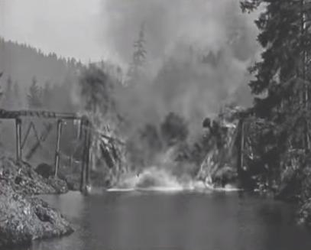

Scientists build things to learn something new.

Engineers learn things to design and build quality products.

Scientists want to achieve scientific breakthroughs.

Engineers want to avoid engineering failures.

------------

Computer Scientists want to understand the algorithms, and the foundation of computing theory.

Software engineers want to learn the design principles and best practices for building quality software systems.

------------

Computer Scientists want to know how the basic technology works and where to improve it.

Software engineers want to know the characteristics of the technologies so they can design the most appropriate technology into their software systems.

So now you get the idea……

-----

Teamwork

With a large enough group of people working together as a team, even the most foolish scheme can be successful.