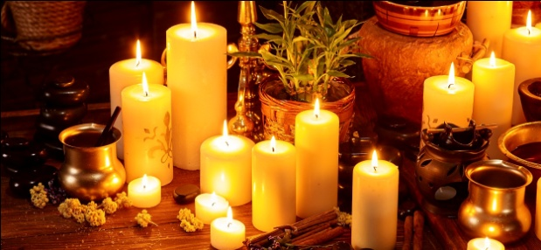

1. The above image is to be replaced from the home page, with this one - 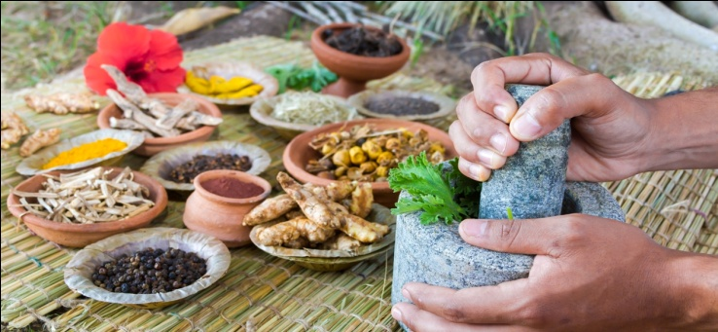
2. Image for the page Dr consultation SERVICES - DOCTOR CONSULTATION – Left side image:-

Right side image - 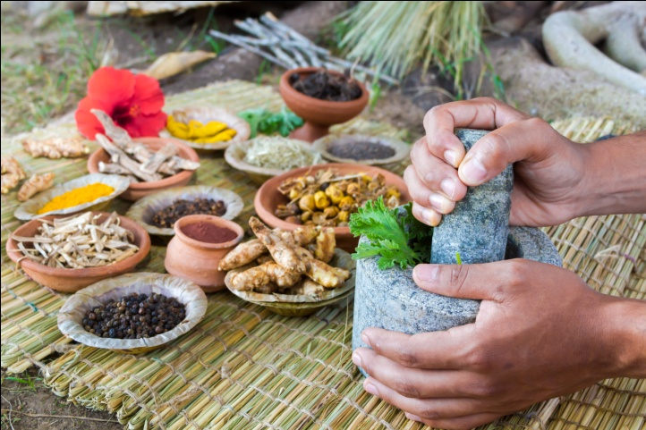

1. ABOUT US - AURAVEDA AT A GLANCE – Under the heading Ayurvedic care - 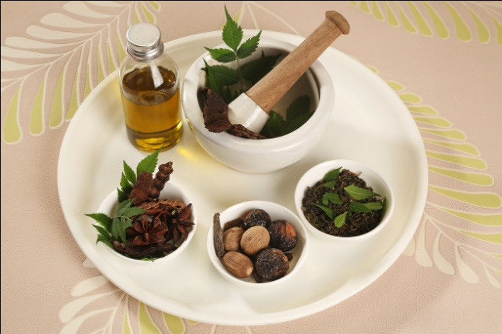
2. SERVICES - HEAL YOUR PROBLEM - SPINE & JOINT CARE –

* Left side image - 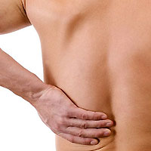
* Rt side image - 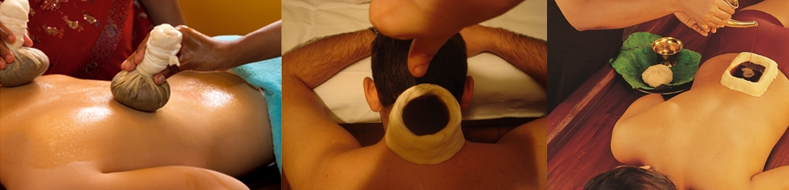

1. SERVICES - HEAL YOUR PROBLEM - MUSCULOSKELETAL CARE –

* Left side image – 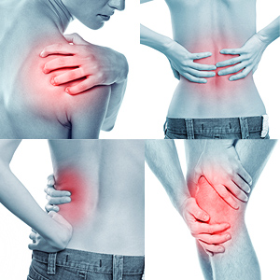
* Right side image –

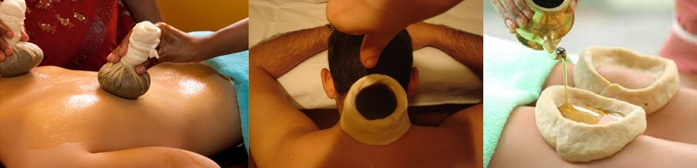

1. SERVICES - HEAL YOUR PROBLEM- OBESITY & WEIGHT MANAGEMENT –

* Left side image – 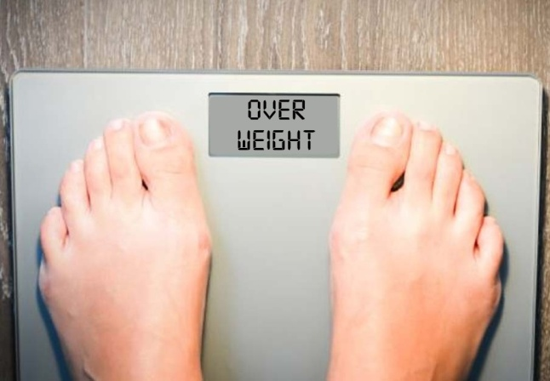
* Rt side image – No need to replace.

1. For NATURAL STRESS CARE & FAST STRESS STOP GAP pages – Right side image. –

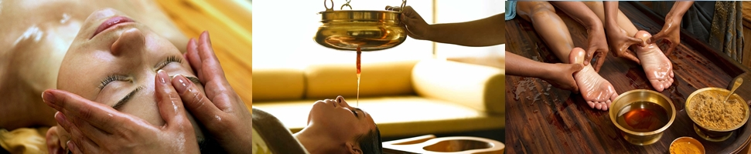

1. SERVICES - HEAL YOUR PROBLEM - SPECIAL NEUROLOGICAL CARE –

* Left side image – 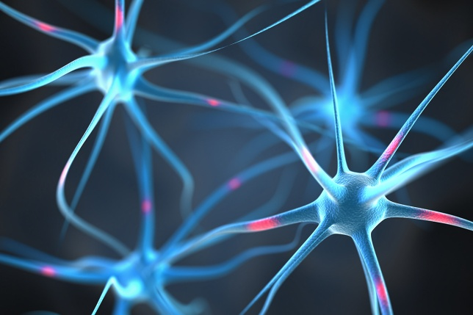
* Right side image –

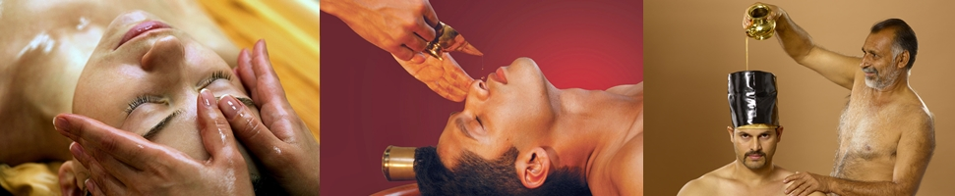

1. SERVICES - HEAL YOUR PROBLEM - RESPIRATORY, SINUSITIS CARE –

* Left side image - 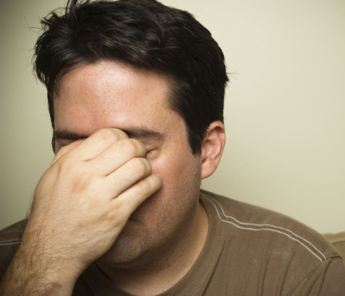
* Right side image –

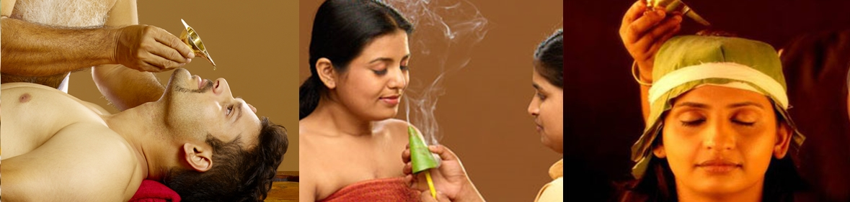

1. SERVICES - HEAL YOUR PROBLEM - FAST STRESS STOPGAP

* Left side image - 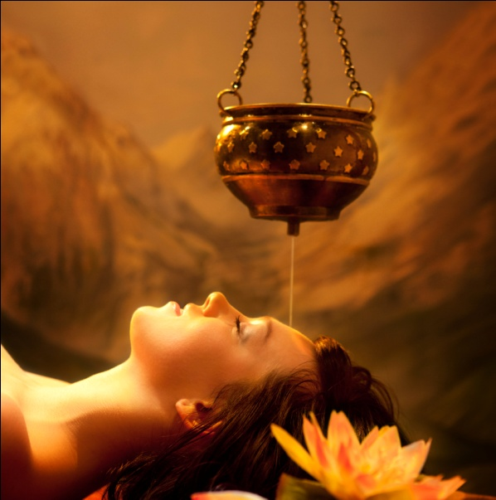

1. SERVICES - SPECIAL PACKAGES – POST-FRACTURE TREATMENT PACKAGE -

* Left side image – 
* Right side image –

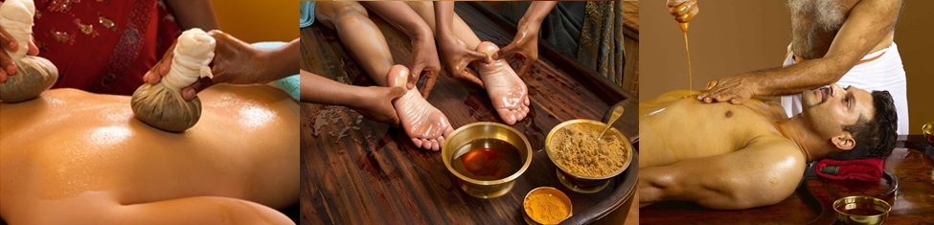

1. SERVICES - SPECIAL PACKAGES - FOR IT-OFFICE-GOERS –

* Left side image - 
* Right side image -



1. SERVICES - SPECIAL PACKAGES - FOR SPORTS-GYM-FITNESS SECTOR –

* Left side image - 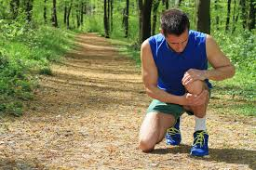
* Right side image – No need to change the present one.

1. SERVICES - SPECIAL PACKAGES - PRAGNANCY-BEFORE & AFTER-CARE PACKAGE -

* Correct the spelling of Pregnancy.
* Left side image - 
* Right side image - No need to change the present image.

1. SERVICES - SPECIAL PACKAGES - OLD AGE CARE PACKAGE –

* Left side image – 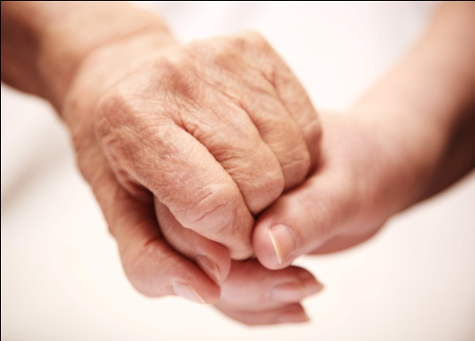
* Right side image –

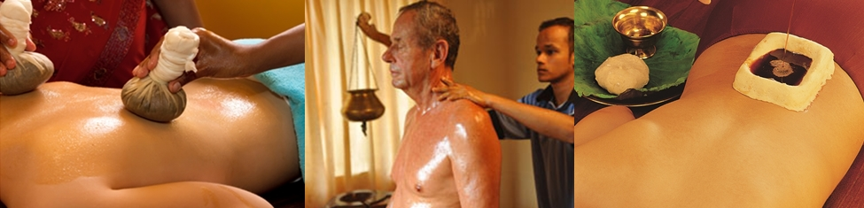

1. SERVICES - SEASONAL PACKAGES - WINTER TREATMENTS –

* Left side image – No change
* Right side image –

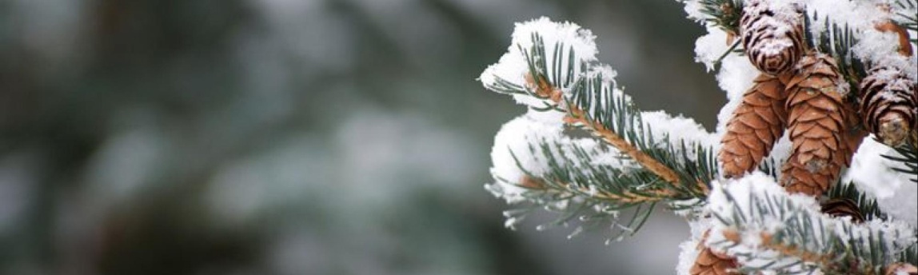

1. MEMBERSHIP PACKAGES –

* Left side image - 
* Right Side image -

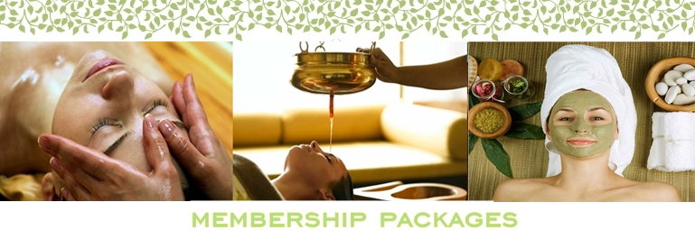

Content to add below the 6 months & 1 Year Tabs _

“Auraveda Wellness centre strongly believes that these wellness therapies are definitely the keys to good health that we all are searching for. It helps in preventing lots of health problems arising out of modern lifestyle and so these wellness therapies should be a part of our routines. You can avail a discount of 15% on any other therapies being our membership holder. Each of you can greatly contribute to your own wellness and healing and we want to inspire you actively participate in this process. “

1. AYURVEDA - CONCEPT OF REJUVENATION –

* Main image - 

1. AYURVEDIC METHODOLOGY –

Main Image - 

1. ROLE OF PANCHKARMA –

Main Image - 