Here is your Tarot reading

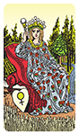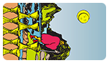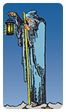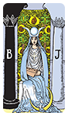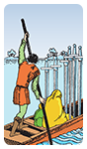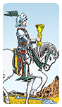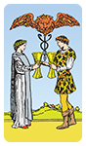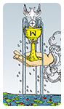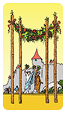

Current Influences

*Your present position. This card reveals influences, and shows the general direction of the reading.*

[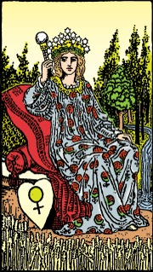](https://www.trustedtarot.com/cards/the-empress/)

The Empress

Traditionally associated with strong maternal influence, the presence of the Empress is excellent news if you are looking for harmony in your marriage or hoping to start a family. Any artistic endeavours you are currently associated with are also likely to be more successful, as this card often finds those exposed to strong bursts of creative or artistic energy. That creative energy may not be in the form of a painting or art project, however: This card also suggests a very strong possibility of pregnancy -- not necessarily yours, but you might be seeing a new addition to your extended family or the family of a close friend in the near future! This card is a good sign for you and those around you.

*Key interpretations:*

* Abundant creativity
* Fertility
* Fulfillment
* Mother figure
* Productivity

*In this position, the card reveals:*

**If you do not already occupy a role as a mother or father figure, you may expect to find yourself stepping into one soon. You will find yourself in the position of attracting wealth and providing stability for those around you, but you will need to trust your intuition.**

Obstacles

*Immediate Influences. This card reveals the nature of the obstacles immediately before you.*

[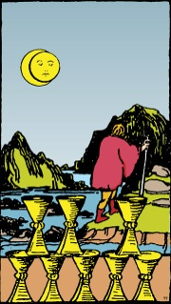](https://www.trustedtarot.com/cards/eight-of-cups/)

Eight of Cups

The Eight of Cups suggests that there is stability and security in your life, but at a personal cost. You are probably unfulfilled by your current life. Depending on the rest of your spread, it may be a strong push for you to move on, and find the courage to strike out in a new direction. You will have to look closely at your work, your relationship, and your own beliefs to identify the source of your dissatisfaction, and then decide if you are willing to set aside some of your life's stability in order to find happiness.

*Key interpretations:*

* Abandonment
* Avoiding
* Changes in lifestyle
* Leaving / Going
* Personal development

*In this position, the card reveals:*

**You will be traveling somewhere new, though this may be mental or physical.**

Past Foundations

*Recent influences or events in the past from which your current situation has arisen.*

[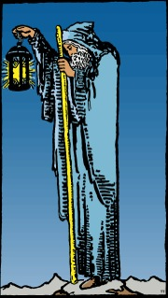](https://www.trustedtarot.com/cards/the-hermit/)

The Hermit

There are times in every life, when one must step back and carefully examine their situations and decisions. Finding the Hermit in your spread suggests this is such a time for you. You are in need of a period of inner reflection, away from the current demands of your position. This retreat can be physical, or a search within. Only a deep and honest introspection will lead to a solution, however.

*Key interpretations:*

* Detachment
* Guidance
* Solitude
* Sour-searching and introspection
* Thinking and reflection

*In this position, the card reveals:*

**You will need to accept that your past pace will slow for a time.**

Past Events

*Reveals a recent influence or event which is coming to an end.*

[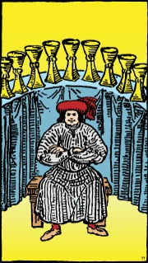](https://www.trustedtarot.com/cards/nine-of-cups/)

Nine of Cups

This card is a very powerful positive indicator for you! It represents a lasting or powerful contentment in your life. While nothing is permanent, somewhere along your life's path you can expect to be truly happy. It is heavily tied to creative endeavour and good wishes for the future.

*Key interpretations:*

* Complete
* Fulfilled
* Generous
* Pleasure
* Satisfaction

*In this position, the card reveals:*

**Your sustained efforts are approaching their reward. You will need to stay strong and keep working until they do.**

Goals and Destiny

*Shows your desired goals and aims, and reveals the best outcome that can be achieved in your current situation.*

[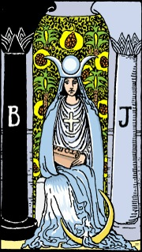](https://www.trustedtarot.com/cards/the-high-priestess/)

The High Priestess

Your identification with the High Priestess suggests you possess inherent good judgment, in the form of strong intuition. She may indicate that reason should take second place to instinct. Your head must trust in the wisdom of your heart for a change. Yet, she is also an aide by nature, and her presence in certain parts of your spread could be indicative of someone close to you coming to your rescue with their own intuition. Intuition is most effective at seeing what is hidden to the senses, so the High Priestess may also come as a warning of concealed facts or influences that are, or will be, important to you.

*Key interpretations:*

* Feminine influences
* Insightful
* Mystery
* Understanding
* Wisdom

*In this position, the card reveals:*

**You may find the most satisfying use of your talents is using them to uplift and inspire the people around you.**

Future

*Reveals a new influence that will soon be brought to bear in your life.*

[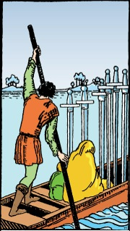](https://www.trustedtarot.com/cards/six-of-swords/)

Six of Swords

Your mental focus can put you on track to leave your current troubles behind, leading to better times ahead. It is important to face your problems from a mental standpoint, thinking through them. There is still trouble ahead for you, but the worst is over.

*Key interpretations:*

* A journey
* Better future
* Escape
* Left over challenges
* Travel

*In this position, the card reveals:*

**A prolonged period of anxiety, which you may have already entered, will eventually be superseded by peace of mind.**

The Querant (you)

*This card reveals your negative feelings, and provides additional information about how you feel in your present environment..*

[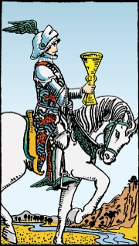](https://www.trustedtarot.com/cards/knight-of-cups/)

Knight of Cups

The Knight of Cups encourages you to remember that victory is not just an exercise in strength of arms, but can be achieved through cleverness and a savvy mind. He can also be given to flights of wild fancy, so you may also interpret him as a warning to maintain your focus. New initiatives in your life are likely on their way, and you must remember to seek novel paths to accomplish goals, but also not lose sight of where you are going.

*Key interpretations:*

* Arrival
* Creative
* Invitation
* New opportunities
* Proposal

*In this position, the card reveals:*

**Giving love is frightening, especially in a new relationship. You must, however, find the courage to do so.**

Friends and Family

*This card shows your influence on the people around you, and their influence on you. It also shows how they fit into your home, work, and surroundings.*

[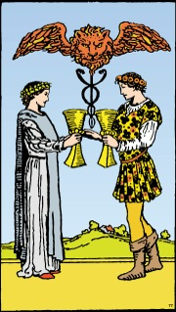](https://www.trustedtarot.com/cards/two-of-cups/)

Two of Cups

The single resounding theme associated with the Two of Cups is partnership. What sort of partnership is less clear, but you are in the past, present, or future, part of a powerful one. This partnership will involve absolute trust and command respect. It may, of course, be a particularly emotional love affair, but it could just as easily be a deep and abiding friendship. The exact nature may be revealed by the rest of the spread. It will be a source of happiness for you, a presence in your life you can count on at every turn, and whose well-being will be as important to you as your own.

*Key interpretations:*

* Commitment
* Friendship
* Love
* Partnership
* Relationship

*In this position, the card reveals:*

**You will form a deep understanding with another person, the rewards of which may not be apparent for some time.**

Hopes, Fears, and Ideals

*Your inner emotions.*

[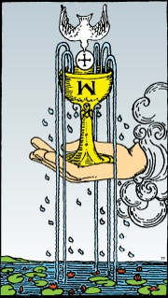](https://www.trustedtarot.com/cards/ace-of-cups/)

Ace of Cups

The Ace of Cups signifies the beginning period of strong emotional health for you. Expect copious joy, happiness, and love to surround you during this time. Existing personal relationships may strengthen, meaningful new ones are likely to form. If marriage is in your future, you are likely to lay the foundations for it during this time.

*Key interpretations:*

* Abundance
* Creativity
* Intense relationship
* Satisfaction
* Success

*In this position, the card reveals:*

**Your burgeoning spiritual awareness will bring a new sense of purpose to your life.**

The Final Outcome

*This card reveals the final outcome to your question. It's the product of all the other influences shown in this spread.*

[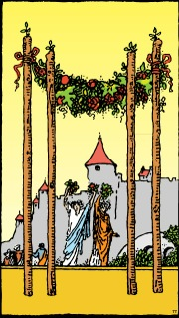](https://www.trustedtarot.com/cards/four-of-wands/)

Four of Wands

Peace and security follow in the wake of the Four of Wands, usually in the smaller aspects of your life. Do not let the limited scope bring you to underestimate the joy that simple successes can bring, however: This is a card of good endings and fresh starts. Its presence should be welcome if you are beginning a new relationship or a new phase of one, such as marriage or engagement, and is especially good for those about to move residences.

*Key interpretations:*

* Celebrations and happiness
* Completion
* Harmony
* New beginnings
* Pleasure

*In this position, the card reveals:*

**Work perfected in the present will be the foundation of your future success.**