Learning Management System
In-House Pilot Ready for Testing
1. Background
The note is about having a unified Learning Management System (LMS) — for the entire organisation -one platform to host technical and behavioural training for the workforce, track individual progress in the first phase as the first phase stabilizes the ultimate objective is to connect training directly to competency gaps identified through the ePMS.
As a first step, an in-house LMS has been built as a standalone pilot. The same is proposed to be deployed as a test case on the inhouse server system (the infrastructure shall be required from Corporate Infocom).

2. Current Status — Pilot Already Built
- A standalone pilot LMS has already been developed in-house by Sh. Nitin Dua, CM (Prog.)
- It includes a working dashboard showing an individual's training progress and assessment scores (currently populated with dummy data for testing).
- A second dashboard has also been built to show how this progress can flow to an employee's controlling officer.
- The pilot is ready to be mounted on Data Centre infrastructure with some dummy trainings and assessments and put to test with a sample size nearly 100 real users.

3. Objective
To provide a single platform where:
- Technical and behavioural training for all executives can be hosted, assigned and tracked.
- Every training carries a built-in assessment, not a separate, disconnected test.
- Progress shall be visible both to the individual and to their controlling officer.
- Over time, Phase-II training can be recommended automatically based on competency data/ role assigned, rather than assigned manually.

4. Key Features (Pilot and Planned)
- Course authoring with one or more sections, each with an attached quiz and automatic scoring.
- Support for SCORM-based courses, as well as video, PDF, HTML and image-based content.
- Individual dashboard — courses completed, in progress, and assessment scores.
- Controlling officer dashboard — team-wide progress at a glance.
- Device-agnostic access (laptop, tablet, mobile) — planned for the final rollout stage.

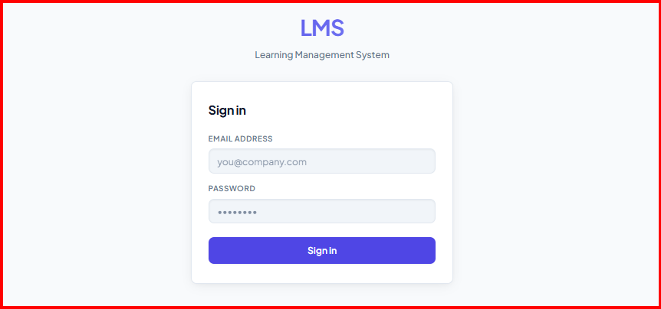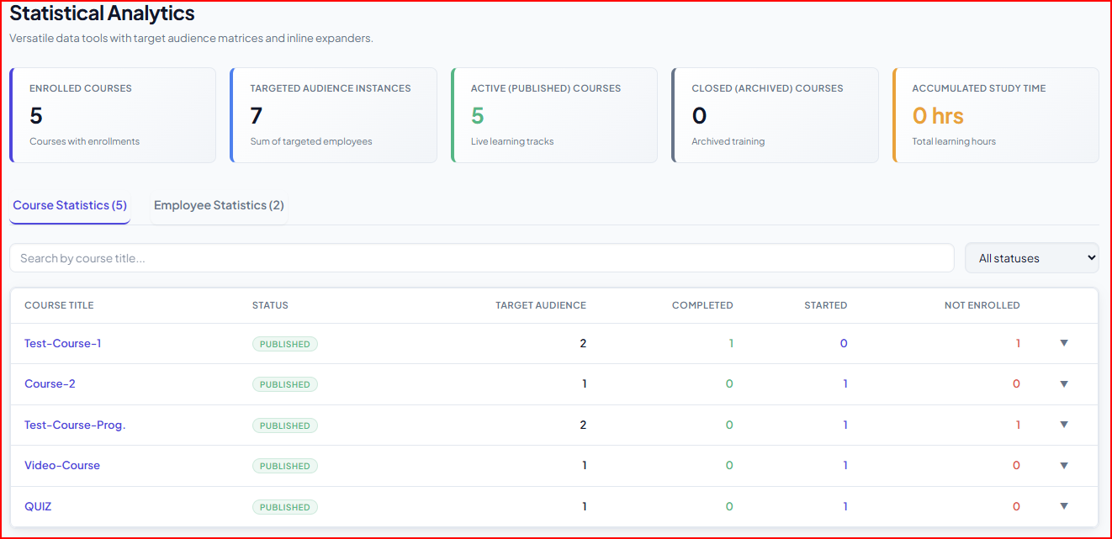
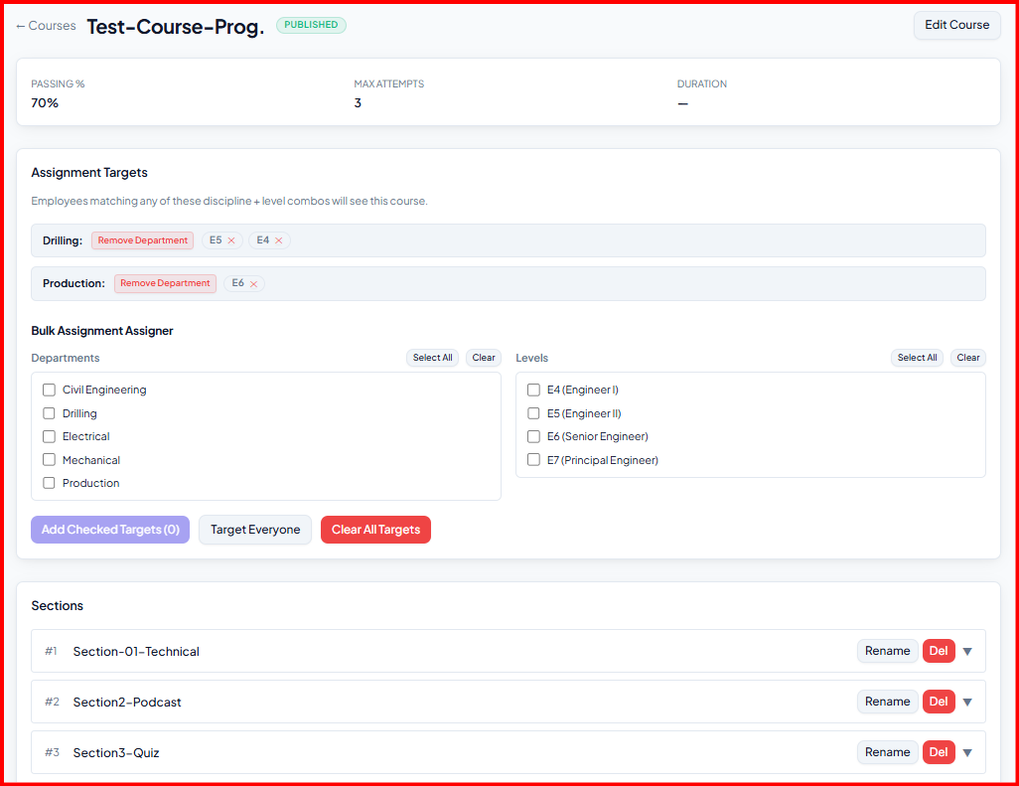
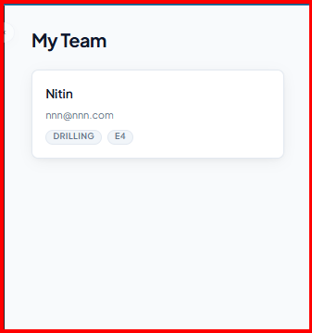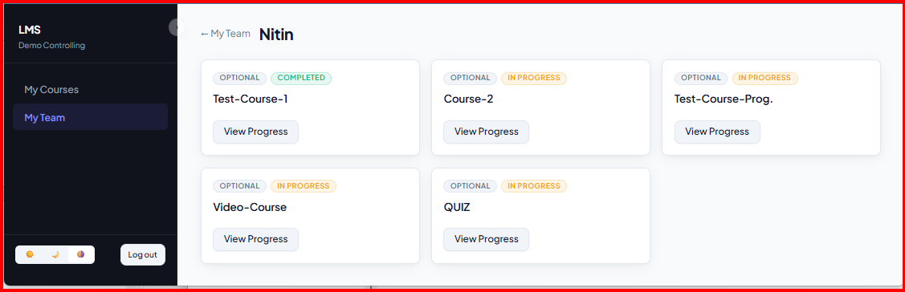
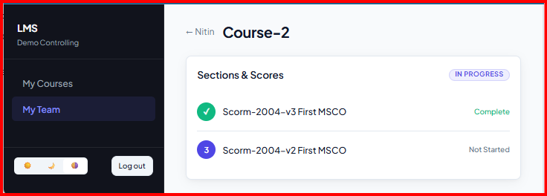
5. Parallel Activities:

- Formation of a Technical Committee with following members:

- Chunuram Hembram, GM (E&T)- Data Centre Group- Corporate Infocom
- Satyajit Das, GM (Programming) – Corporate Infocom
- Shrinath Das, CE(E&T)- DRDC-Vadodara.
- Sh. Nitin Dua, CM (Programming) as a co-opted member, having developed the pilot.

Sh. Ansul Tiwari, CE(P)-Strategy Group to be associated with the committee till final roll out.

Responsibilities of the Technical Committee:

- Validation of the pilot developed.
- Providing on premises IT resources/ infrastructure for mounting the LMS.
- Uploading of the Content provided by ONGCA and ATI-GOA. (training conducted by other institutes etc)
- Ensure all the functionalities like running of the content, assessments, GAP analysis etc for successful implementation of the LMS system.
- Rolling out the system organisation wide.
- Maintaining and day to day troubleshooting the LMS system post implementation organisation wide. Responsibility: Corporate Infocom.

- Identification of mandatory and desirable training courses for E1 to E5 level executives all disciplines by interacting with SME’s .

- Nomination of SME’s to be taken from concerned Directorate(s): Responsibility-Strategy Group.

- ONGCA , ATI GOA to interact with SME’s and finalise the list of such Technical trainings for each discipline.

- ONGCA, ATI GOA to curate above training courses (E1 to E5) through vendor engagement along with assessments and provide the content to the technical committee.

- For E6 and L1, L2 and L3 roles ONGCA and ATI GOA to curate the managerial/ Behaviorial courses through vendor engagement along with Assessments for the six behavioural competencies as being assessed through ADC’s. Send the content to technical committee.

Technical committee to upload the above courses and achieve all the functionality of LMS for these courses as provided by Training Institutes. Training institutes to work in close collaboration with the technical committee for successful integration. Responsibility: Training Institutes and Corporate Infocom.

6. Basic Flow
- Department or training partner (ONGCA , ATI GOA) uploads a course with one or more sections. ONGCA and ATI GOA gives the training content to Technical committee and they upload the content in the LMS
- A quiz is attached to each section, to be completed before moving ahead.
- The learner completes the section and its quiz; the score is recorded automatically.
- The dashboard updates for both the learner and their controlling officer.
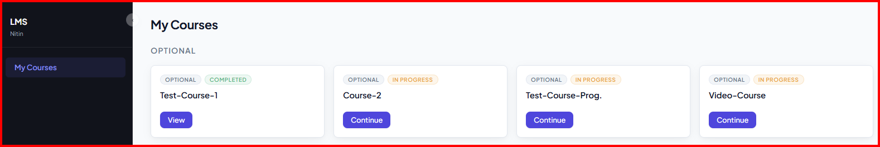
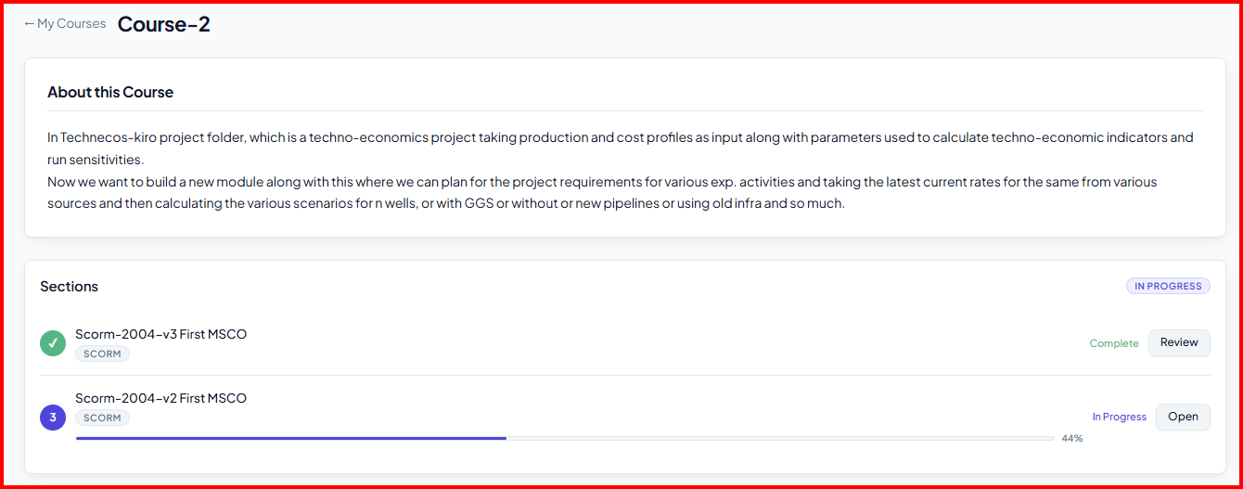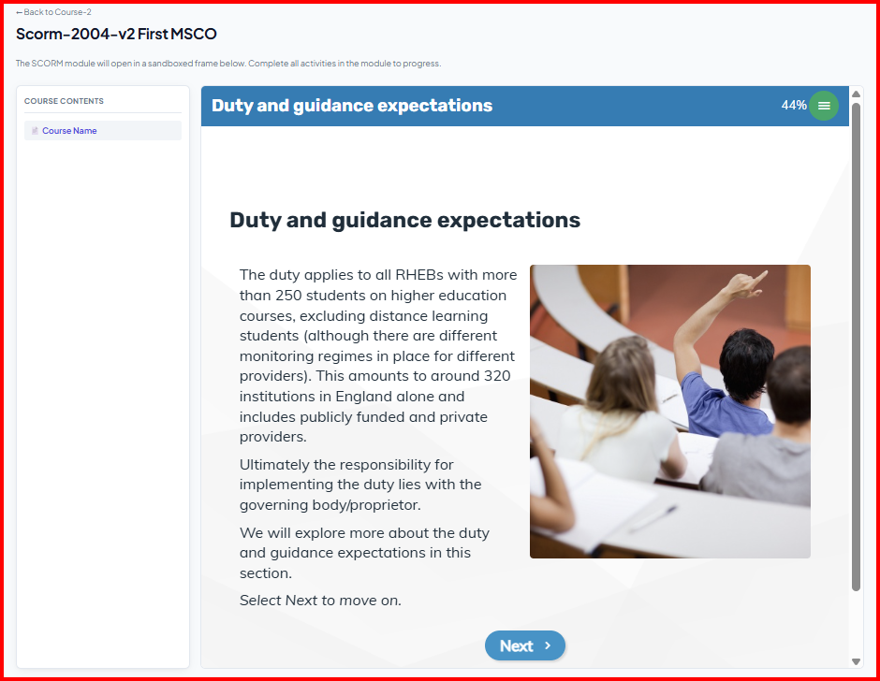
7. Why an In-House System
- No initial cost and no recurring per-employee licence cost, unlike a purchased product.
- Full control over data — everything stays inside our own Data Centre.
- Free to support any content type, rather than being limited to what a vendor allows.
- Can be built around our own grade structure and, later if proceeds, can be integrated with SAP and ADC data — something a bought product is unlikely to support.

8. Basic Requirements for the Testing Stage
- A modest server/VM’s allocation from the Data Centre to mount the pilot — one or two hosts would be sufficient at this stage.
- Access for approximately 100 users for the next test phase with appropriate hardware (inputs to be given by the Technical Committee).
- A short list of test content — a few freely available training videos and PDFs — to run through the system.
- Nomination of a small technical committee to validate the pilot and take it forward and they shall be responsible for future maintenance and upkeep of the system.

8. Implementation Plan
Stage | What Happens
Stage 1 | Validate the existing pilot and mount it on Data Centre hardware; test with dummy data.  Target: within 15 days of resources being made available.
Stage 2 | Open the system to about 100 users with real test content on better infrastructure;  Validate the dashboard, progress reporting, and controlling officer view.
Stage 4 | ONGCA and ATI Goa to curate course and hand over to Technical Committee.
Stage 5 | Scale to the full organisation.
Stage 6 | Make the system device agnostic, make it accessible from laptop, tablet and mobile.

Result and Responsibility:
To test the prototype model on a small scale, then scale it for organisation wide usage, monitor the stability and health of the module. Once fully operational to maintain and upgrade as and when required.
Responsibility: Corporate Infocom- Technical Committee

10. Benefits
- One place for all workforce training, instead of scattered content with no consistent tracking.
- Transparent, near real-time progress visible to management through the reporting chain.
- No recurring licence cost — meaningfully lower cost over the long run than a purchased product.
- A working foundation already in place for future integration with the ePMS.
11. Future Scope
- AI-assisted course creation: using AI tools to help departments draft quizzes and even video-based training content faster, with a human reviewing before anything goes live.
- Expert locator: automatically identifying strong performers in each domain from assessment data, to serve as internal trainers or reviewers.
- Full device-agnostic rollout across the organisation, once the platform is proven at scale.

- ePMS:
Objective: Identify the competency Gaps and suggest corresponding trainings based on data analytics with no human intervention.

Develop an ePMS system :

- It is proposed that role based technical competencies for E1 to E5 positions and Non-CRC roles be identified through a professional vendor. HR Strategy.

- Once the competencies are identified these will act as feeding stock for deriving measurable KPI’s . The PAR system needs to be aligned with these measurable KPI’s. Corporate PAR

- A report is required to be generated from SAP showing the GAP in required Competency and exhibited competency of the individual based on PAR rating. Corporate PAR

- These results to be submitted to Technical Committee/Corporate Infocom for integrating in LMS so as to have a completely automated recommendation purely based on data analytics removing any human biases for the training and developmental journey of the individual.

12. Request
We request management's approval to:
- Nominate the technical committee, under Option 1 or Option 2 above.
- Allocate the modest Data Centre resources needed to mount and test the pilot.
- Proceed with Stage 1 and Stage 2 as outlined, with a review before scaling to Stage 3.

